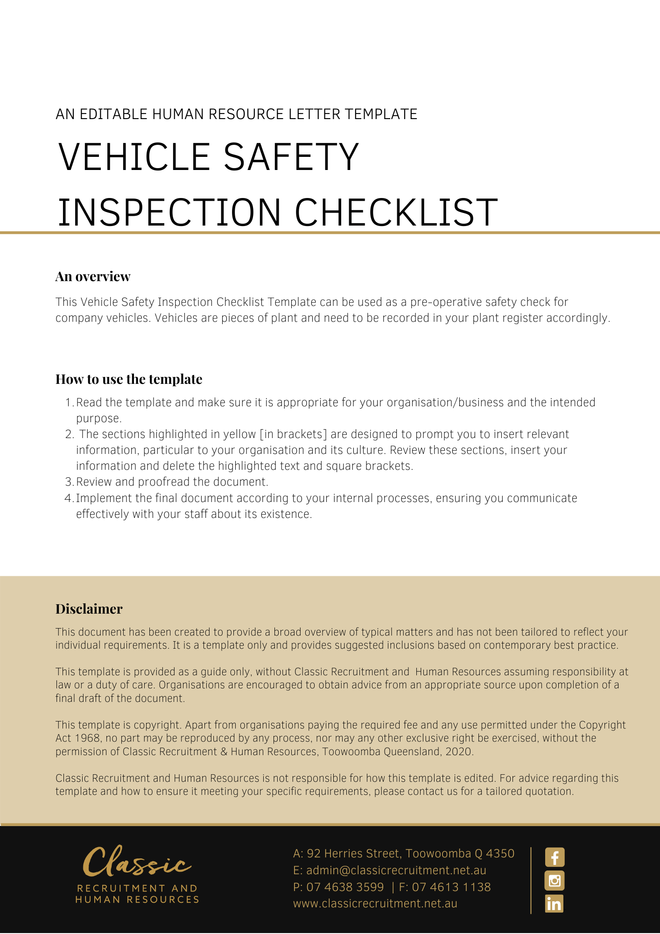
Vehicle Safety Inspection Checklist

Driver
Licence number
Plant ID No
Vehicle registration
Insurance policy
Date of inspection

Item | Yes | No | Action To Be Taken
Lights
Check operation and visibility of:
Headlights
Parking lights
Indicators/blinker
Hazard lights
Brake lights
Reverse lights
If trailer attached:
Parking lights
Indicators/blinkers
Hazard lights
Brake lights
Reverse lights
Brakes and Warnings
Check operation of handbrake
Check for firm brake pedal
Check operation of horn
Interior
‘No Smoking’ signs displayed prominently
Internal cleanliness maintained, including upholstery
Cargo barrier in place, where appropriate
Safety belts in good order
Exterior
Any damage to body work noted
Windscreen in good order and clean
Windscreen wipers and washers operating
Water in windscreen washer reservoir
Tyre tread checked for wear
Treads matching for front and rear tyres
Tyre pressure checked
General Safety
System in place for reporting problems
Servicing as required
First Aid Kit, Sunscreen, Insect Repellent
Contents assessed in compliance with first aid requirements
Container and contents clean and orderly
System in place to replenish kit items
Expiry dates checked
Out of date items disposed of
Transportation of Clients
Wheelchair hoist fitted, if required
Appropriate for the transport of clients
Facility to secure clients appropriately
Client behaviour while travelling in a vehicle is known
Other Issues
Return completed form to : [Insert Position (e.g. CEO/Director/Owner)]
Reviewed by [name]:
Position:
Date: |  | Date for next inspection:

