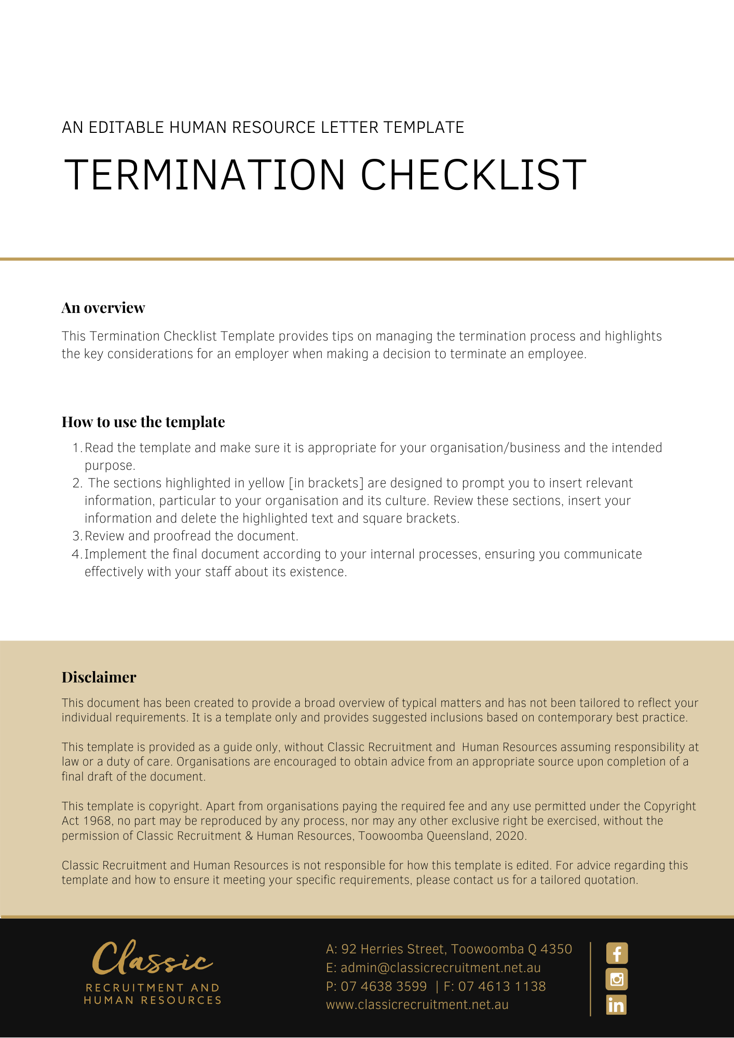
Termination Checklist

Employee: | Date effective:
Home or forwarding address:

Termination considerations
- Consider the time and resources to replace and train a new employee. The termination should be treated as a last resort.
- Consider whether you have a valid reason for dismissal and documents to support that reason.
- Ensure you have appropriately managed any conduct and/or performance issues. See the Performance Management Checklist.
- Check the termination of employment provisions in the employee’s terms and conditions of employment (for example an applicable award, agreement, contract, or other industrial instrument). Ensure you comply with these provisions.
- Check whether you have a Termination Policy and make sure you comply with the procedures outlined in the Policy when terminating the employee's employment. If the employee is being terminated for reason of redundancy, see the Redundancy Checklist.
- Check what legislative provisions apply in relation to the termination.
- Ensure the reason for dismissal is not unlawful or discriminatory.
- Act fairly in conducting the dismissal.
- Inform the employee of the meeting in advance and provide them with an opportunity to have a support person present.
- Meet with the employee to discuss the reason(s) for the dismissal.
- Allow the employee an opportunity to respond.
- Discuss any prior warnings.
- Inform the employee of the dismissal and the reason(s).
- Keep a record of the discussion with employee.
- Calculate the employee’s pay-out entitlements as at the date the termination of employment will take effect and prepare a detailed statement to issue to the employee.
- Notice: there are minimum notice requirements in the Fair Work Act 2009 (Cth), which must be complied with. However, if the employee’s contract of employment, applicable award or agreement provides a more generous notice entitlement, you should apply this notice period.
If the employee does not have an up-to-date contract of employment or if it does not expressly state the required notice period, a period of reasonable notice may be implied. This may be more than the minimum notice requirements in the Fair Work Act 2009 (Cth). As such, you should seek legal advice before terminating the employee’s employment.
- Notify the employee of his/her termination in writing stating the reasons for the dismissal and their final date of employment. You should make sure these reasons do not expose your business to the risk of legal action. For example, the reasons should not be discriminatory or unlawful. If you are not sure how to word the termination letter, have a look at the sample documents provided as part of the HR Advance service. If you are still unsure, obtain legal advice.
- Summary dismissal: if the conduct of the employee is wilful or deliberate behaviour that is inconsistent with the continuation of the contract of employment, it may be sufficiently serious to warrant summary dismissal. In circumstances of serious or wilful misconduct, an employer can dispense with notice of termination and dismiss the employee instantly. [In such circumstances, check whether your business has a disciplinary policy and if so comply with it. Ensure the investigation process is conducted fairly and give the employee an opportunity to respond to the allegations.] If you are not sure whether the employee’s actions warrant a summary dismissal, seek legal advice prior to terminating the employment.
- Payment in lieu of notice: if you are concerned about the employee remaining in the business during any relevant notice period, you may make a payment to them in lieu of notice if the employee’s contract of employment, award or agreement, allows you to do so. Alternatively, you may have the employee stay at home rather than performing work if there is a provision to enable this in their terms of engagement (this is commonly known as placing the employee on gardening leave during their notice period).
- Notify other parties affected by the termination, (e.g. the employee’s superannuation fund, workers’ compensation and other insurers (where relevant), other employees and managers, payroll, key customers, security and IT etc). If the termination of the employee’s employment is for performance or conduct related issues, keep the reasons for the termination confidential.
- Arrange the return of any property of the employer which is in the employee’s custody, possession or control (e.g. company provided vehicle, mobile telephone, laptop, business cards, office keys, security passes etc). Also, change any passwords and other security measures, which would allow the employee in question to continue to gain access to the business or its computer network. See the Property Return Checklist.
- Provide a statement of service if required by an applicable award or agreement, or where requested by the employee. If the employee has requested a written reference, seek legal advice before agreeing to this request.
- Small businesses should comply with the Small Business Fair Dismissal Code (‘Code’). The Code currently applies to national-system employers that employ fewer than 15 employees (on a headcount basis). If a small business employer can demonstrate compliance with the Code, the employee will be precluded from claiming they have been unfairly dismissed.

Prior to departure:
Termination/resignation documents received and placed on the employee’s personnel file.

On departure: Complete the HR Advance Property Return Checklist

On departure: Payroll and administration
Advise Payroll/Accounts:
- Termination date
- Final pay
- Leave entitlement pay-out
- Summary of expenses
- Issue a Group Certificate to the relevant employee, within required time period after the employee’s employment ceases.
- Update the employee’s employment records to record all details of the termination of the employee’s employment.
- Other [insert relevant information]

Date: | [Insert Position (e.g. CEO/Director/Owner)]:

