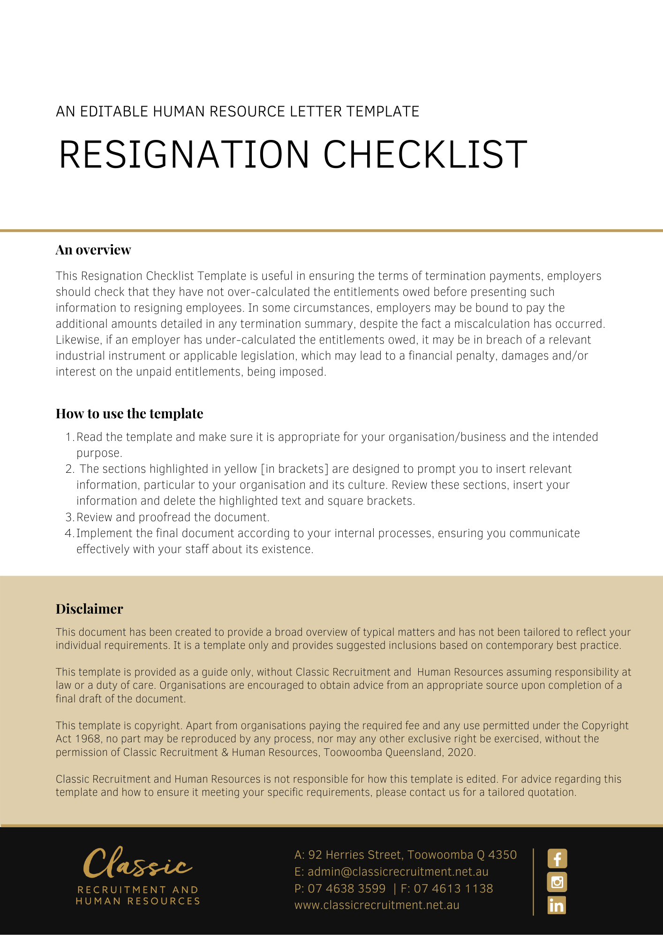

Resignation Checklist

Employee Name | Resignation Date

Considerations
- Discuss the situation with the employee and, if appropriate, assess whether there is some action you can take to prevent the resignation, e.g. monetary incentives or flexible working hours.
- If there are identifiable alternatives to the employee’s resignation which the business can accommodate, confirm any altered conditions in writing, noting other contractual conditions remain unchanged. Alternatively, prepare an up-to-date contract which includes the new conditions of employment.
- If there are no identifiable alternatives to the employee’s resignation, obtain the employee’s written confirmation of resignation. If written confirmation is not supplied, write to the employee confirming your receipt of their resignation and your acceptance of it.
- Consult your business' termination/resignation policy.
- Confirm with the employee the precise date their resignation will take effect, taking account of the period of notice the employee is required to provide. If you intend to provide the employee with a payment in lieu of notice, make arrangements with payroll and confirm this in writing with the employee.
- Notify other parties affected by the resignation, (e.g. the employee’s superannuation fund, workers’ compensation and other insurers (where relevant), other employees, payroll department, key customers etc.).
- If appropriate, discuss with the employee about the terms of the announcement to other staff concerning their departure.
- Calculate the employee’s pay-out entitlements as at the date the termination of the employee's employment will take effect and prepare a detailed statement of entitlements to issue to the employee.
- Re-check that the quantum outlined in the statement of termination entitlements is correct before providing it to the employee.
- Arrange the return of any property of the employer which is in the employee's custody, possession or control (e.g. company vehicle, mobile phone, laptop, business cards, office keys, security passes etc.). Refer to the Property Return Checklist.
- Prepare and issue a statement of service, if the employee has requested one.
- Prepare and issue a written reference only if it is appropriate. Note that there is no obligation to provide a written reference if the employee requests one.
- Update the employee’s employment records to record all details of the employee’s termination of employment.
- Issue a Group Certificate to the relevant employee within the required time period, after the employee’s employment ceases.
- Issue a Separation Certificate to the employee if requested by the employee or Centrelink.
- Ensure the employee completes all relevant paperwork to resign from any offices held with the employer.
- Advise IT and building security to de-activate all security passes, email accounts and any other relevant security measures.
- Update the employer’s phone list.
- Finalise final superannuation contributions within the required time period.
- Ensure the employee prepares a memo outlining work not completed up to termination.
- Allocate future appointments from the resigning employee’s diary to another employee.
- Have the resigning employee complete an exit interview questionnaire.
- Issue a final payslip.

Date: | Completed by:

