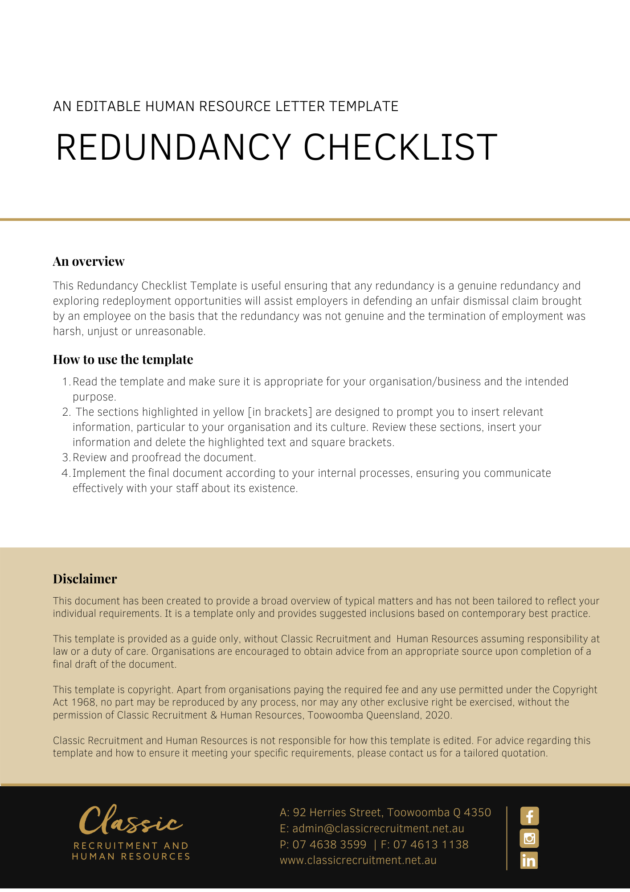

Redundancy Checklist

Sequence of tasks
Preliminary steps — Prior to making a definite decision to make a position redundant
Assess the motivating reasons for the redundancy. Consider whether the reason for the redundancy would amount to a genuine redundancy.
Do you no longer wish the job to be performed by anyone because of changes in the operational requirements of your enterprise or due to insolvency or bankruptcy?
Are there reasons of an economic, technological, structural nature that necessitates a restructure of the business? Obtain data to support those reasons.
Consider alternatives to redundancy, such as transfers, retraining or redeployment (within the employer’s enterprise or the enterprise of an associated entity of the employer).
Do you still need to consider redundancies?

Selection of employee to retrench
Select employees for redundancy, in a fair and non-discriminatory way.
Identify employees for redundancy by objective selection criteria which are applied consistently to employees whose position may be made redundant. Relevant factors may include a consideration of an employee’s:
(i) qualifications
(ii) skill set
(iii) experience
(iv) performance

Consultation
Consider obligations contained in awards, agreements, contracts, legislation and employer policies that mandate consultation and notification with employee(s) and/or unions about the proposed redundancies before they take effect.
Consider whether you are obliged to, or will elect to offer voluntary redundancies.
Discuss re-deployment opportunities with employees.
Comply with obligations in awards, agreements, contracts and legislation.
Notify affected employee(s) and relevant unions (where required) of impending redundancies.
Ensure affected employee(s) understand the genuine operational reasons for the impending redundancies.
Notify the employee of his/her redundancy and final date of employment in writing.

Entitlements
Identify any entitlement to redundancy/severance pay an employee might have under an applicable award or agreement, contract of employment, employer policy or legislation.
Consider whether there are exclusions from paying redundancy pay under the applicable award or agreement, contract of employment, employer policy or legislation.
Discuss with an accountant or tax adviser any applicable tax free components of the redundancy/severance payments.
Consider whether you will offer additional severance payments to employees above their legal entitlements. If so consider using a Deed of Release.
Check applicable award or agreement, contract of employment and legislation for minimum notice periods. Comply with these notice periods.
Calculate termination entitlements.

General
Notify other parties affected by the redundancy, eg employee’s superannuation fund, workers’ compensation and other insurers (where relevant), other employees and managers, payroll, key customers etc.
Issue an employment separation certificate.
Check the applicable award, agreement or contract of employment, employer policies and legislation to see whether you must issue a statement of service.
Notify Centrelink where a decision has been made to terminate the employment of 15 or more employees for reasons of an economic, technological, structural or similar nature before termination.
Arrange the return of any property of the employer which is in the employee’s custody, possession or control (eg company vehicle, mobile phone, laptop, business cards, office keys, security passes etc). Also, change any passwords and other security measures, which would allow the employee in question to continue to gain access to the business or its computer network.

