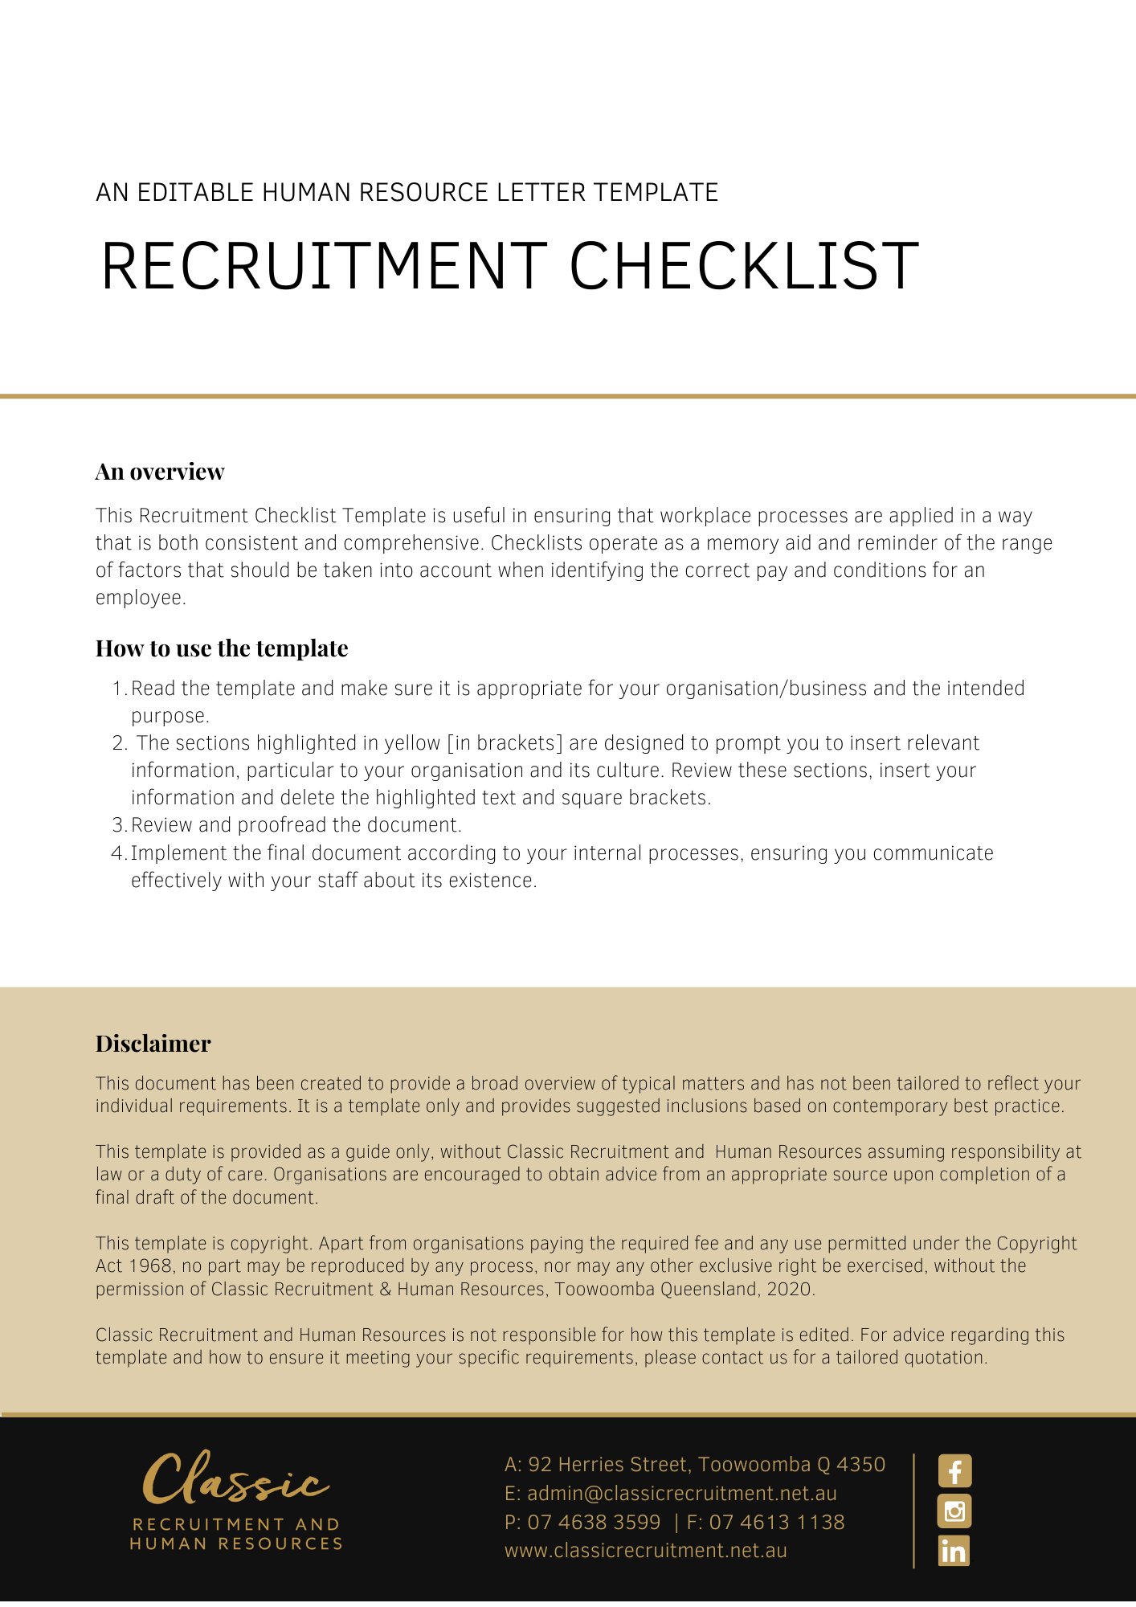

Recruitment and Selection Checklist

Sequence of tasks
- Ensure you have a recruitment policy in place. Recruitment should proceed in line with that policy.
Preliminary steps
- Evaluate the need for a new employee. Consider alternatives to employing a new employee.
- Evaluate job description and educational qualifications.
- Create specifications and other documents relevant to job.
- Review budget and long-term needs of business. Is a new employee affordable and is the investment justifiable?
- Prepare a budget for the recruitment process.
- Decide whether to handle recruitment in-house or whether to use an external source, such as a recruitment agency or consultant.
- If applicable, locate recruitment agency/consultancy.
Advertising position
- Ensure the advertisement is written in clear and non-discriminatory language.
- Advertise the vacancy, both internally and externally.
Pre-interview selection
- Identify objective selection criteria against which job applicants will be assessed.
- Set up a procedure to review and screen job applicants.
- Prepare pre-interview employment questionnaire.
- In selecting job applicants for interview and employment, do not refuse interview/employment (without first obtaining legal advice) based on discriminatory grounds such as: age, race, sex, carer responsibilities, disability, sexual preference, marital or domestic status, pregnancy etc.
- Reject job applicants that do not meet basic requirements, such as minimum qualifications, work experience and skills.
Interview process
- Establish a selection panel.
- Prepare a list of interview questions.
- Consider a pre-employment medical examination (if relevant to the position).
- Advise job applicants of the interview.
- Interview suitable job applicants.
- Consider the need for a second interview.
- Advise job applicants of a second interview.
- Ensure the job applicant is not subject to post-employment restraints that preclude their employment.
- Check job applicant’s references and verify that their qualifications are valid.
- Check that job applicants are legally able to work in Australia.
- Consider conducting criminal record check (if relevant to position).
- Prepare short-list of suitable job applicants.
- Select the most suitable and qualified job applicant.
Offer of employment
- Make job offer verbally, but be clear it is subject to acceptance of a written offer (including probationary period) and, if accepted, confirm starting date.
- Prepare a formal letter of offer/employment contract.
- Ensure the employment contract meets basic minimum legal requirements (consider a pay and conditions checklist).
- Provide the successful job applicant with a ‘Fair Work Information Statement’.
- Obtain tax and superannuation details from successful job applicant.
- Advise all unsuccessful job applicants.
General
- Evaluate recruitment policies and processes regularly and improve as required.
- Destroy those documents relating to unsuccessful job applicant within a short period who have not provided consent for their personal information to be retained.
- Consider retention of recruitment documents taking into account privacy legislation.
- Retain unsuccessful job applicant documents for future positions only by consent.

