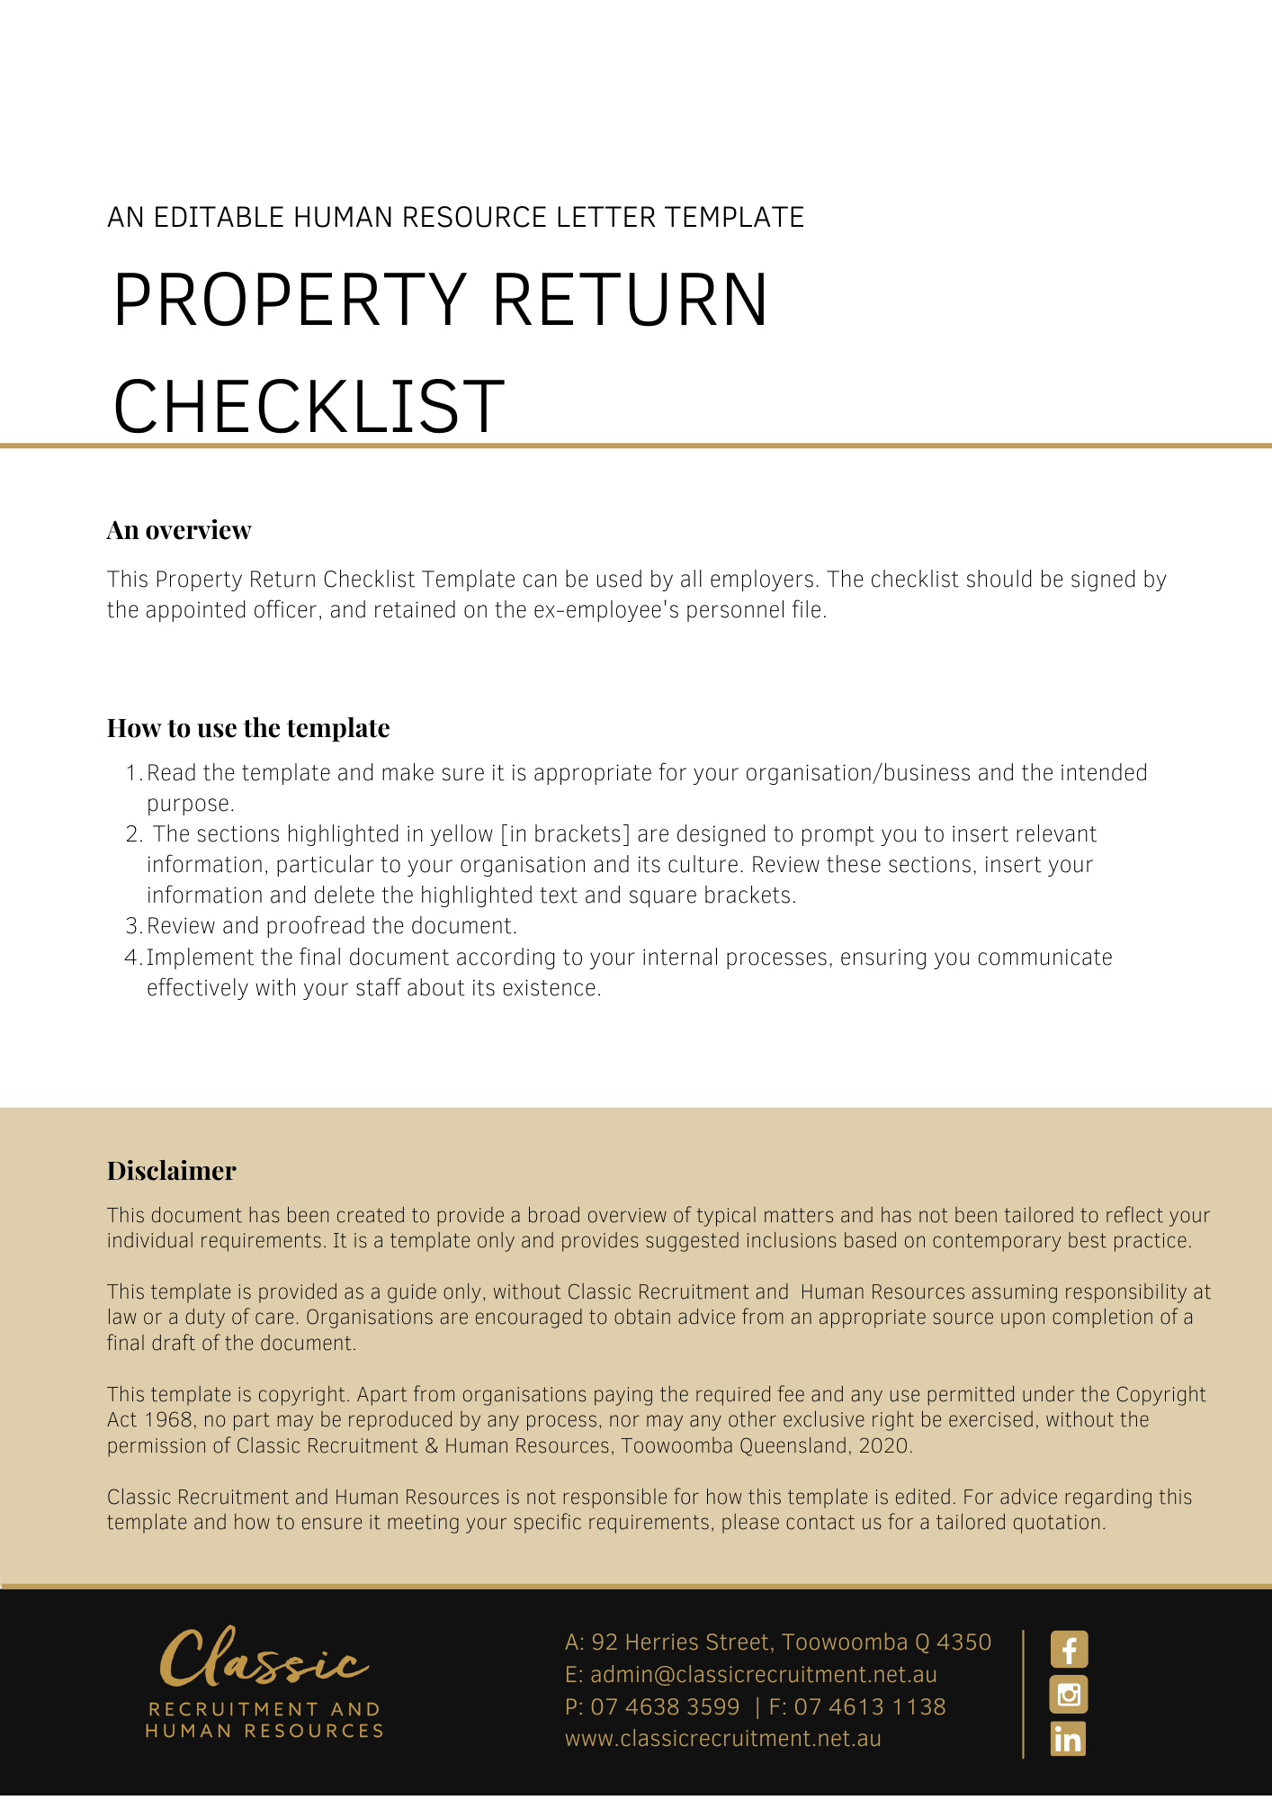

Property Return Checklist

Name: [Employee Name]

Position: [Employee Position]

Termination date: [Termination Date]

The following property of [Company Name] must be recovered or actioned prior to [Employee Name] leaving the employment of [Company Name]. The [Insert Position] must initial and tick the appropriate columns.
Item | Returned | Not applicable | Initial
- Uniforms and Personal Protective Equipment
- Security/access cards
- Office entry keys/passes
- Office internal keys/passes
- Locker key/pass
- Filing cabinet keys/pass
- Building entry keys/passes
- Parking permit
- Staff ID card

Vehicles, tools of trade, equipment
- Company vehicle and keys
- Company vehicle inspection
- Vehicle accessories belong to the company (e.g. GPS devices, Bluetooth accessories, First Aid kits, fire extinguishers, etc)
- Tools of trade supplied by the business
- Equipment supplied by the business

IT
- Mobile phone
- Mobile phone charger
- Pager
- Information storage devices - e.g. flash storage drives, CDs/DVDs
- Laptop and charger
- Other computer equipment

Business cards
- Business credit cards
- Cabcharge cards
- Petrol card

Printed material
- Office stationery (e.g. letterheads)
- Name badges
- Business cards
- Price/customer lists
- Policy and procedure manual
- Product catalogues, samples, etc
- Precedents
- Customer contact details (e.g. phone, email, customer business cards, etc)

Confidential information and intellectual property
- All confidential information of the business
- All Intellectual property of the business

Other items (please specify)

Actions to be taken in relation to items not returned

Comments

[Insert Position]
Signature: ..........................................................................
Date: ..........................................................................
Print Name: ..........................................................................

