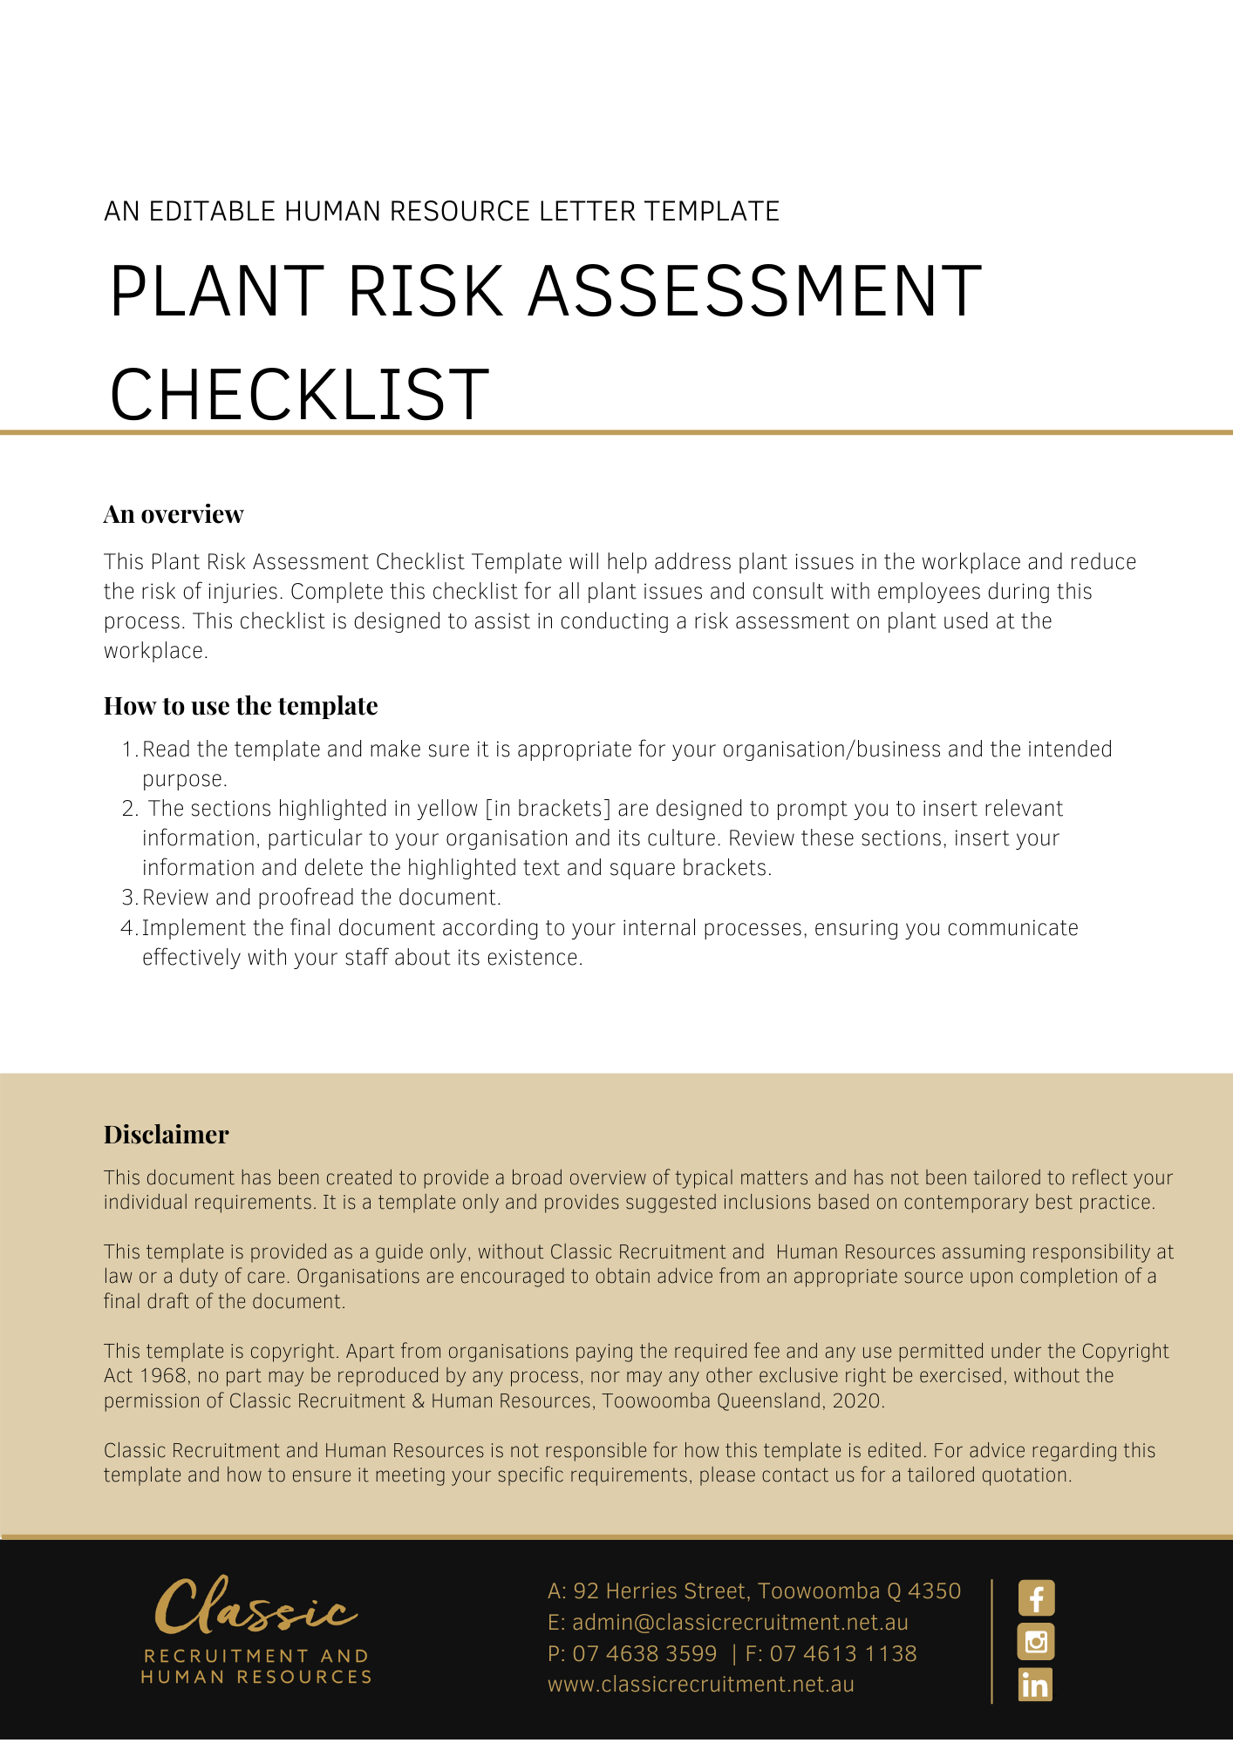
Plant Risk Assessment Checklist

Plant : [type/number] |  | Location:
If required, under relevant legislation, plant registration number: |  | Currency of any plant registration:
Date checklist completed |  | Date for review
If second hand, this plant was purchased with a list of any reasonably foreseeable faults |  | List associated each SWMS/SWP where this plant is likely to impact on a worker
This plant has been altered since purchase |  | If this plant is used in any processing of hazardous compounds, appropriate controls are available for protection of employees/workers involved with operation, maintenance, transport, storage, cleaning and waste disposal:
Location of plant log book if required: |  | Log book is up-to-date:
Name of person completing checklist
 |  |  |  | YES | NO
- The ground is stable and plant is properly installed.
- Machine guards

- Guards and protection devices:
- are in place and operational;
- are suitable for their purpose;
- not easily bypassed — either by intention or accident;
- are situated at sufficient distance from the danger point or area;
- do not restrict the operating cycle;
- comply with relevant WHS legislation and Australian standards [Check relevant legislation]
Any further comments on guarding:
- Any emergency stop switches and buttons are appropriately placed, clearly identified, and are in working condition.
- There is adequate working space.
- Any confined space issues have been identified, and entryways placarded.
- The work area is controlled from pedestrians and forklifts.
- Belts, pulleys and other rotating parts are guarded.
- The machine is regularly inspected and maintained in accordance with manufacturer’s instructions. [Check the manufacturer’s instructions]
Comments:

Machinery is kept clean.
INJURY RISKS
- There is NO risk of injury from entanglement with moving parts of the equipment.
- Material falling off the equipment is not possible.
- There is NO risk of injury from uncontrolled or unexpected movement of the machine.
- There is NO risk of injury from the equipment tipping or rolling.
- There is NO risk of injury from being thrown or under the equipment.
- There is NO risk of injury from being trapped between the equipment and materials or fixed structures.
- There is NO risk of injury from work pieces being ejected.
- There is NO risk of injury from being sheared between two parts of the equipment or between a part of the equipment and a work piece or structure.
- There is NO risk of injury from contact with high pressure fluids associated with the equipment.
- There is NO risk of injury from contact with electricity associated with the equipment.
- There is NO risk of injury from equipment catching fire or overheating.
- There is NO risk of injury from potential exposure of gases, vapours, liquids, dusts associated with the equipment.
- There is NO risk of injury from unprotected falls from heights.
- There is NO risk of injury from by explosion of gases, vapours, liquids, dusts or other substances, triggered by the operation of the equipment and the material handled by the equipment.
- There is no repetitive movement required to operate the equipment.

Comments:
- There is NO risk of injury from a constrained body posture or excessive load associated with the equipment.
- Coming into contact with excessive temperature — hot and cold.
- There is NO exposure to noise levels in excess of 85 dB(A).
Comments:
- There is NO exposure to radiation/vibration/or other hazards.
- Danger points of the equipment have been effectively guarded to prevent access.
- Access to danger areas if required, is guarded with interlocking.
- Guarding controls the risk of any parts or materials being ejected from the equipment.
- All control devices are within safe and easy reach.
- The equipment provided with appropriate warning alarm devices for start up and malfunctions.
- Warning signs are displayed near machinery.
- Safe operation manuals available for the machinery.
- Employees/workers have received training in the safe operation of the plant.
- Employees/workers are supervised to ensure correct procedures are followed.
- Personal protective equipment is provided and appropriate to the hazards faced. Any hazardous compounds likely to be encountered during the operation, maintenance, transport, storage and cleaning of the plant is also to be taken into account. List PPE:
- Extension leads and power boards are located in a safe position.
- Electrical equipment is regularly inspected and tagged.

Action Required: [Address all questions that have a NO response]

Date actions completed: :
Name: | Position:
Signature:

Return completed form to: [Insert Position (e.g. CEO/Director/Owner)]

