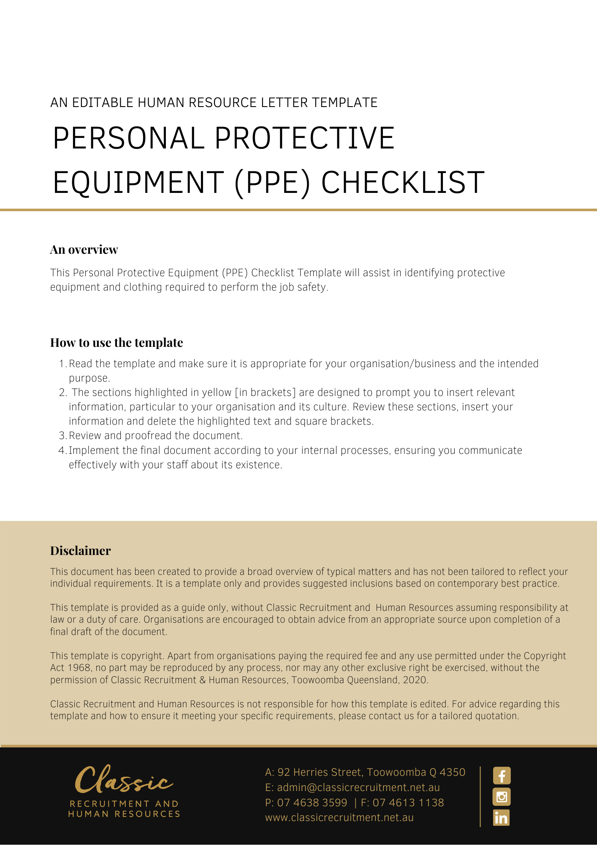
Personal Protective Equipment [PPE] Checklist

PPE is personal and commentaries here must account for each and every individual worker who has to wear such equipment, e.g. body size for clothing; sight impairment for safety-glasses; facial hair for breathing apparatus

Date checklist completed |  | Date for review
Name of person completing checklist

PPE Checklist | YES | NO
Selection of Personal Protective Equipment [PPE]
- Has a risk assessment been done to determine what PPE is required?
- Have other control measures been implemented for the hazard identified (hierarchy of control) and what are they?
- Have employees/workers been consulted in the process of selecting PPE for particular tasks?
- Does the PPE fit properly and is comfortable to wear?
- Are employees/workers trained in PPE procedures, such as the fit, use and maintenance of PPE?
- Do employees/workers wear PPE in accordance with the instructions provided?
- Is the PPE stored in a clean area where it will not be damaged or exposed to contaminants?
- Is a maintenance program established for PPE and documented?
- Have medical conditions or physical characteristics of employees/workers been taken into consideration?
Supervision
- Has suitable training and resources been provided to Supervisors to enable them to ensure the proper, selection, fit, use, cleaning and maintenance of PPE?
- Are employees/workers aware of the disciplinary action to be taken if PPE procedures are not adhered to?
- Has responsibility for supervision and enforcement of the organisations PPE policy and procedures been allocated to a senior manager?
- Are Supervisors provided disciplinary powers and appropriate support?
Potential Hazards Requiring PPE
- If there is a danger of cuts, or exposure to corrosives, chemicals or infectious materials are protective goggles, gloves, aprons or shields worn?
- Are hard hats provided where there is a risk of falling objects?
- Is footwear provided where there is a risk of foot injuries from hot or corrosive substances, crushing or penetrating objects?
- Are safety glasses, goggles provided for eye protection where there is a risk of flying objects, sparks, and filaments?
- Is respiratory protection provided in areas where there is exposure to dust, gases, chemicals
- Is other appropriate PPE provided for hot work, work near traffic, vibration, moving parts?
List additional hazard and PPE identified:
Signage
- Are signs posted in the workplace wherever it is necessary to wear PPE?
- Is the signage in the mandatory format?
- Is PPE provided in accordance with the relevant WHS legislation and Australian Standards and stamped accordingly?
Action Required:

Date actions completed:
Name: | Position:
Signature:

Return completed form to: [Insert Position (e.g. CEO/Director/Owner)]

