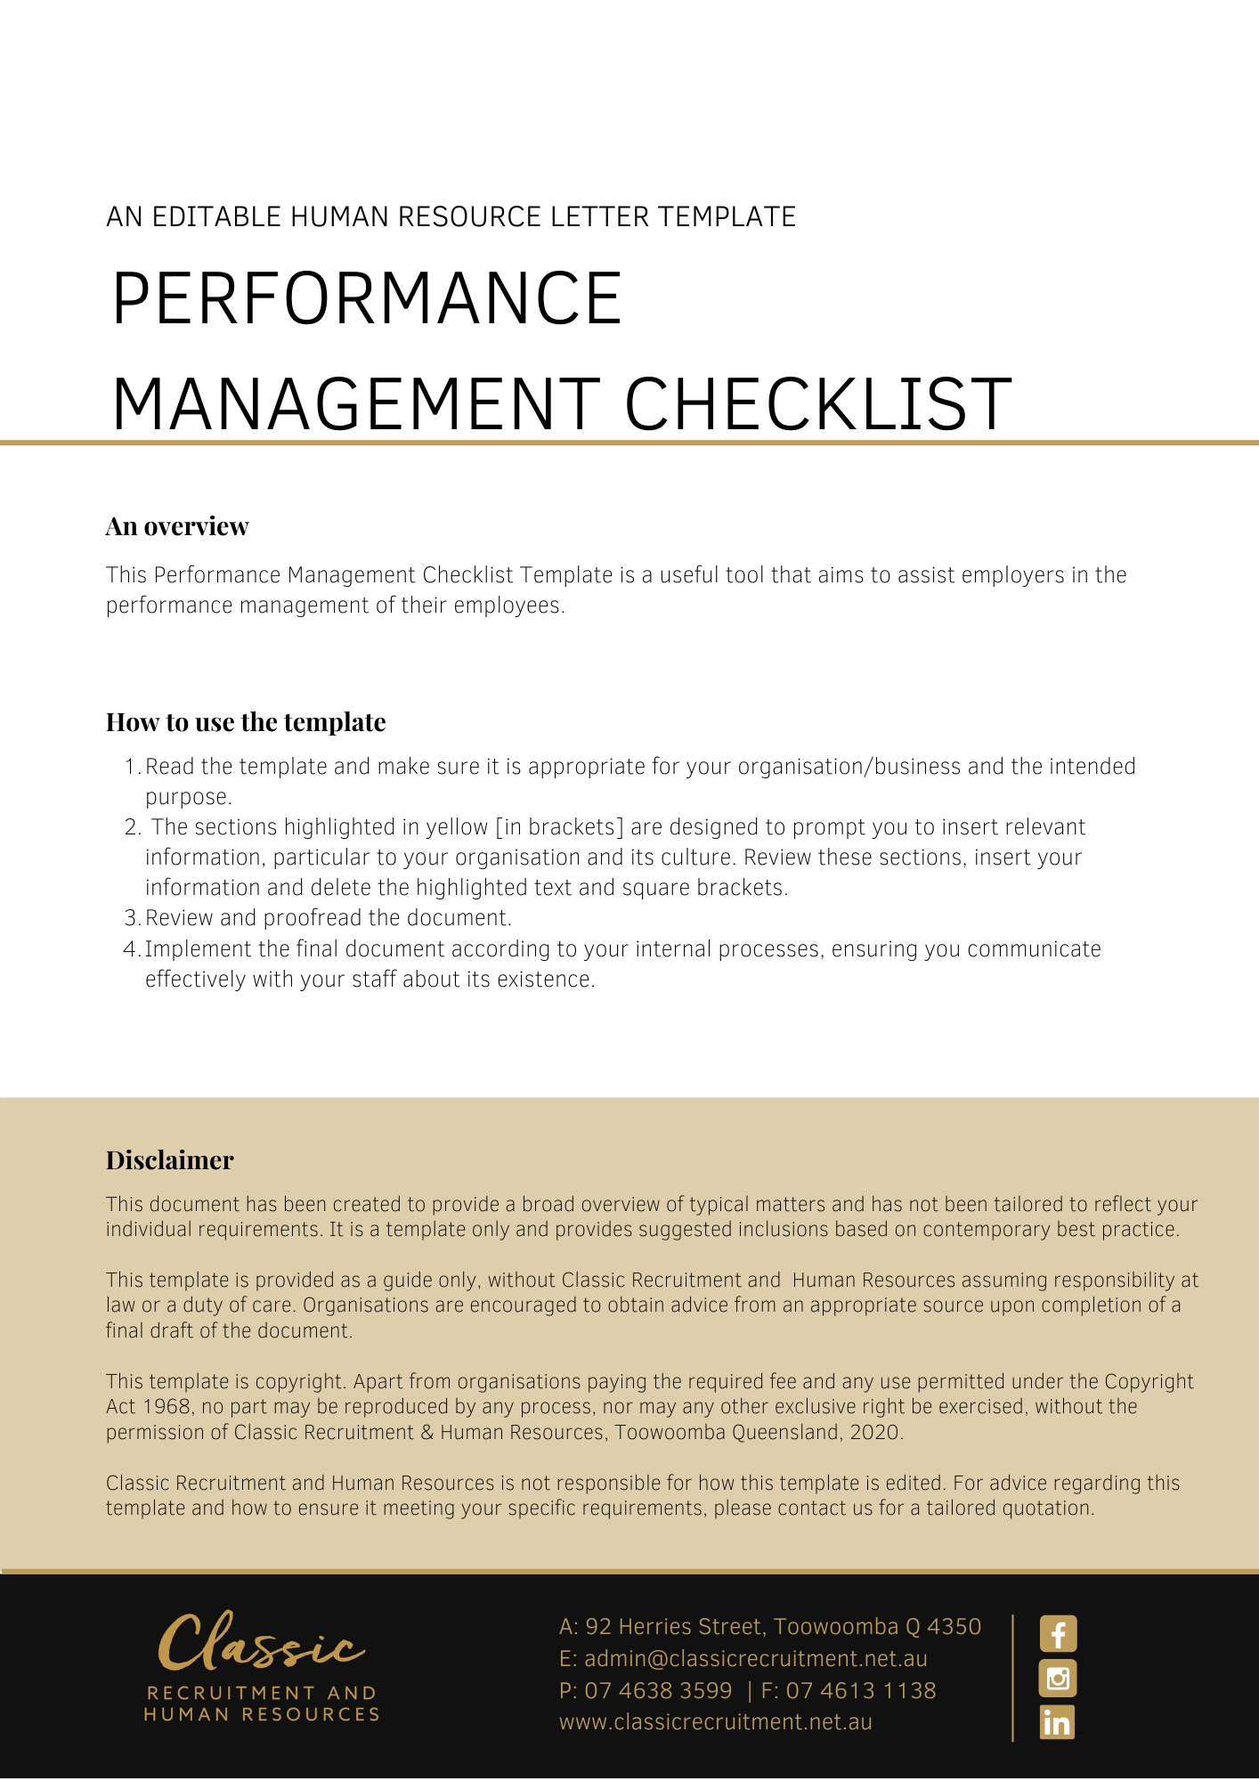

Performance Management Checklist

In considering an employee’s performance, you may take into account the following:

Preparation
- Study relevant documents that refer to job performance. These may include job descriptions, the employment contract, applicable awards or enterprise agreements, organisation policies and procedures, and individual performance assessment forms.
- Check whether the employee has been provided with sufficient information about the job to understand what is required from him/her to perform the job effectively – e.g. what are the key outcomes/results required? What was communicated to them about performance expectations either formally or informally?
- Check whether the employee has received adequate training and supervision and been supplied with adequate resources and other assistance to perform the job effectively.
- Assess the employee’s performance in an objective way. Focus on actual job performance and outcomes. Seek objective evidence such as actual samples of job behaviour or relevant records (e.g. attendance, error rates etc.).
- Ensure that people who conduct assessments (such as supervisors/managers) have received adequate training in how to conduct objective assessments.
- If a formal performance assessment process is used, ensure that it focuses on actual performance rather than personal characteristics and does not inappropriately discriminate against particular employees either directly or indirectly.

Conducting the interview
- Meet with the employee, having collected objective evidence about job performance as per above.
- Discuss good and poor features of the employee’s performance using actual behaviour-based examples. Point out consequences of poor performance such as costs, disruption to other employees, loss of business etc. Try to focus on the behaviours and conduct and avoid making overarching statements that might be seen to be attacking the individual on a personal level (e.g. “You didn’t provide the reports on time, so...” vs “Because you were lazy...”).
- Allow employee the opportunity to respond to the examples of poor performance, for example to mention any mitigating circumstances.
- Explore strategies that may assist in improving performance such as retraining, development courses, changing work methods/procedures, improving resources/back-up etc.
- Again explain (and provide a copy of) the key performance standards and outcomes require for the job.
- If further assessment and discussion is to occur, schedule this. Allow employee sufficient time to improve performance if that is an issue.
- Keep a record of the meeting contents and decisions.

After the interview
- If you have committed to actions such as those listed in 10 above, arrange for them to occur.
- Continue to assess employee performance in an objective way.
- If performance does not improve to the required standard, discuss this with employee again. If you reach this stage, it is good practice to invite the employee to have a representative or witness present at the interview and to also have a witness present on the interviewer’s behalf.
- Explain potential consequences of continued poor performance such as disciplinary action, formal warnings or termination of employment.
- If further assessment and discussion is to occur, schedule this.
- Keep a record of the meeting contents and decisions.
- Implement any decisions that result from this process.

Ongoing steps
- If job requirements and outcomes change, ensure the employee is made aware of the changes and given adequate retraining and resources to cope with them.
- If documents such as organisation policies change, inform employees of the changes and ensure they understand them.
- Conduct regular formal performance assessments and support them with more regular informal discussions between employee and manager/supervisor.

- Note: In serious cases of poor performance or misconduct, some steps in the process can be expedited, depending on the circumstances of each case. For example, point 17 could be raised during the initial meeting, in which case you would also have witnesses/representatives present at this stage (as per point 16).
- Important: If you are unsure about whether the particular circumstances warrant termination of employment, you should seek advice.

This document is only a general guide and, in any circumstance where termination of employment is a likely outcome, specific advice is recommended to manage your legal risks.

