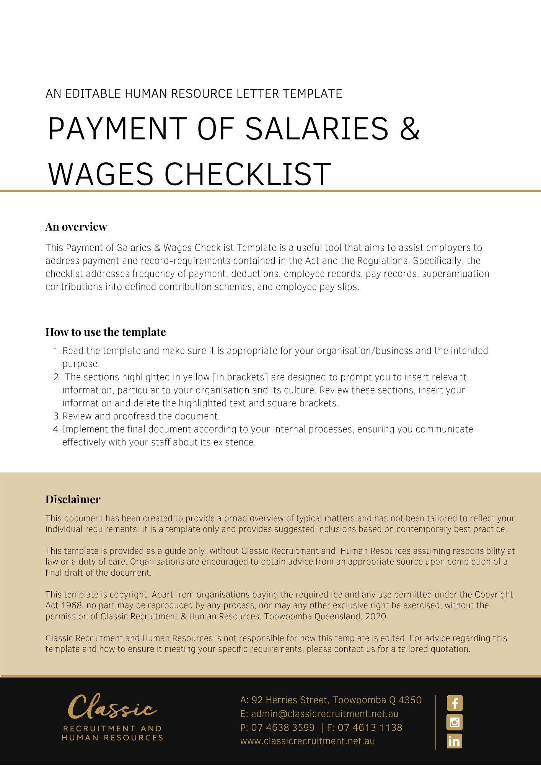

Payment of Salaries and Wages Checklist

Sequence of tasks
Frequency of payment
Decide how often wages and salaries are to be paid — up to a maximum period of one month, but may be a lesser period depending on an applicable award or enterprise agreement (e.g. weekly, fortnightly, monthly).
Decide when pay day will fall, if required (consistent with any relevant industrial instrument or contract of employment).
Decide the method of payment (e.g. cheque, electronic funds transfer, or as specified by an enterprise agreement or award).
Deductions
Make any required deductions. Deductions may be required by:
- Law (eg. taxation);
- Court orders (eg. garnishee orders in relation to child support or debt recovery); and/or
- An order of the Fair Work Commission.
Make authorised deductions. Deductions may be authorised by:
- An industrial instrument (e.g. an enterprise agreement or award); and/or
- The employee in writing.
Employee records
Make and keep records specifying:
- the employer’s name;
- the employee’s name;
- whether the employee’s employment is full-time or part-time;
- whether the employee’s employment is permanent, temporary or casual;
- the date on which the employee’s employment began; and
- the Australian Business Number (if any) of the employer.
Pay records
Make and keep records of:
- the rate of remuneration paid to the employee;
- the gross and net amounts paid to the employee;
- any deductions made from the gross amount paid to the employee;
- the hours worked by the employee, if the employee is a casual or irregular part-time employee who is guaranteed a rate of pay set by reference to a period of time worked; and
- the details of payment of any incentive-based payment, bonus, loading, penalty rate, allowance or separately identifiable entitlement the employee is entitled to.
Overtime
If a penalty rate or loading (however described) is payable for overtime hours actually worked by an employee, make and keep records of either:
- the number of overtime hours the employee worked each day; and
- when the employee started and ceased working overtime hours.
Superannuation
In relation to superannuation contributions (other than for defined benefit schemes) make and keep a record of:
- the amount of the contributions made;
- the period over which the contributions were made;
- the date on which each contribution was made;
- the name of any fund to which a contribution was made; and
- the basis on which the employer became liable to make the contribution, including a record of any election made by the employee as to the fund to which contributions are to be made, and the date of any relevant election.
Averaging of hours
In relation to any agreement for an averaging of hours of work, make and keep a record of the agreement (which may include a contract of employment).
Leave
If an employee is entitled to leave, make and keep a record of:
- any leave that the employee takes; and
- the balance (if any) of the employee’s entitlement to that leave from time to time.
In relation to any accrued leave which an employer and employee agrees to cash out, make and keep a record of:
- a copy of the agreement; and
- the rate of payment for the amount of leave that was cashed out; and
- when the payment was made.
Individual Flexibility Arrangement
In relation to any agreement in writing between an employee and employer for an individual flexibility arrangement, make and keep a record of:
- a copy of the agreement; and
- a copy of the notice or agreement that terminates the agreement.
Guarantee of annual earnings
If an employer gives a guarantee of annual earnings, make and keep a record of:
- a copy of the written guarantee; and
- a copy of any revocation of the written guarantee, with date noted on it.
Employee pay slips
Ensure pay slips are either in electronic form or hard copy
Ensure pay slips specify:
- the employer’s name;
- the employee’s name;
- the period to which the pay slip relates;
- the date on which the payment to which the pay slip relates was made;
- the gross amount of the payment;
- the net amount of the payment;
- any amount paid to the employee that is a bonus, loading, allowance, penalty rate, incentive-based payment or other separately identifiable entitlement; and
- the Australian Business Number (if any) of the employer.
For amounts deducted from the gross amount of the payment, include on the pay slip the name (or name and number) of the fund or account into which the deduction was paid.
For employees paid at an hourly rate, include:
- the rate of pay for the employee’s ordinary hours (however described);
- the number of hours in that period for which the employee was employed at that rate; and
- the amount of the payment made at that rate.
For employees paid an annual rate of pay, include on the pay slip the rate as at the latest date to which the payment relates.
For superannuation contributions* made for the benefit of an employee, include on the pay slip the amount of each contribution that the employer made during the period to which the pay slip relates.
Then, include either:
- the name, or the name and number, of any fund to which the contribution was made; or
- the amounts of contributions that the employer is liable to make in relation to the period to which the pay slip relates, and the name, or the name and number, of any fund to which the contributions will be made.
* Other than a defined benefit interest in a defined benefit fund.
Note: There may be other record keeping requirements that do not directly rate to the payment of salaries and wages that are not included in the above checklist.

