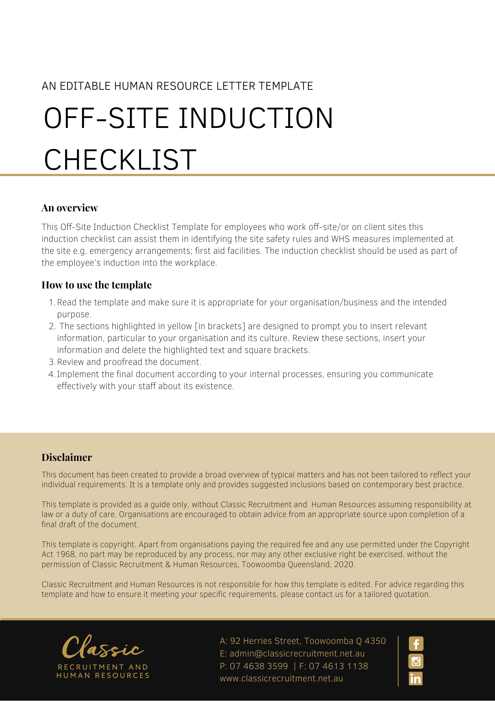
Off-Site Induction Checklist

Instruction: Complete this checklist to identify and assess the risks that employees/workers are exposed to while working off-site. Complete for each site and consult with employees/workers during this process.

Name of person completing the checklist:
Date checklist completed:
Employer
Host employer [employer of the workplace/site you are working at]
Location:
- Who is the Manager in charge of the workplace you are at for that day?
- If there is an incident in the workplace or you have WHS concerns, who can you report to?
- Have you undergone a formal induction into the workplace/site you are currently working at? |  | YES | NO
- Where is the first aid kit located in the event of an injury?
- Is there a register of injuries book where an incident can be recorded? |  | YES | NO
- Where is the assembly point for this workplace/site in the event of an evacuation?
- Are there evacuation plans and procedures displayed in the event of a fire? |  | YES | NO
- Are you aware of the closest emergency exit to where you are conducting your work activity? |  | YES | NO
- Have you completed a risk assessment/inspection of your work area to identify any hazards or risks? |  | YES | NO
- Is the required equipment available and in good working order (eg no frayed electrical leads) to enable you to conduct your work in a safe manner? |  | YES | NO

Action required: [Address all questions that have a NO or unsatisfactory response]

Date actions completed: :
Name: | Position:
Signature:

Return Completed form to: [Insert Position (e.g. CEO/Director/Owner)]

