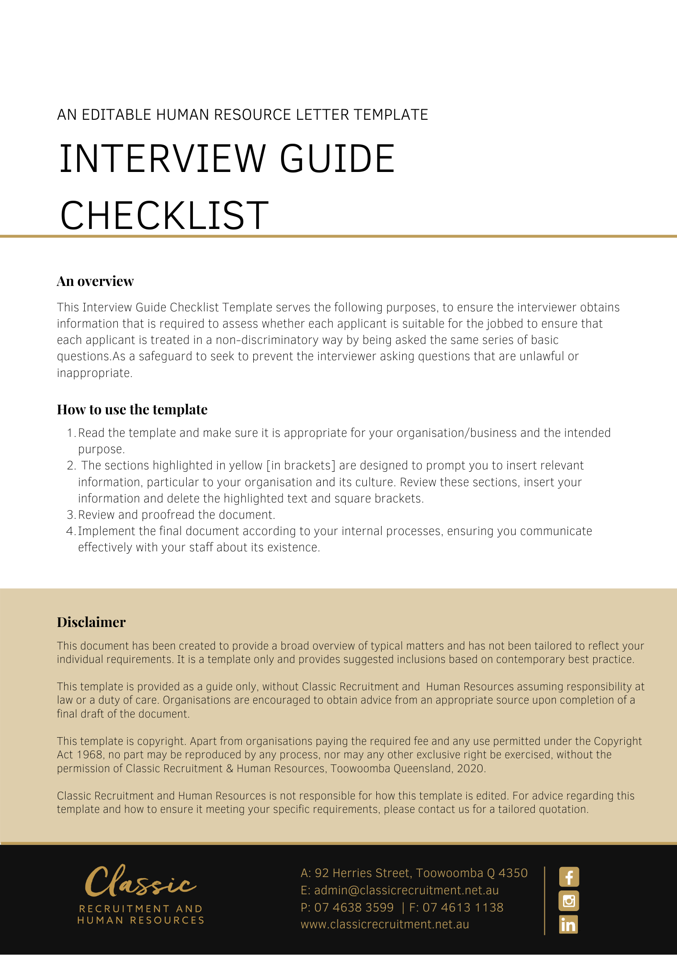

Interview Guide Checklist

Job title: [Job Title]

Location: [Work Location]

Applicant: [Applicant Name]

Interviewed by: [Interviewee Name] Date: [Date Interview Conducted]

Introduction checklist
- Introduce yourself, welcome the applicant and thank him/her for coming.
- Explain the role and structure of this interview. Inform the applicant that you will take notes during the interview.
- Briefly explain why the vacancy exists, if appropriate.
- Place the vacancy in context, providing an overview of the business and its plans plus details of how the vacancy fits into the organisation structure.
- Briefly describe the role and responsibilities of the job and provide a copy of the job description if available.
- Move towards the specific interview questions.
- Remember that assessment and selection criteria must be based on job-related competencies in order to prevent possible breaches of equal opportunity legislation. Avoid asking about race/ethnicity, disability, sexual orientation/identity, marital/relationship status, family responsibilities, religious or political beliefs and affiliations (unless these are necessary for the role).

Essential criteria
- [Essential knowledge, skills, qualifications and experience]

Desirable criteria
- [Desirable knowledge, skills, qualifications and experience]

Assessment of criteria
- [Set out the questions relating to each criterion that you will ask the applicant]

Other questions/discussion
- Allow the applicant time to ask his/her own questions, and to explore/discuss any other issues.
- Explain other information about the job, such as salary, working hours, fringe benefits, HR policies, etc.

Conclusion checklist
- Explain next stage(s) of the recruitment/selection process and indicate a time frame for them.
- If you intend to contact referees nominated by the applicant (or alternate referees you may nominate), ensure you have the applicant’s permission to do so (alternatively, this question may be asked at a later stage if contact with referees will not be made until a later stage in the recruitment process, for example after a further interview or when a shortlist of candidates has been finalised).
- Give the applicant a final opportunity to ask further questions.
- Thank applicant for attending and arrange their departure.
- Make sure you have completed the Assessment of Criteria section above.

