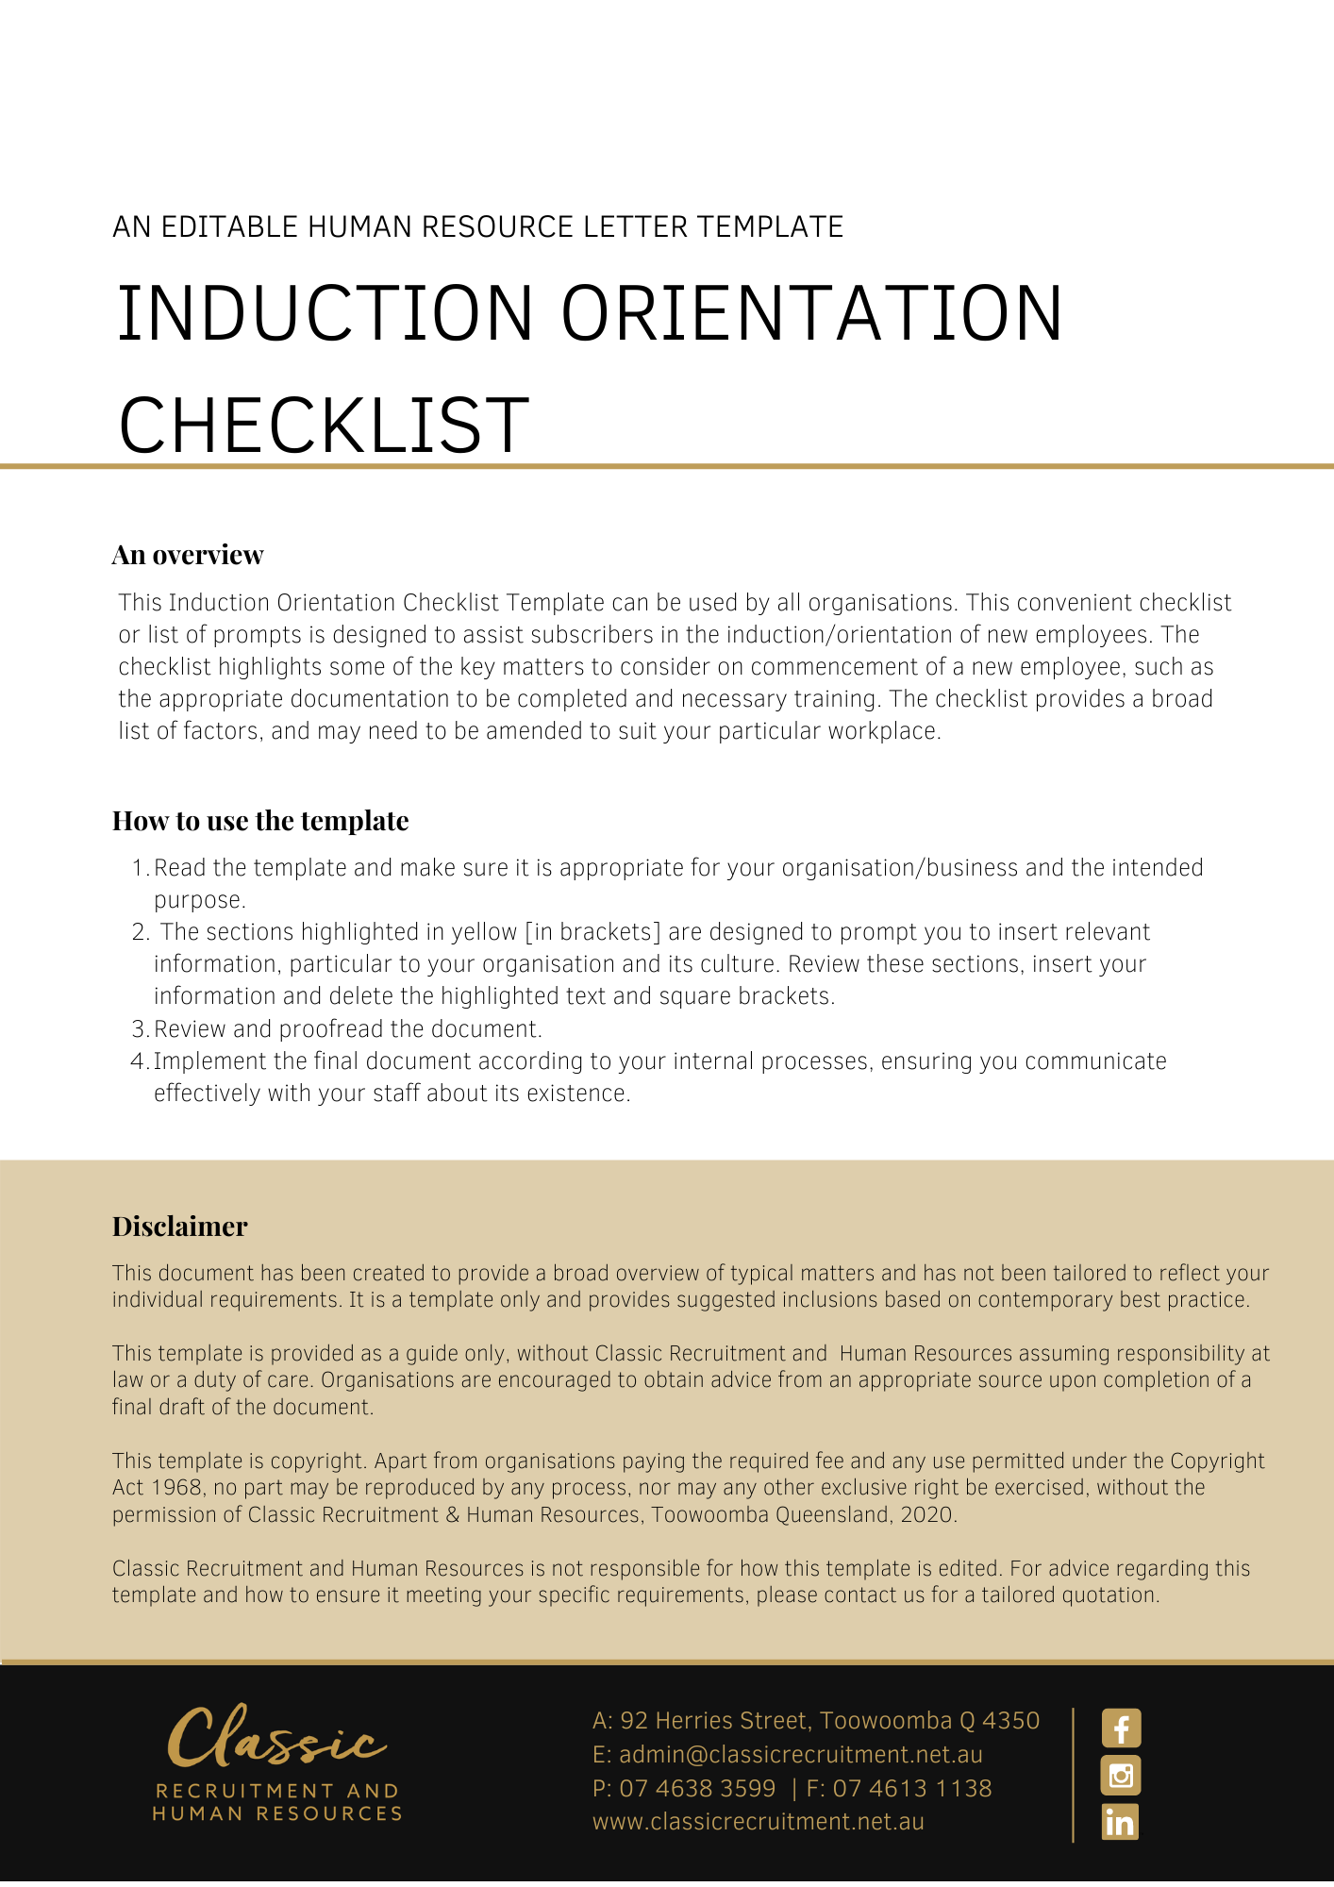

Induction / Orientation Checklist

Employee Full Name: ………………………………………………………………………………
Position: ………………………………………………………………………
Commencement Date:…./..…./…...

ORIENTATION
No | Matters to be covered in Orientation | Completed | N/A
1 | Give the employee a copy of the Fair Work Information Statement (available here)
2 | Obtain completed Employee contact information form
3 | Obtain completed Australian Taxation Office Tax File Number Declaration form, salary payment form, superannuation fund form (including Standard Choice form)
4 | Obtain any other applicable payroll forms
5 | Discussion about hours of work, training, and other information (e.g. recording time, information technology matters)
6 | Brief description of the organisation's history, clientele, services offered and organisational structure (including key personnel and contact officers)
7 | Escorted walk through the premises including:  (a) introduction to staff;  (b) features such as lunchroom and bathroom facilities;  (c) first aid supplies, emergency equipment;  (d) exits;  (e) evacuation procedures and meeting points;  (f) location of nearest chemist, newsagent, bank, park, food court etc
8 | Health and safety responsibilities (e.g. demonstrating basic understanding of lifting/moving requirements, and reporting of hazards, near misses and injuries)
9 | Work appearance (footwear, style of clothes, grooming)
10 | Explain job description, responsibilities, administration requirements and performance requirements for the employee
11 | Discuss probation period and any related matters
12 | Leave arrangements and notification
13 | Issue any equipment to Employee (e.g. laptop, uniform, security pass, PPE, tools etc)
14 | Create a written record of employer property issued to the employee
15 | Employee’s work space including issue of access codes and passwords
16 | Firm policies and procedures (including completion of acknowledgement form where applicable) - in particular, ensure that any workplace surveillance and discrimination and harassment policies are provided to the employee
17 | Equipment training including: computer, phone, facsimile, email, internet, machinery etc
18 | Discuss complaints procedures
19 | Assign a mentor or buddy for the employee
Date Orientation/Induction Satisfactorily Completed: …./…./….
Title of Person Responsible For Orientation/Induction (e.g HR Officer):

……………………………………………

Signature: ………………………………………………………………………

Signature Of Employee: ………………………………………………………………………

NOTE: A copy of this completed form is to be placed in the Employee’s Personnel file.

