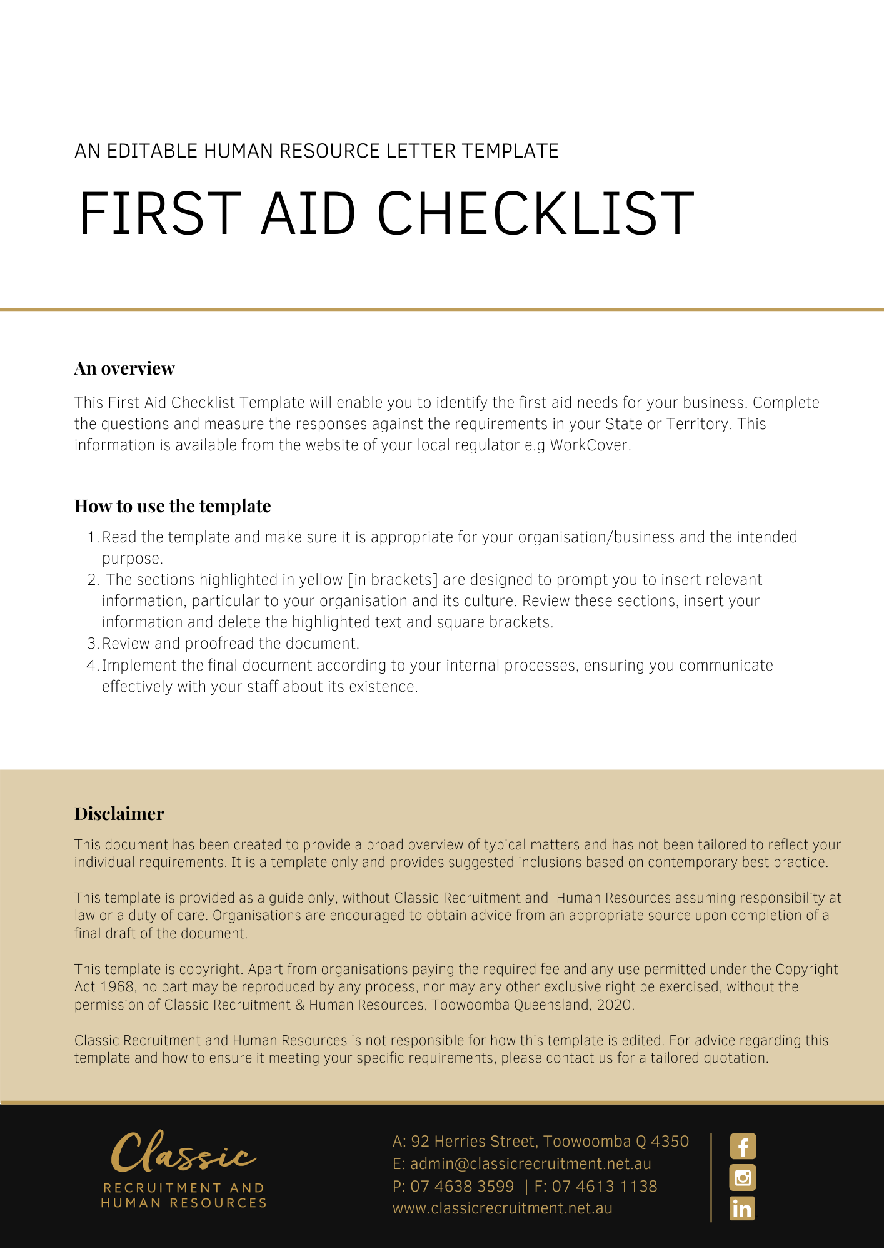
First Aid Planning Tool

Answer the following questions:

Work activities | What type of work is performed? List the work activities that may cause injury.
 | List the types of injury or illness likely to be experienced
 | What types of hazards are there at the workplace?
People at the place of work | How many employees/workers or other persons are generally on-site?
 | What is their distribution? [eg one or more locations]
 | Do any employees/workers have special needs?
 | If yes, list:
The workplace | What is the size of the workplace?
 | What is the layout of the work place? (eg single level/multiple buildings)
Workers working away from the workplace | Do you have employees/workers who work away from the work premises?
 | If yes, how many? And in how many locations?
Past experience | Is there a current first aid plan and does it work?
Recommendations

Use the answers to determine needs and check the legal requirements for your State/Territory to ensure you meet minimum requirements.
Return Completed form to: [Insert Position (e.g. CEO/Director/Owner)]

