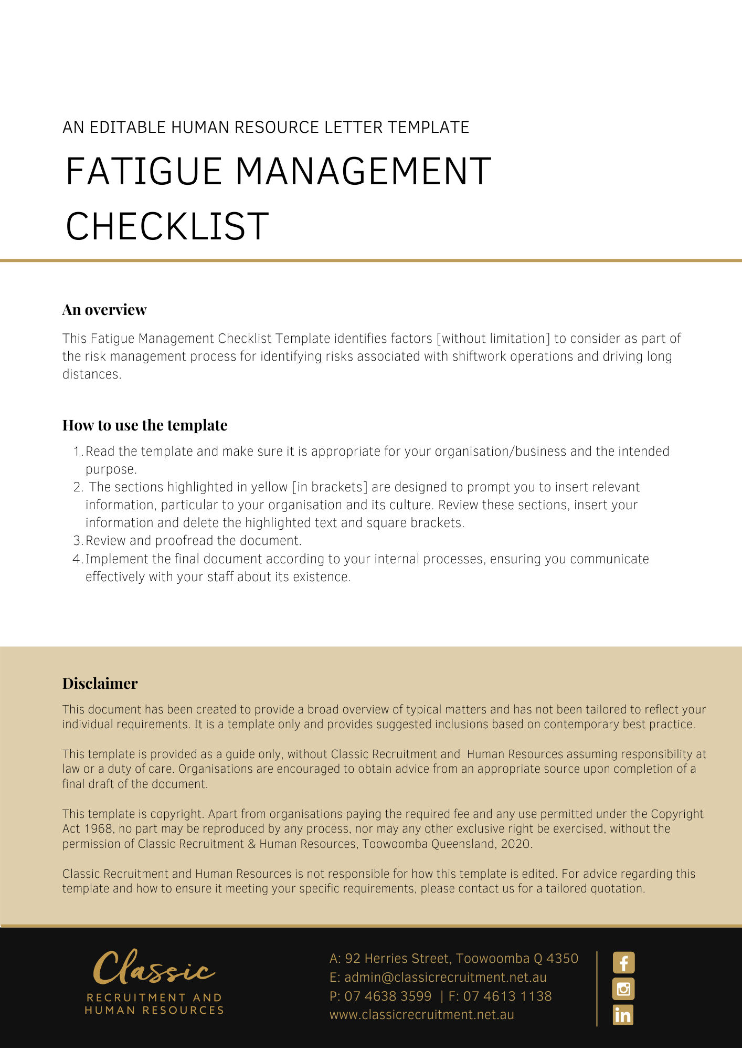
Fatigue Management Checklist

Part 1: Identifying fatigue risk factors
Answer the following questions to determine if employees/workers are at risk from fatigue. Each Yes answer indicates the risk of fatigue — the more responses with a YES — the higher the risk of fatigue.

Risk factors | Yes |  | No
Work scheduling and planning
Does anyone consistently work or travel between midnight and 6:00am?
Does the work schedule prevent full-time workers having at least one day off per week?
Does the work schedule make it difficult for workers to consistently have at least two consecutive nights sleep per week?
Do work practices include on-call work, call-backs and/or sleepovers?
Do planned work schedules vary from those actually worked?
Does the work schedule involve rotating shifts?
Does anyone travel more than one hour to their job?
Is it possible for workers to vary tasks to minimise fatigue
Is there a consultation process/opportunity for workers to raise fatigue issues
Mental and physical work demands
Does anyone undertake work that is physically demanding?
For example, tasks which are especially tiring and/or repetitive such as: bricklaying, typing, process work, moving bags of cement, felling trees
Does anyone undertake work that is mentally demanding?
For example, work that requires long periods of vigilance, work that that requires continuous concentration and minimal stimulation, work performed under pressure, work to tight deadlines, emergency callouts, interacting/dealing with the public
Working time
Does anyone regularly work in excess of 12 hours a day including overtime?
Is the break between shifts less than 10 hours?
For example, split shifts, quick shift changeovers.
Is work performed at low body clock times (between 2:00am and 6:00am)?
Environmental conditions
Does anyone perform work in harsh or uncomfortable conditions (eg hot, humid or cold)?
Does anyone work with plant or machinery that vibrates?
Is anyone exposed to hazardous substances?
Is anyone consistently exposed to loud noise?
For each of the questions — you have answered YES, it indicates that employees/workers may be at risk of fatigue.
Which positions and job roles are at risk:
Have risk assessments been conducted for these roles and their activities that consider fatigue?

Part 2: Review the management practices

Fatigue Management Practices |  |  |  | Yes | No
Shiftwork
Is information and training provided for shift workers on sleeping, eating and fitness?
Is adequate and glare-free lighting provided for work at night?
Are entrances, exits and car parks well-lit and are appropriate security measures in place?
Are there after-hours canteens or meal preparation facilities?
Is first aid equipment and training provided for after-hours staff?
Are safety procedures and equipment safeguards adequate to protect tired employees working under night lighting?
Can dangerous or critical tasks be rescheduled to the daytime wherever possible?
Is the roster system checked every 12 months?
Do shift times take circadian rhythms into consideration?
Is adequate rest and recovery time provided in between shifts?
Are employees exposed to hazards such as noise, heat and chemicals?
Are prolonged heavy manual handing tasks or repetitive work required?
Driving
Do employees drive long distances to and from work?
Do long distance drivers take adequate rest breaks?
Are reasonable deadlines established?
Are commercial drivers given 24 hours notice to prepare for working time of 14 hours or more?
Do continuous periods of work time exceed 5 hours?
Action Plan [to address where ever you answered “NO”. List the actions required to make the workstation safe]
Problem identified: | Corrective action to be taken: |  | Due Date
Date checklist completed:
Date checklist to be reviewed:
Name of person who completed checklist:

Completed form to be returned to: [Insert Position (e.g. CEO/Director/Owner)]

