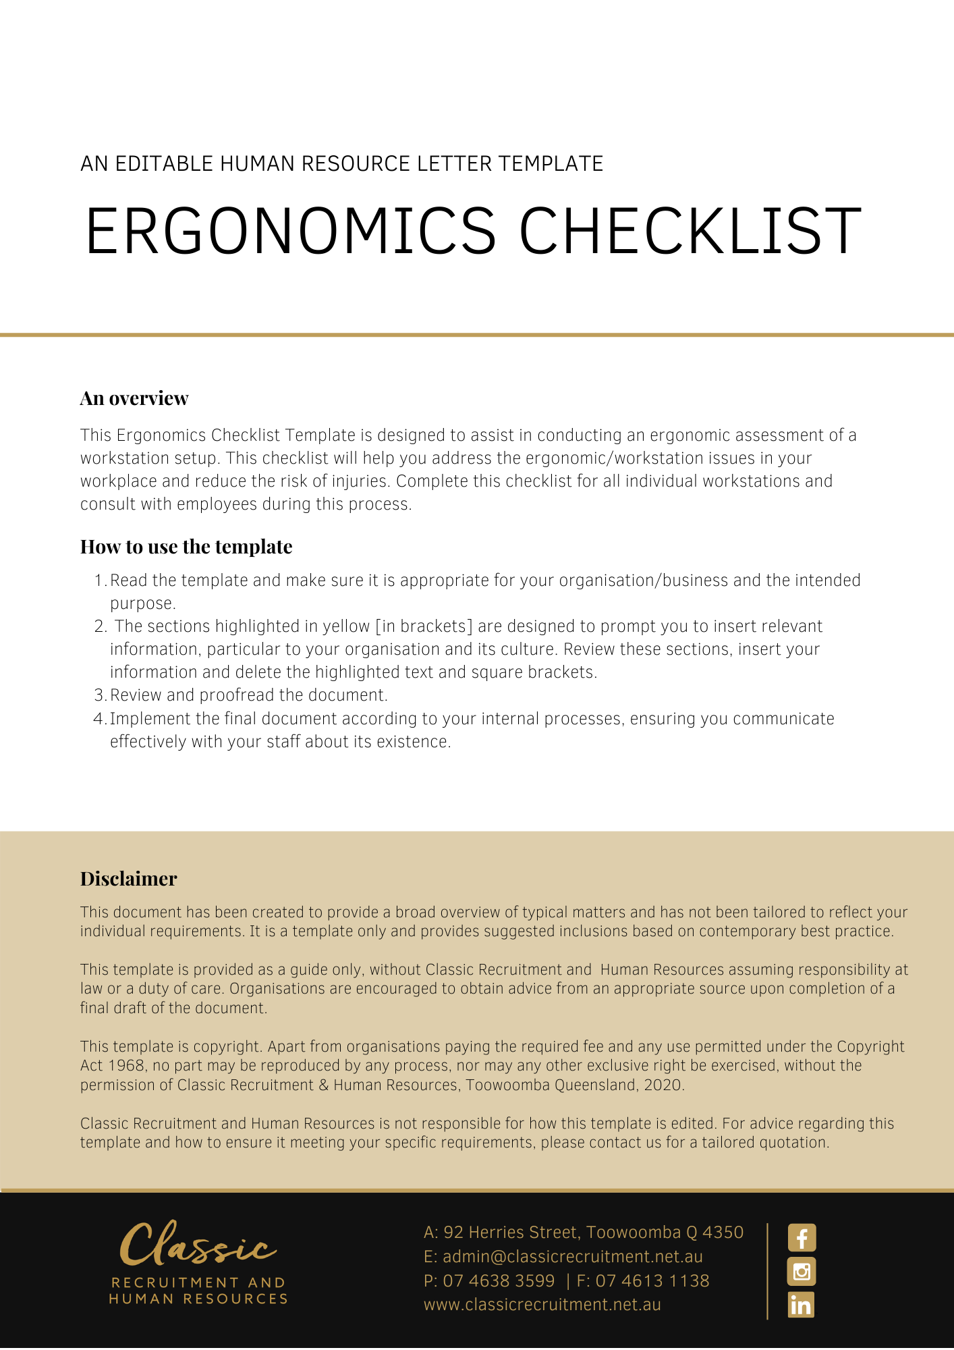
Workstation Ergonomics Checklist

Instruction: Use the checklist to identify areas that need to be addressed
Date checklist completed:
Date checklist to be reviewed:
Name of person who completed checklist:
Workstation of (Name):
Location:

 |  |  |  | Yes | No
 | Chair
 | Is the chair easily adjustable from a seated position? (ie seat height, backrest height, backrest tilt)
Is the height of the chair appropriate? Check:
When shoulders are relaxed, and elbows are by the side and at 90 degrees, are the forearms positioned:
 | - just above the desk surface for keying tasks?
 | - just on desk surface for writing tasks?
 | Are the thighs now parallel to the floor when the feet are touching the ground or footrest? If not, a footrest will need to be provided or current one adjusted (do not alter the above arm position)
Is height of backrest appropriate? Check:
Is the height of the backrest adjusted so that the lumbar support of the chair is positioned in the curve of your lower back? (not around your hips)
Is the angle of the backrest appropriate? Check:
Is the backrest angle adjusted so that when you are sitting up straight (approx 90–95 degree angle at the hips), the backrest is against your back and touching your shoulder blades?
Is the depth of the seat pan appropriate? Check:
When you are seated in the chair, are there 2-3 finger spaces between the back of the knee and the edge of the seat?
 | Desk
Are the desk dimensions appropriate? Check:
Is the desk height between 680mm and 735 mm high (for a fixed height desk)
 | Is there enough room [at least 1600mm x800mm] on the desk to complete computing and writing tasks in separate areas?
Are you able to sit as close as possible to desk with no impediments? If no, check:
Are there any boxes, old equipment etc, being stored under the desk, or arms on chairs that stop you from getting your chair as close as possible to the desk?
Is the desk height adjustable? If yes:
When the thighs are parallel to the ground and feet flat on the floor and elbow directly under the shoulder adjust desk height so that forearms are parallel to floor or angled down slightly.
 | Keyboard and Mouse
 | Is the centre of the alphabetical section of the keyboard positioned directly in front of the user and the computer screen?
 | Is there enough room between the keyboard and the edge of the desk to rest the wrists, whilst not typing?
 | Are the wrists elevated off the desk while typing? (ie do NOT rest your wrists on desk or wrist rest while typing, only in typing breaks)
 | Is the keyboard close enough to allow elbows to remain under the shoulder and close to body?
 | Are the legs of the keyboard retracted, to ensure flat wrists while typing?
 | Do your wrists remain in a ‘neutral’ position while typing or using the mouse? (ie not angled upwards, downwards or sideways)
 | Is the mouse moved using the shoulder as the pivot point not the wrist (wrist should move across the desk with the mouse)
 | Is the mouse at the same level as the keyboard and close enough so the elbows remain directly under the shoulders?
 | Monitor
 | Is the monitor positioned approximately one arms length away? (ie you should not have to lean forward to read screen)
 | Is the top of the screen positioned at your eye level? (If ‘no’, modify height with an adjustable monitor stand)
 | Is the monitor positioned at right angles to light sources (eg window) and free from glare?
 | Phone and Documents
 | Is the phone positioned within easy reach, on the non dominant side?
 | Do you have to regularly write notes or use the computer while talking on the phone?
 | If yes, do you use a headset to prevent neck strain caused by cradling the phone?
Do you have to refer to documents while typing/entering data? If yes, check:
Do you have a document holder positioned between the monitor and keyboard or adjacent to the screen? (This is to prevent twisting of the neck, looking down.)
 | Laptops
 | Do you regularly use a laptop for periods of 1hr or more?
If YES, do you use a docking station or lap top stand with external monitor, keyboard and mouse?
If NO, you will need to purchase the equipment listed above AND start at the beginning of this checklist to make sure your equipment is set up safely.
Action Plan [to address wherever you answered ‘NO. List the actions required to make the workstation safe]
Problem identified: |  | Corrective action to be taken: | Due date

Completed form to be returned to: [Insert Position (e.g. CEO/Director/Owner)]

