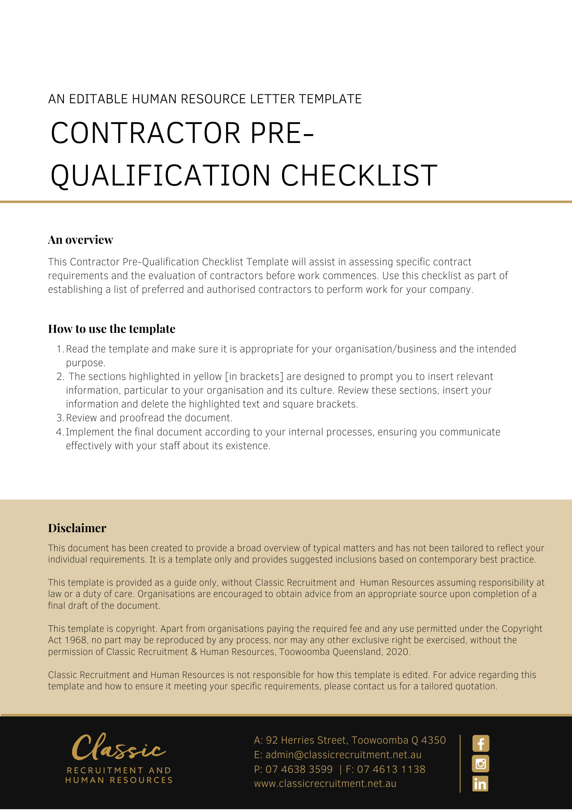
Contractor Pre-Qualification Checklist

 | Contractor name
 | Services provided
 | Date to commence
 | Job title
 | Department
 | Supervisor
 | As part of the contractor approval process all contractors are required to answer the following questions and provide copies of relevant documents where applicable.
 |  |  |  |  |  | YES |  | NO
OHS/WHS Policy and Management
- Company OHS/WHS policy
- OHS/WHS management systems manual or plan [table of contents page to be provided as evidence]
- OHS/WHS certification eg AS/NZS 4801
Safe Work Practices and Procedures
- OHS/WHS procedures or specific safety instructions relevant to its operations and this contract
- Procedures for maintaining, inspecting and assessing the hazards of plant operated/owned by the company
- Safe operating procedures for plant and equipment
- Procedure for electrical testing and tagging system [evidence/statement]
- Procedure for tagging or lock out of faulty equipment
- Procedure for storing and handling hazardous substances
- Procedures for identifying, assessing and controlling risks associated with manual handling/manual tasks
- Competencies as required eg forklift, confined spaces
- Emergency response planning for the job/work on site
- Site emergency evacuation procedures
- Personal Protective Equipment [PPE] used [please list]
Hazard Identification and Incident Investigation
- Procedure for workplace and equipment inspection
- Procedure for hazard and incident reporting including reporting of near misses and notifiable incidents
- Procedure for incident investigation
Documentation and Records
- Safe Work Method Statements/Job Safety Analyses
- Material Safety Data Sheets [MSDS]/Safety Data Sheet (SDS) for hazardous substances to be brought on-site
- Records of safety training conducted
- Site rules (Mandatory PPE, drugs, alcohol, smoking, etc.)
 | - Plant & equipment maintenance schedule
 | - Inspection checklists for worksites/equipment
 | - Records of toolbox talks/OHS/WHS committee meetings
 | - Evidence of current workers compensation policy (copy of current certificate)
 | - Details of public liability insurance (copy of certificate)
 | The information provided is true and accurate at the time of submission.
 | Completed by: [name] |  |  | Position:
 | Signature |  |  | Date:

Office use only:
Approved | Yes | No | Review Date
Approved by  [Name]: |  |  | Position:
Signature:
For an approved contractor, that had a NO answer, provide details on exemption/s:
If not approved, explain:
Further requirements to be re-considered as an Approved Contractor:

