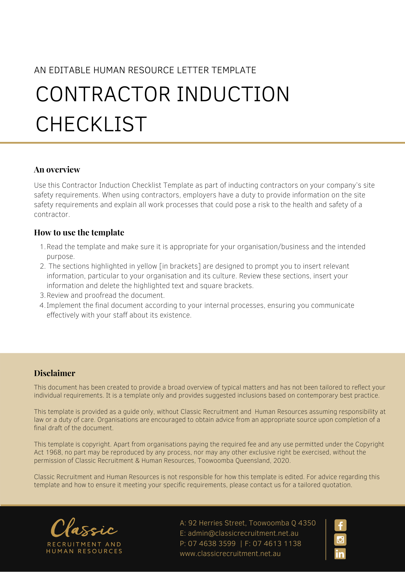
Contractor Induction Checklist

Instruction: Complete when conducting an induction of a new contractor or new employee engaged by an existing contractor working on site. Induction is to be conducted on or prior to commencement, and annually thereafter.

Contractor name:
Date commenced:
Job title
Department
Supervisor
 |  | YES | NO
- Organisation overview and site tour
- Company OHS/WHS policy and procedures
- Injury reporting and first aid facilities
- Who to contact for first aid and location of first aid kit
- How to report a hazard/OHS/WHS concern
- Emergency procedures (assembly point, exits, contacts)
- Consultation arrangements established, contractor advised of, and included in, company’s consultation arrangements
- Specific job task and safety considerations
- Safe operating procedures (plant & equipment)
- Safe work method statements (contractors)
Conducted by: |  | Date:
I have received and understood the Induction Program
Employee/Contractor signature:
Signature: |  | Date:

Return Completed form to: [Insert Position (e.g. CEO/Director/Owner)]
Position to make diary entry made for annual induction:
Date for next induction:

