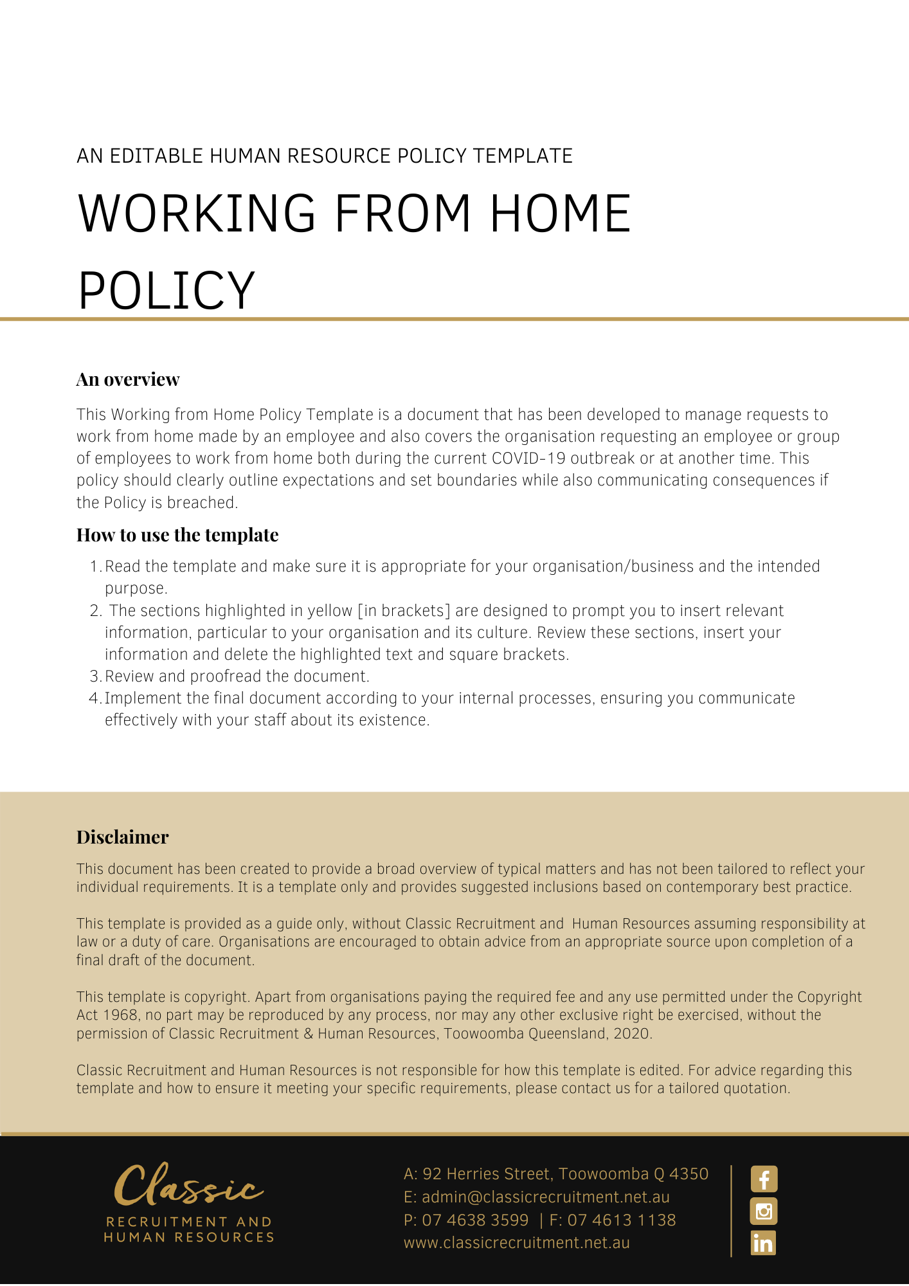

Working from Home Policy

Overview
[Company Name] has implemented a Working from Home Policy. The Policy takes effect immediately. This Policy has been developed to manage requests to work from home made by an employee and also covers [Company Name] requesting an employee or group of employees to work from home both during the current COVID-19 outbreak or at another time.

Under the model Work Health and Safety laws, [Company Name] has a duty of care for the health and safety of our employees and others at the workplace. These laws apply even if employees are required to work somewhere other than their usual workplace, for example, from home.

Employees also have a duty to take reasonable care of their own health and safety, and to not adversely affect the health and safety of others. This policy seeks to explain procedures for managing Working from Home and wherever possible, implement appropriate controls while following government directions.

For the safety of employees and others in the workplace, this policy must be followed at all times.
[Company Name] sets guidelines and policies in the workplace as follows. We believe it is important to clearly communicate our expectations of all employees. It is every employee’s responsibility to act in accordance with this Policy.

This Policy contains a procedure that describes how to request, assess, and implement and monitor a working from home agreement.

Eligibility
All [Company Name] are eligible to request a work from home arrangement and will be considered on a case by case basis.

During the COVID-19 outbreak, [Company Name] may request that some or all employees work from home. This will generally be to prevent exposure to the risk of contracting COVID-19.

When working at home, [Company Name] require the worker to perform at the same standard as they would in the office.

[Company Name] will require employees can demonstrate that the home-based work environment meets our work from home requirements.

Procedure
Request to work from home

- during the COVID-19 outbreak, the [Insert Position (e.g. CEO/Director/Owner)], may request for an employee, or a group of employees to work from home, when necessary or needed
- employees may request to work from home too. Such requests should be directed to the [Insert Position (e.g. CEO/Director/Owner)]

Consultation
When a request is made to work from home, the employee and the [Insert Position (e.g. CEO/Director/Owner)] will consult on the following matters:

- whether the employee’s role is suited to a work from home arrangement
- the hours and type of work to be performed from home
- the workstation and equipment required to perform the tasks and the work safely
- effective means of communication to ensure the employee can access assistance from emergency services
- access to adequate facilities including a first aid kit and emergency response equipment
- the process to monitor the agreement and the frequency at which it will be reviewed

Work from Home Agreement
Following consultation between the employee and the [Insert Position (e.g. CEO/Director/Owner)], they will complete a Work from Home Request Form. The [Insert Position (e.g. CEO/Director/Owner)] will ensure the Work from Home WHS Evaluation is satisfied prior to the agreement being made. Following confirmation that the employee’s home environment meets [Company Name] health and safety standards and operational needs, the implementation of the agreement can proceed from the agreed date. Alternatively, if the [Insert Position (e.g. CEO/Director/Owner)] determines that a work from home arrangement is not suitable, they will consult with the employee on the outcome.

Monitoring the health of the worker and conditions of the work environment
The [Insert Position (e.g. CEO/Director/Owner)] will regularly consult with the worker to discuss the agreement to ensure it continues to meet the needs of both parties. Notes from these discussions will be filed in the appropriate personnel files.
If an employee is unwell and is unable to perform their duties from the home work environment, the employee must notify the [Company Name] in the same manner as if the employee was expected to be working from [Company Name] premises and in accordance with the Leave Policy.
If an employee has been requested by the [Insert Position (e.g. CEO/Director/Owner)] to work from home during the COVID-19 outbreak, the worker must not present to the [Company Name] office or work-related events without first receiving authorisation from the [Insert Position (e.g. CEO/Director/Owner)].
Where the [Insert Position (e.g. CEO/Director/Owner)] and/or the employee identify a need to improve the work from home arrangement (e.g. adequate facilities, health and safety matters, operational requirements), the [Insert Position (e.g. CEO/Director/Owner)] and employee must consult and the [Insert Position (e.g. CEO/Director/Owner)] will inform the employee of a resolution in a timely manner.

Authorisation Amendment or Termination
[Company Name] may, at any time, amend or terminate a work from home agreement. This may be a result of:
  - a change in the employees’ role and/or work duties
  - the worker changing their residential address, or the work environment is altered
  - a change in agreed working hours
  - control measures not implemented
  - operational factors
  - risks to health and safety
Any amendment to or termination of an agreement will be recorded, and the record filed in the appropriate personnel file.

COVID-19 Diagnosis or Exposure
If you begin to display symptoms of the virus, you must follow Government guidance to find out what to do next. You must seek medical attention and notify the [Insert Position (e.g. CEO/Director/Owner)] at the earliest opportunity. In order to protect your fellow colleagues, you are required to remain absent from the workplace on personal leave and provide us with a medical certificate. You are required to get a medical clearance from your doctor or provide us with the QLD Health Coronavirus test result confirming a negative result prior to returning to the workplace.

If you have been in contact with someone who has a confirmed case of COVID-19 and you are not unwell, you are required to notify the [Insert Position (e.g. CEO/Director/Owner)] immediately. In order to protect your fellow colleagues, we ask you to seek direction from your health care provider and remain absent from the workplace on unpaid leave (or annual leave with your approval) until you are cleared to return. In this instance, [Company Name] will consider on a case by case basis whether it is possible for you to work remotely from home. Advance authorisation to work remotely is needed in every case.

If you have been in contact with someone who has a suspected case of COVID-19, you are required to notify the [Insert Position (e.g. CEO/Director/Owner)] immediately. We will likely make the decision to send you home and require you not to attend work as a safety precaution until results have been obtained. In these circumstances, we may require you to work remotely if possible. Advance authorisation to work remotely is needed in every case.

Self-Isolation
You must not attend the workplace during any self-isolation period that the Government requires you to undertake.

If you are unwell during this self-isolation period, you should follow the usual procedure to notify [Company Name] that you require personal leave and obtain a medical certificate in support of your leave. You are required to get a medical clearance from your doctor prior to returning to the workplace.

If you are well during this period of isolation, [Company Name] will also consider on a case by case basis whether it is possible for you to work remotely. If you are unwell during this period of isolation, [Company Name] will consider any available type of leave that may be taken to cover the absence. If there are no forms of accrued paid leave available, the absence will be unpaid.

Some important points to consider
As you are an important part of the [Company Name] team, your wellbeing and that of our fellow workers is fundamental to you fulfilling your workplace obligations to [Company Name]. It is our policy that employees should follow these guidelines, communicate proactively with the [Insert Position (e.g. CEO/Director/Owner)] or the [Insert Position (e.g. CEO/Director/Owner)] and comply with government directions.

What do I need to do?
You need to review the Working from Home Policy and make yourself familiar with the contents of the policy. In the event that you have any questions, make sure you address these to either the [Insert Position (e.g. CEO/Director/Owner)] or the [Insert Position (e.g. CEO/Director/Owner)].

What happens if I do not comply with the Working from Home Policy?
The consequences of a breach of this policy will vary depending on the type and seriousness of the breach and will be at the discretion of [Company Name]. Depending on the circumstances, [Company Name] may take disciplinary action up to and including termination of employment.

Given the contagious nature of COVID-19 and the health ramifications it is imperative that employees should contact either the [Insert Position (e.g. CEO/Director/Owner)] or the [Insert Position (e.g. CEO/Director/Owner)] with any concerns they may have relating to their personal wellness in the first instance.

Policy and further information
To the extent that the contents of the Working from Home Policy refers to obligations on [Company Name], they are guidelines for management or summaries of applicable legislative requirements only and are not contractual terms, conditions or representations on which a staff member may rely. [Insert Position (e.g. CEO/Director/Owner)] is available to assist with any queries you have relating to the policy which is detailed above.

Refer to the COVID-19 and Workplace Health & Safety Policies for further information and guidelines.

Document Control
This Policy will be reviewed on a regular basis and approved by the [Insert Position (e.g. CEO/Director/Owner)].

Implementation date | Author | Approved by | Date of next review
[Date] | [Name] | [Position] | [Month, Year]

Work from Home Request Form
Request to Work from Home
Date:
Employee Name:
Residential Address:

Contact Number:
Managing Partner Name & Signature:
Date:
I request to work from home:
- On a regular basis:
- For a specified period:
dates: _______ / _______ / _______ to _______ / _______ / _______
or
I have been requested by [Company Name] to work from home during the COVID-19 outbreak:
- For a specified period:
dates: _______ / _______ / _______ to _______ / _______ / _______
- For a period unknown: , commencing on _______ / _______ / _______ and will be reviewed on _______ / _______ / _______

Employee Responsibilities
I understand that as a worker working from home, I have a responsibility to:
- take care for my own health and safety
- notify the [Insert Position (e.g. CEO/Director/Owner)] of any significant change to my home which may have implications for my health and safety
- comply with health and safety instruction given by the [Insert Position (e.g. CEO/Director/Owner)]
- cooperate with the [Company Name] health and safety policies and procedures

I agree to:
- completing the Work from home WHS evaluation and returning photos of my work from home set up to [Company Name] and if items are not adequate, consent to a suitably qualified person engaged by [Company Name] to attend my home to complete a work from home evaluation
- being contactable during normal office hours on the contact number listed on this form
- return to work when requested to do so by the [Insert Position (e.g. CEO/Director/Owner)]
- report to [Company Name] and the [Insert Position (e.g. CEO/Director/Owner)] any change to my work or home environment that may impact on my health and safety
- not present to [Company Name] premises or work-related events where I have been requested by the [Insert Position (e.g. CEO/Director/Owner)] to work from home during the COVID-19 outbreak.
Employee Signature: |  |  | Date:
Date form received by [Company Name]:
Agreement
Home based work duties to be performed:
As per current Role Description or as inserted here

Agreed hours of work:

Means of communication to ensure the worker can access assistance from emergency services:

Process and frequency of monitoring the agreement:

Proposed working environment is safe:
Yes No

The Work from home WHS evaluation is completed and verified with attached photos and all action items are addressed:
Yes No

Work from home agreed:
Yes No
If no, describe the reason:

[Insert Position (e.g. CEO/Director/Owner)] Signature:
Date:
Employee Signature
Date:

Work from home WHS evaluation Form

Work from Home Details
Employee name:
Residential address:
Phone Number:
Emergency Contact Name:
Emergency Contact Number:
Date of Work from home WHS evaluation: |  | _______ / _______ / _______
Photos to verify the details below attached |  | Yes | No
[Company Name] [Insert Position (e.g. CEO/Director/Owner)] name & Signature:

WHS Standard |  | x N/A | Comments / Corrective Actions | Completed (date/person)
Housekeeping
- Work areas free from rubbish and obstructions
- Work areas are free from slip/trip hazards
- Emergency information and contact details available and easily accessible
Hallways
- Unobstructed
- Adequate lighting
Floor
- Flooring is in good condition i.e. no lifted or worn surfaces
- Furniture and fittings in good condition
- No sudden changes in floor surfaces without warning
- No slippery or steep surfaces
Steps, Stairs and Landings
- No observed worn or broken steps
- Handrails fitted where required
- Steps in a condition where they do not present a slip risk
- Clear of obstructions
- Adequate lighting
Electrical
- No observed broken plugs, sockets, switches
- No observed frayed or defective leads
- General electrical equipment in good condition
- No observed cable-trip hazards
- RCD, power boards with safety switch present / in use.
Environment
- Lighting adequate and free from glare from natural light or overhead lights and no flickering lights.
- Noise at a comfortable level i.e. not disrupting work tasks
- Temperature and airflow at a comfortable level e.g. not too hot or cold
- Work area is segregated from other hazards in the home (e.g. hot cooking surfaces in the kitchen)
First Aid
- Basic first aid kit available
Fire Control
- Smoke detectors are installed, working and properly maintained.
Chair
- Adjustable to get correct height, back rest adjustable to get lumbar support, seat size supports legs.
- Sufficient space on desk for equipment required for the task e.g. document holder, printer, phone.
- Sufficient leg space under desk.
Computer screen (PC)
- Height – top of screen is approximately at eye level.
- Screen directly in front of you and about an arm’s length away.
Laptop
- Do you have a Docking Station or other suitable set-up so that top of screen is approximately at eye level?
Keyboard and mouse
- Keyboard positioned directly in front of you
- Mouse next to keyboard – easy access, arm in close (no stretching required).
- Hand/arm position correct height and comfortable
Comments
Photos have been provided by the worker to demonstrate the workers work from home set up:
Yes No
Employee Signature:
Date: | _______ / _______ / _______
[Insert Position (e.g. CEO/Director/Owner)] Signature:
Date: | _______ / _______ / _______

Details of Issue | Action Details | Responsible Person | Verification / Date of Completion

