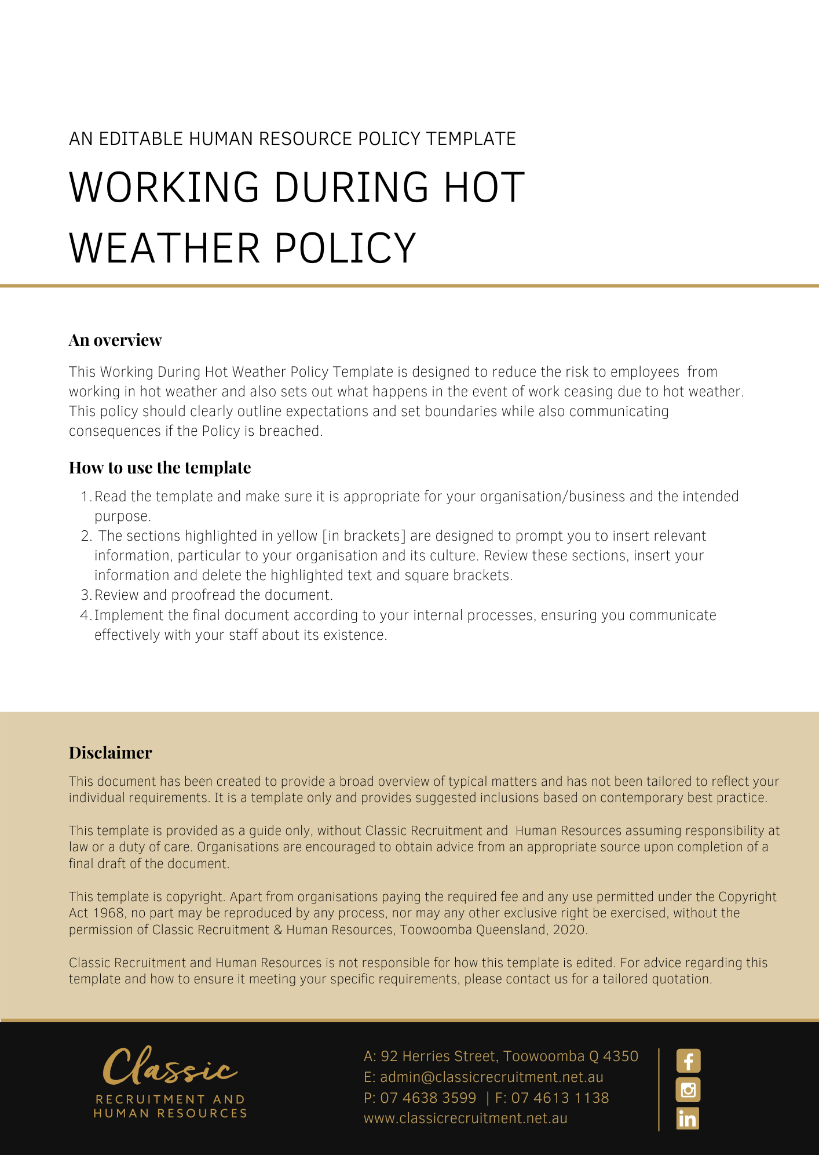

Working During Hot Weather Policy

Overview
This Policy outlines the obligations of employees of [Company Name], who carry out work during hot weather.

This Policy is intended to help reduce illness and injuries that can occur, and other risks that arise as a result of dehydration, heat stroke, heat exposure and other health challenges that occur in hot weather.

This Policy applies to all workplace participants.

This Policy does not form part of any employee’s contract of employment or contract for service(s).

Work During Hot Weather
Working in hot and/or humid environments can be uncomfortable, but more importantly can lead to a heat-related illness, which can have serious consequences.

The way heat affects people varies from person to person depending on your general health, age, fitness, body weight and other variables.

For this reason, this Policy outlines general guidelines that will assist employees in combating heat-stress, but employees should have regard to their personal circumstances when following this Policy.

Employee Obligations
On days of extreme heat, you should ensure you:

- drink enough water (this would need to be more than the ordinary recommended daily intake of water for an individual, for men this is roughly about 13 cups (3 litres) and for women is about 9 cups (2.2 litres). This might be broken down into smaller servings such as drinking a small cup (200ml) of water every 15 - 20 minutes).

- eat regular meals and snacks (to help replace salt and electrolytes lost through sweating).

- take appropriate breaks; and

- monitor yourself and others for signs of heat-related stress throughout the day.

Identifying Signs of Heat-Related Stress
You should familiarise yourself with the signs and symptoms of heat-stress. Some of the most common signs and symptoms of heat-stress include:

- confusion.
- dark-coloured urine (a sign of dehydration).
- dizziness.
- fainting.
- fatigue.
- headache.
- muscle or abdominal cramps; and
- nausea, vomiting, or diarrhoea.

Reporting Heat Related Issues
If you feel that your working environment is becoming too hot, please notify your [Insert Position (e.g. CEO/Director/Owner)] as soon as you become concerned about the heat.

If you identify that you, or another workplace participant, are suffering from the signs and/or symptoms of heat-stress, then you should notify your [Insert Position (e.g. CEO/Director/Owner)] as soon as you become aware.

Your [Insert Position (e.g. CEO/Director/Owner)] will discuss your concerns and consider what action, if any, should be taken at that point. This may include action provided for in this Policy.

Alternative Duties
In the event a decision is made to address heat related issues in a particular way, then (assuming it is safe to do so) may, at its discretion, direct you to:

- carry out alternative duties.
- carry out your normal (or alternative duties) in an area or location away from the heat; and/or
- carry out your normal (or alternative duties) during periods of the day where the temperature is cooler.

Cessation of Work
May direct you to cease work due to extreme or unsafe hot weather conditions. Such a cessation of work will be considered a ‘stand down’ and may result in employees being sent home without pay until the extreme or unsafe weather subsides.

When deciding whether to cease work, will have regard to:

- workplace conditions.
- the requirements of the job.
- individual worker attributes; and
- the health and safety of its employees.

Breaches of This Policy
A breach of this Policy may lead to disciplinary action including, but not limited to, termination of employment.

Variations
[Company Name] reserves the right to vary, replace or terminate this Policy from time to time.

Policy and further information
To the extent that the contents of this Policy refers to obligations on [Company Name], they are guidelines for management or summaries of applicable legislative requirements only and are not contractual terms, conditions or representations on which a staff member may rely. Management is available to assist with any queries you have relating to the Policy which is detailed above.

Management is available to assist with any queries you have relating to the policy which is detailed above. Further information may be found in:

Insert appropriate Policy Name eg. Workplace Health & Safety Policy

Document Control
This Policy will be reviewed on a regular basis and approved by the [Insert Position (e.g. CEO/Director/Owner)].

Implementation date | Author | Approved by | Date of next review
[Date] | [Name] | [Position] | [Month, Year]

