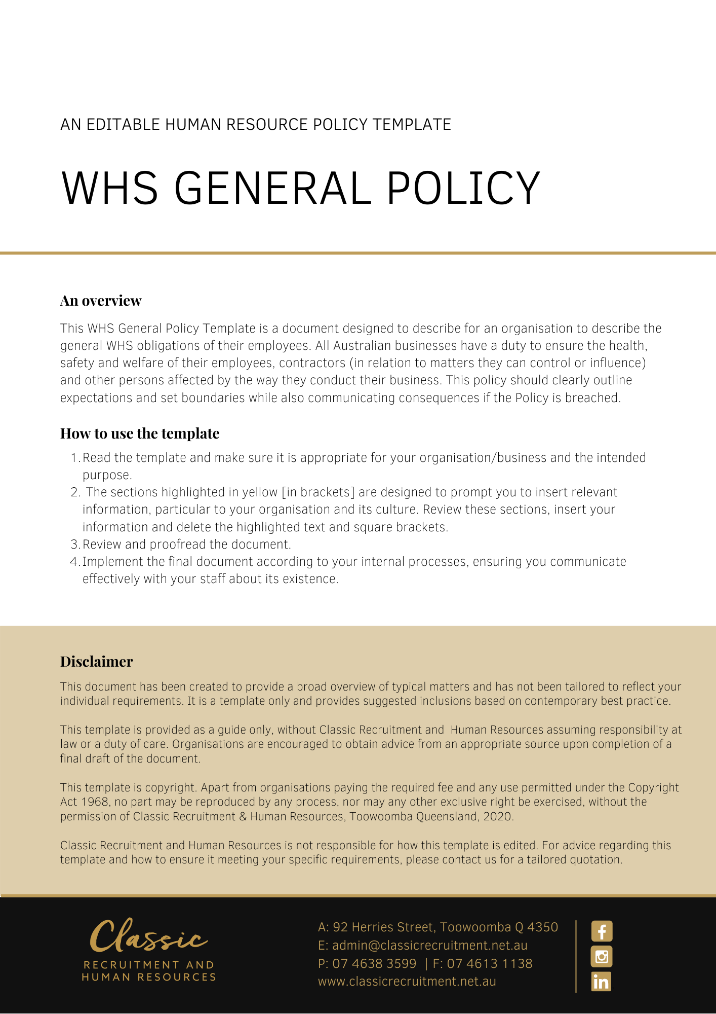

WHS General Policy

Overview
[Company Name] is committed to providing a safe and healthy working environment for all workers, and other persons, so far as reasonably practicable. This will be achieved by management and employees working together, following a program of health and safety activities and procedures which are monitored, reviewed, and audited to achieve best practice.

[Company Name] undertakes to regularly review this policy to take account of changes in legislation, activities, services, and products. As a result of this review, changes may be made to this policy from time to time and all employees and contractors are required to comply with those changes.

Application
This policy applies to:

- all employees of [Company Name] (whether full-time, part-time or casual) and all persons performing work at the direction of, or on behalf of [Company Name] (for example contractors, subcontractors, agents, consultants, temporary staff and ‘workers’ as otherwise defined under relevant occupational/work health and safety (OHS/WHS) legislation) (collectively referred to as ‘workplace participants’); and

- all of [Company Name]’s workplaces and to other places where workplace participants may be working or representing [Company Name], for example, when visiting a customer, client or supplier (collectively referred to as ‘workplace’).

[Company Name] Health and Safety System
The OHS/WHS system relates to all aspects of health and safety including (without limitation):

- OHS/WHS Strategy Plan.

- Defined OHS/WHS responsibilities.

- Exercising due diligence.

- Health and safety training and education.

- Adopting a risk management approach to manage health and safety risks.

- Consultation with Persons Carrying on a Business or Undertaking and employees on matters related to health and safety.

- Emergency procedures and drills.

- Workplace inspections.

- Incident/accident reporting.

- Management of injured workplace participants.

[Company Name] Health and Safety Objectives

- To provide a safe and healthy work environment for all our employees, contractors, and other persons.

- To provide safe and healthy methods of work.

- To provide programs of health and safety activities and procedures which are continually updated and effectively carried out.

- To identify and eliminate or reduce hazards and risks to health and safety.

- To continually monitor and improve work health and safety.

- To provide education and training resources; and

- To comply with all relevant laws, rules, standards, and codes of practice.

Management Responsibilities
All officers, managers and team leaders/supervisors are responsible and accountable for the safety of workplace participants, contractors, and company property under their control so far as reasonably practicable. Managers and team leaders/supervisors are responsible for ensuring all policies, procedures, safe work practices and safe work procedures are followed at all times.

Employee Responsibilities
All employees are required to comply with health and safety legislation and [Company Name]’s policies and procedures by taking reasonable care that their acts or omissions do not adversely affect their health or safety both themselves and that of other persons. Employees must report all hazards and incidents to their supervisors as soon as practically possible to ensure their own health and safety and the health and safety of others in our workplace, including contractors and third parties.

Contractors
All contractors engaged to perform work for [Company Name] are required to comply with the health and safety legislation as amended from time to time, the policy, programs and procedures of [Company Name] as they relate to work health and safety and to observe all directions on health and safety given by management. Failure to comply or observe a direction will be considered a breach of the contract and sufficient grounds for termination of the contract.

Volunteers
All volunteers of are required to comply with health and safety legislation and ’s policies and procedures by taking reasonable care that their acts or omissions do not adversely affect their health or safety both themselves and that of other persons. Volunteers must report all hazards and incidents to their supervisors as soon as practically possible to ensure their own health and safety and the health and safety of others in the workplace, including employees, contractors and third parties.

Definitions
In this policy:

‘Person Carrying on a Business or Undertaking’ means an individual or organisation that arranges, directs, or influences work to be done or contributes something towards the work being done. It can include partners in partnerships, sole traders, trustees of trusts or committee members of unincorporated associations, public or private companies and incorporated associations.

Variations
[Company Name] reserves the right to vary, replace or terminate this policy from time to time.

Policy and further information
To the extent that the contents of this Policy refers to obligations on [Company Name], they are guidelines for management or summaries of applicable legislative requirements only and are not contractual terms, conditions or representations on which a staff member may rely. Management is available to assist with any queries you have relating to the Policy which is detailed above.

Document Control
This Policy will be reviewed on a regular basis and approved by the [Insert Position (e.g. CEO/Director/Owner)].

Implementation date | Author | Approved by | Date of next review
[Date] | [Name] | [Position] | [Month, Year]

