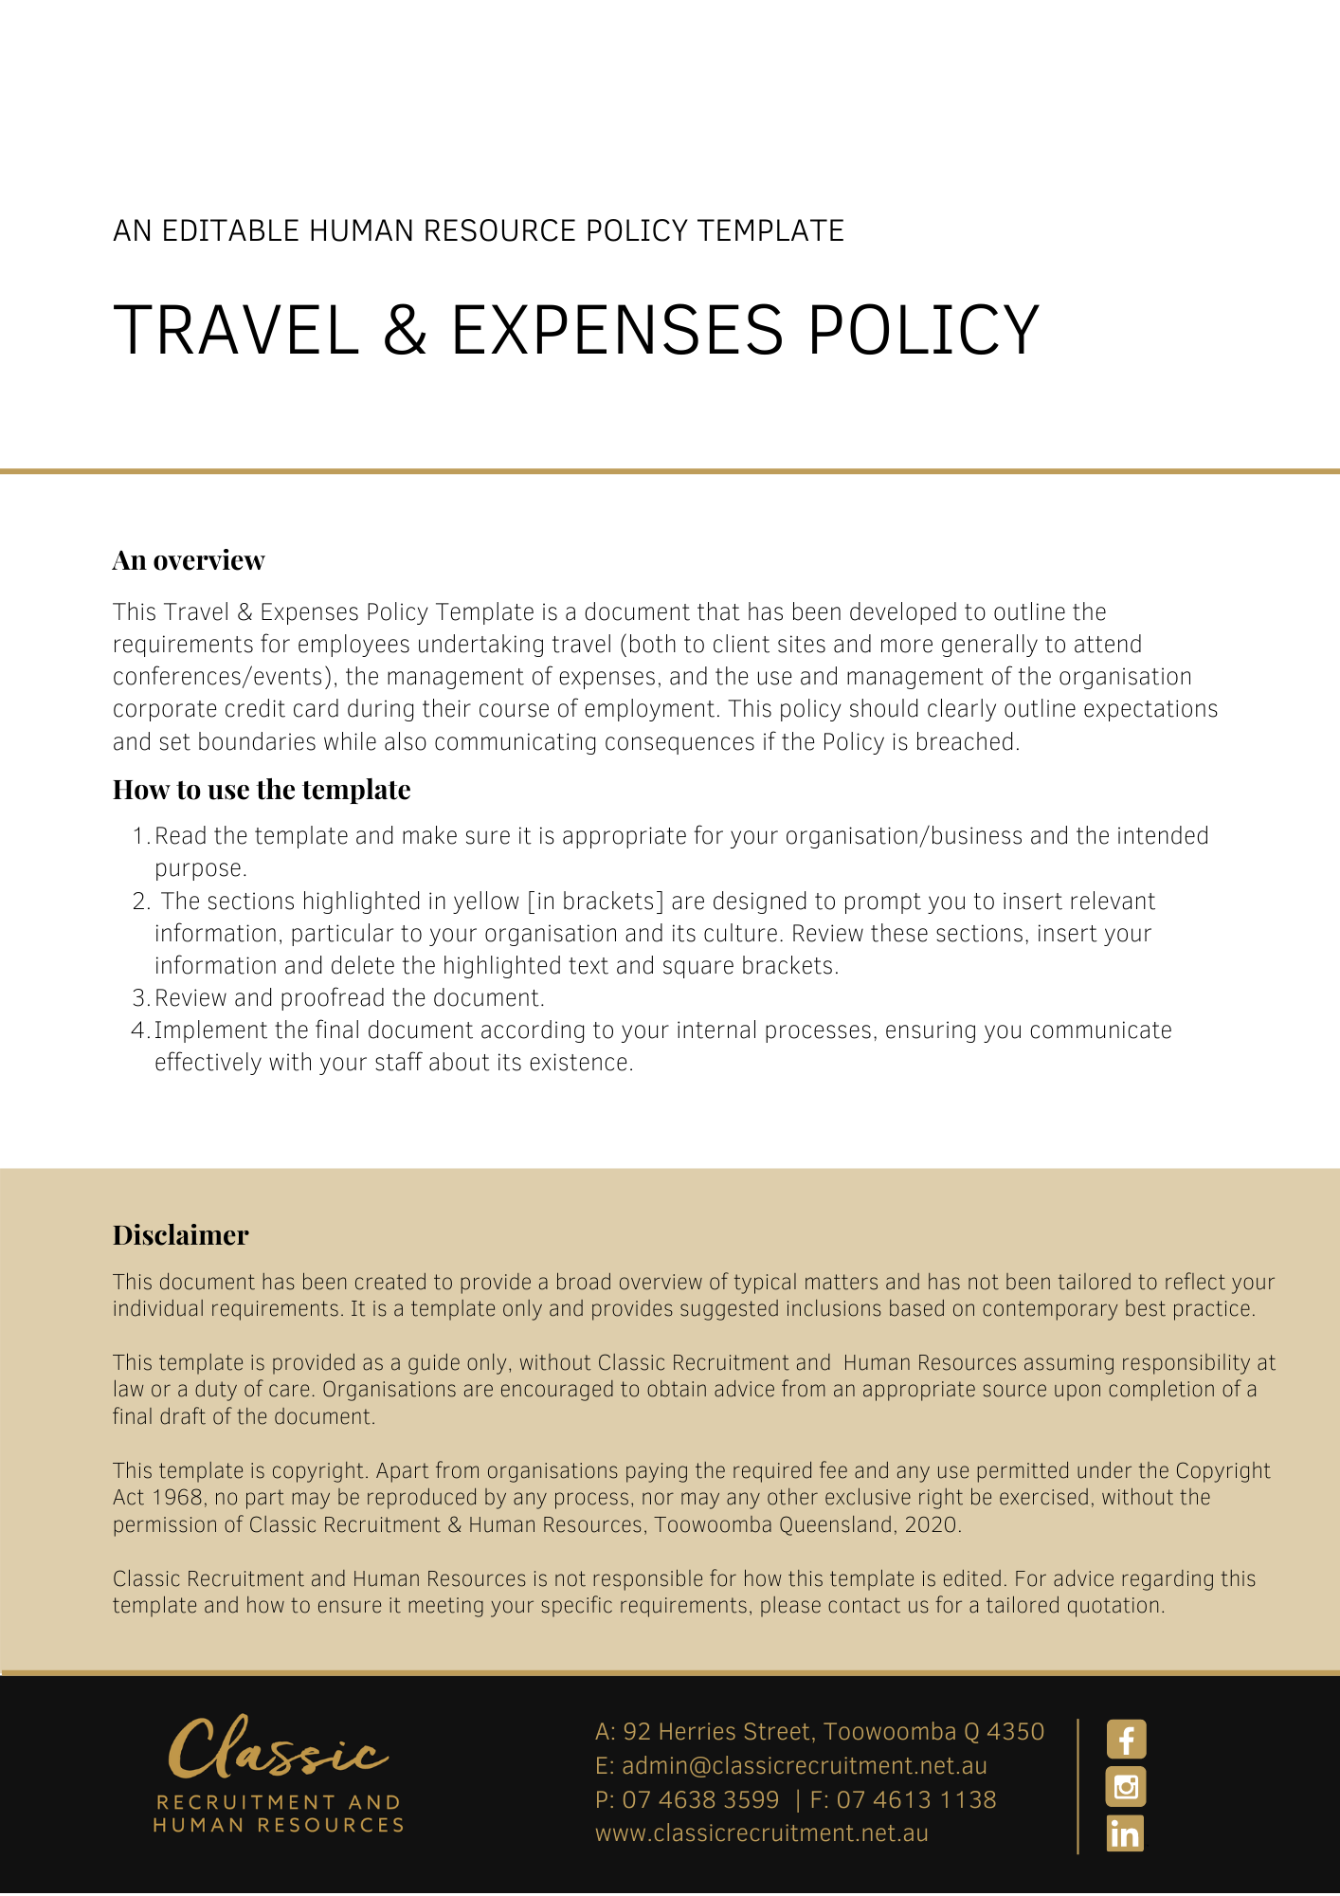

Travel & Expenses Policy

Overview
[Company Name] has implemented a Travel & Expenses Policy. The policy takes effect immediately. This policy outlines the requirements for employees undertaking travel (both to clients sites and more generally to attend conferences/events), the management of expenses, and the use and management of the [Company Name] corporate credit card during their course of employment.

Application
This policy applies to all employees of [Company Name] regardless of whether they are permanent full-time, permanent part-time or casual employees.

Principles
[Company Name] has developed this Policy to assist in ensuring the safety and wellbeing of employees undertaking travel as part of their employment and will develop procedures to help manage known associated risks. [Company Name] reserves the right to decline high risk travel requests (DFAT smarttraveller.gov.au is one resource that will be used to determine travel risk). All travel must be managed in line with this policy and the procedures.

Employees are expected to manage travel and expenses in a cost-effective manner that allows [Company Name] to meet its financial obligations. Employees must exercise thoughtfulness in the use of, whether for travel or expenses. Corporate credit card management, travel and reimbursement practices must be appropriately documented and effectively executed.

Transactions to the corporate credit card must be made for legitimate business and managed in line with this policy and the procedures. Approvals and authorisations must be sought prior to entering into any financial arrangement/transaction. No person may approve their own expenses.

Any transaction to the corporate credit card must be approved in writing by the [Insert Position (e.g. CEO/Director/Owner)] prior to usage.

Travel
Any travel to a client site should [Delete after reading: Do employees log their meetings in a group calendar or their own individual calendar?] be planned for and approved by the Managing Partner. For any travel where employees are required to complete a journey of more than 1 hour [Delete after reading: Amend this if it does not meet your requirements] each way, approval and a plan for managing fatigue is to be agreed with the [Insert Position (e.g. CEO/Director/Owner)] prior to confirming attendance on site.

While attending client’s premises and sites, employees must take reasonable care for their own health and safety and comply with any on site safety requirements such as the completion of onsite inductions. Employees should exercise common sense, care, and diligence to ensure that you are performing your duties in a safe environment and manner. If you have concerns about your safety at a client site, you should not perform work and get assistance and guidance from the [Insert Position (e.g. CEO/Director/Owner)].

Employee use of personal vehicles is permitted for local travel, within a 100km radius of [Insert City/Town]. For all other travel, a rent a car should be booked. Employees must ensure they are currently licenced and understand that any infringements incurred when travelling are for their own account.

Expenses
Provided prior authorisation has been obtained, [Company Name] will reimburse employees for all reasonable expenses properly incurred in the performance of their duties, subject to the provision of receipts or other evidence of payment and of the purpose of each expense. Evidence will normally be in the form of a Tax Invoice.

Some important points to consider
As you are an important part of the [Company Name] team, your safety while travelling is important and it is our policy that employees should not be travelling without prior written approval.

What do I need to do?
You need to review the Travel & Expenses Policy and make yourself familiar with the contents of the policy. In the event that you are required to travel, make sure you complete a written request for approval, outlining all details of the trip, by either the [Insert Position (e.g. CEO/Director/Owner)] or the [Insert Position (e.g. CEO/Director/Owner)].

What happens if I do not comply with the Travel & Expenses Policy?
The consequences of a breach of this policy will vary depending on the type and seriousness of the breach and will be at the discretion of [Company Name].

Depending on the circumstances, [Company Name] may take disciplinary action against you up to and including termination of employment.

Policy and further information
To the extent that the contents of the Travel & Expenses Policy refers to obligations on [Company Name], they are guidelines for management or summaries of applicable legislative requirements only and are not contractual terms, conditions or representations on which a staff member may rely.

Management is available to assist with any queries you have relating to the policy which is detailed above.

Further information may be found at:

https://www.smartraveller.gov.au/

Document Control
This Policy will be reviewed on a regular basis and approved by the [Insert Position (e.g. CEO/Director/Owner)].

Implementation date | Author | Approved by | Date of next review
[Date] | [Name] | [Position] | [Month, Year]

Travel Request Form

Please complete this form to apply for travel away from the office.

The completion of this form is required for any travel where employees are required to complete a journey of more than 1 hour [Delete after reading: Amend this if it does not meet your requirements] each way.

Approval of this form and a plan for managing fatigue is to be agreed with the [Insert Position (e.g. CEO/Director/Owner)] prior to confirming attendance on site with the client.

While attending client’s premises and sites, employees must take reasonable care for their own health and safety and comply with any on site safety requirements such as the completion of onsite inductions. Employees should exercise common sense, care, and diligence to ensure that you are performing your duties in a safe environment and manner. If you have concerns about your safety at a client site, you should not perform work and get assistance and guidance from the [Insert Position (e.g. CEO/Director/Owner)].

Employee use of personal vehicles is permitted for local travel, within a 100km radius of [Insert City/Town]. For all other travel, a rent a car should be booked. Employees must provide evidence they are currently licenced and acknowledge that any infringements incurred when travelling are for their own account.

[Insert Position (e.g. CEO/Director/Owner)] will consider the request and if approved, will keep a copy of the approved form as an employee record in the personnel or payroll file. If you have any queries or need assistance with filling out this form, please contact the [Insert Position (e.g. CEO/Director/Owner)].

Employee to complete

Name of employee: _____________________________________________

Name of employer: Dornbusch Partners Pty Ltd

Client Site/Professional Development Attendance details

Start date: _____/_____/20____and time…………………………

Date of return to work: _____/_____/20____ and anticipated time of return…………………………

Total days absent: _____ days Total hours absent: _____hours

Travel time anticipated………………

Fatigue Management Strategy……………………………………………………………………………

………………………………………………………………………………………………………………..

Signature of employee: Date: / /

Approval of travel (to be completed by [Insert position (e.g. CEO/Director/Owner)])

Approved Not approved

Reason for refusal (if applicable):

Name of [Insert Position (e.g. CEO/Director/Owner)]:

Signature of [Insert Position (e.g. CEO/Director/Owner)]: Date: / /

A copy of this form will be kept as a record.

