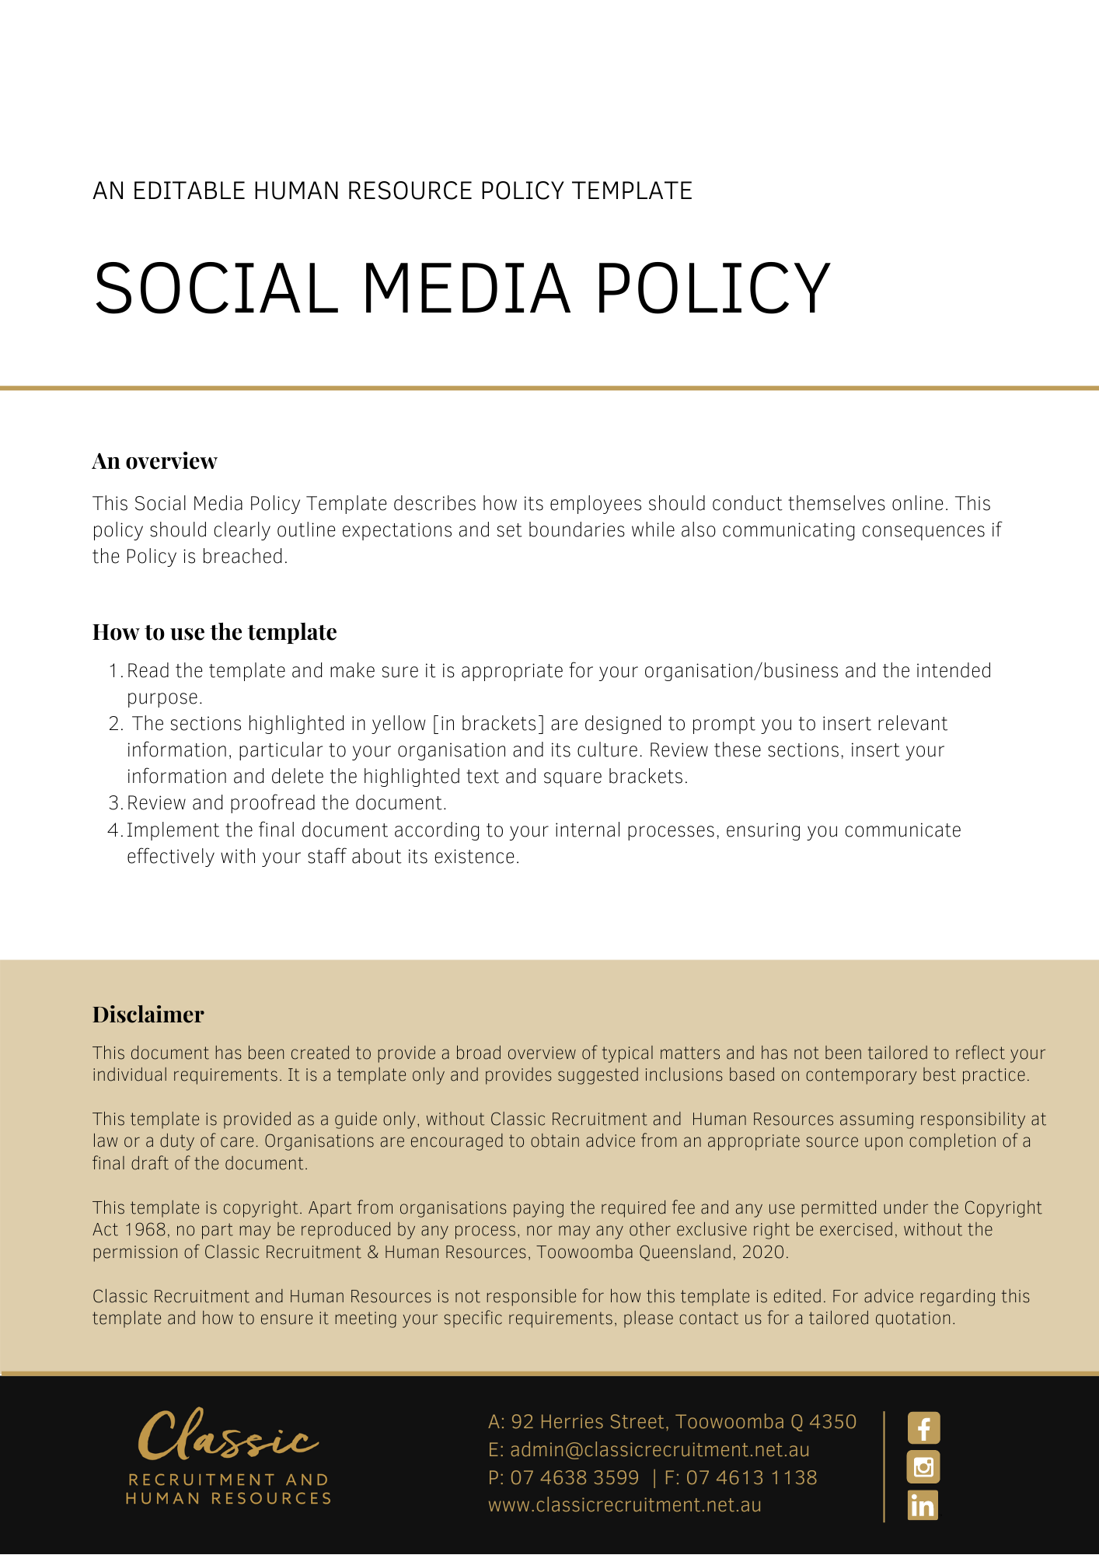

Social Media Policy

Overview
[Company Name] has implemented a Social Media Policy. The policy takes effect immediately. This policy has been developed to inform employees of our expectations regarding their usage of social media while employed by [Company Name]. Other than what is set out in the ‘Social Media for Personal Purposes’ section of this policy, this policy does not apply to an employee’s personal use of social media.

[Company Name] sets guidelines and policies in the workplace as follows. We believe it is important to clearly communicate our expectations of all employees. It is every employee’s responsibility to act in accordance with this policy.

Application
This policy applies to all employees of [Company Name] regardless of whether they are permanent full-time, permanent part-time or casual employees. The policy applies to all employees while at any [Company Name] workplace and any other place where the employee performs work for the business.

This policy applies to all employees and clients while they are in a workplace under the management and control of [Company Name] and/or using computer equipment, communications equipment such as telephones, the internet and/or email.

Social Media Usage
For the purposes of this policy, ‘social media’ means websites and internet-based applications used for social networking/interaction, sharing of information/content and creation of communities through online networks of people.

Examples of social media to which this policy relates, includes the following (‘social media channels’):

- Social networking sites. E.g. Facebook, LinkedIn, Twitter, Instagram.
- Video and photo sharing sites. E.g. YouTube, Flickr.
- Blogs including corporate blogs and personal blogs.
- Forums and discussion boards.
- Online encyclopaedias such as Wikipedia.
- Any other websites or online platforms that allow individual users or companies to use simple publishing tools.

[Company Name] embraces social media as an important tool for stakeholder engagement and encourages its employees to use social media in a personal capacity as a way to reach out and develop their personal and professional networks.

Having said this though, employees must take care to clarify whom they are representing when using social media. They must take responsibility for the accuracy and appropriateness of what they say in any social media communications which reference [Company Name] or related activities, or from which communications [Company Name] could reasonably be identified as the author.

Social Media for Business Purposes
You must have approval from the [Insert Position (e.g. CEO/Director/Owner)] before you are permitted to represent [Company Name] on social media channels by communicating (‘posting’) on social media sites on the behalf of [Company Name].

When approved, if you post information or material (‘content’) on social media sites on behalf of [Company Name] you must:

- Ensure that the content you post is factually accurate and complies with [Company Name] policies.
- Ensure that the content you post does not constitute legal advice or fall outside of your area of knowledge or expertise.
- Ensure that the content you post is not obscene, defamatory, threatening, harassing, discriminatory or hateful to another person or entity, including [Company Name], its employees, its members, its contractors, its partners, its competitors and/or other business-related individuals or organisations.
- Ensure that the content you post is not confidential or commercially sensitive to [Company Name], its employees, clients, competitors and/or other business-related individuals or organisations, or otherwise inappropriate for communication via these channels.
- Ensure that the content you post does not include another person’s personal information without their express written consent.
- Ensure that the content you post does not breach applicable legislation including laws relating to copyright, privacy, financial disclosure, discrimination/equal opportunity and defamation.
- Be respectful of all individuals and communities with whom/which you interact online.
- Be polite and respectful of others’ opinions.

Permitted posts relating to [Company Name] activities via social media channels will generally be:
- Part of a marketing strategy.
- Part of an overall communication strategy targeting specific stakeholder groups. E.g. a specific targeted client segment.
- Part of an approved approach to communicating information regarding [Company Name] to its clients and wider industry sector community. E.g. updates via Twitter or LinkedIn groups on [Company Name] happenings/initiatives

Social Media for Personal Purposes
[Company Name] acknowledges that, generally, activities carried on outside of your employment are your own affair. However, activities that impact on or affect your job performance, the performance of others, or our business interests or reputation or those of our clients are part of this policy.

Accordingly, in your personal use of social media you must follow these guidelines:

- You must not refer to [Company Name] or its employees, agents or volunteers, in a derogatory or negative manner.
- If you cite [Company Name] in your employment or professional profiles you must ensure that the information is accurate and up-to-date.
- You must not ‘tag’ or identify as relating to [Company Name], any images or videos taken at events and social occasions, without prior written approval from the [Insert Position (e.g. CEO/Director/Owner)]. This will include, for example, photographs of client events in which our logo is visible.
- If you have a personal blog and wish to post content referring to [Company Name] or from which [Company Name] could reasonably be identified, you must ensure that the the [Insert Position (e.g. CEO/Director/Owner)].approve the content before it is posted.
- You must not represent any social media posts as being the views of [Company Name] without consent from the [Insert Position (e.g. CEO/Director/Owner)].
- You must not engage in conduct online that is likely to bring [Company Name] into disrepute or otherwise damage its interests.
- You must not engage in conduct that would breach any policy of [Company Name] including but not limited to policies proscribing discrimination, harassment and bullying.
Using social media platforms for personal purposes during work hours must be kept to a reasonable minimum and should only occur during break times.

What do I need to do?
You need to review the Social Media Policy and make yourself familiar with the contents of the policy. In the event that you have any questions, make sure you address these to the [Insert Position (e.g. CEO/Director/Owner)].

What happens if I do not comply with the Social Media Policy?
The consequences of a breach of this policy will vary depending on the type and seriousness of the breach and will be at the discretion of [Company Name]. Depending on the circumstances, [Company Name] may take disciplinary action up to and including termination of employment.

The recommendations described in this policy are not intended to be exhaustive, nor do they anticipate every possible use of social media. Employees should contact either the [Insert Position (e.g. CEO/Director/Owner)] with any queries relating to appropriate social media use in the first instance.

Policy and further information
To the extent that the contents of the Social Media Policy refers to obligations on [Company Name], they are guidelines for management or summaries of applicable legislative requirements only and are not contractual terms, conditions or representations on which a staff member may rely. Management is available to assist with any queries you have relating to the policy which is detailed above.

Document Control
This Policy will be reviewed on a regular basis and approved by the [Insert Position (e.g. CEO/Director/Owner)].

Implementation date | Author | Approved by | Date of next review
[Date] | [Name] | [Position] | [Month, Year]

