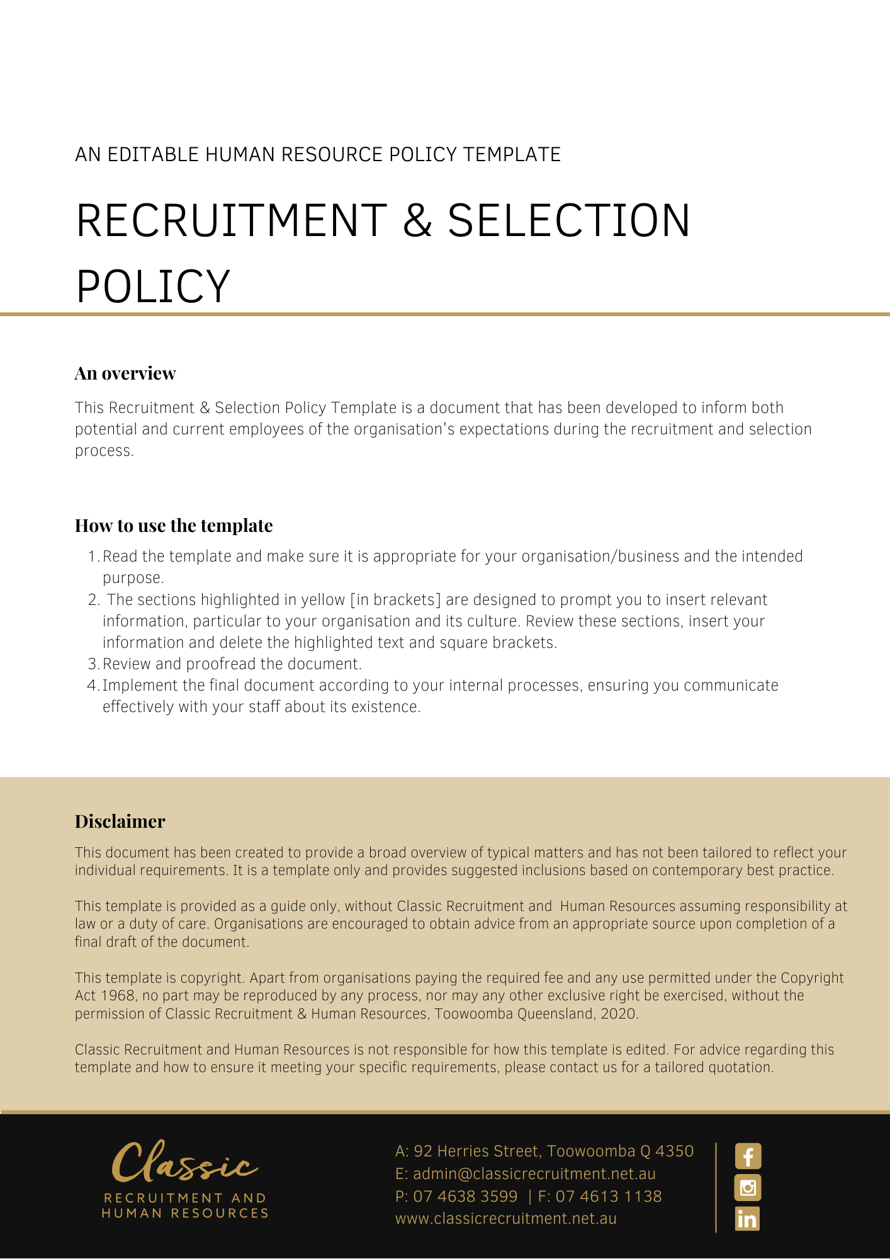

Recruitment & Selection Policy

Overview
[Company Name] has implemented a Recruitment & Selection Policy. The policy takes effect immediately and has been developed to inform employees of our expectations while employed by [Company Name].

The aim of this policy is to confirm our commitment to equity in relation to selection and recruitment and describes our processes in relation to the recruitment and selection of employees. This Policy applies to all employee positions up to and not including the [Insert Position (e.g. CEO/Director/Owner)] role, where the positions are permanent or fixed term for more than six months [Delete after reading: This is customisable to whatever you prefer]. It explains our objectives and the responsibilities of both management and employees.

Application
This policy applies to all employees of [Company Name] regardless of whether they are permanent full-time, permanent part-time or casual employees. This policy applies to all employees while they are in our workplace under the management and control of [Company Name] and/ or using [Company Name] vehicles, machinery, plant or substances and/or performing work in the conduct of [Company Name] (including at a client site away from their usual workplace).

Privacy and confidentiality
All Information relating to recruitment, selection and appointment of employees will remain confidential to those involved in the formal process. Any Personal Information collected, stored, used, or disclosed will be managed in accordance with [Company Name] Code of Conduct and the Information Communication and Technology (ICT) Usage Policy. Information will only be released where legislation recognises lawful access by some government agencies.

Documentation
All recruitment and selection documentation not retained in the recruitment system must be returned to Human Resources for record keeping and filing.

Recruitment and selection expenses
All advertising, interview, travel, employment agency, criminal history checks, relocation and associated expenses are met by [Company Name]and will be communicated to candidates as part of the recruitment process. The [Insert Position (e.g. CEO/Director/Owner)] alone can approve the payment of/or reimbursement of expenses associated with the recruitment and onboarding of candidates and/or employees.

Identifying the hiring need
Prior to commencing a recruitment process, a review of the need for the position should be conducted, taking into account the following:

- strategic and operational plans for the work area
- current staffing structure
- the diversity of staffing profiles
- employee profiles and specialisations - current and future requirements
- current staffing and skill levels
- review current employees on extended leave (such as Parental Leave)
- any foreseeable changes which might impact on the area or the role
- how the needs for the position might best be met.

Recruitment Approval
Prior to any recruitment campaign, approval must be given by the [Insert Position (e.g. CEO/Director/Owner)].

The recruitment and selection process cannot commence until the Position Description, remuneration range and advertisement text have been approved by the [Insert Position (e.g. CEO/Director/Owner)].

Position descriptions
A recruitment campaign will usually result in a review of an existing position description or the creation of a new position description, as appropriate, which outlines the key outcomes and activities to be undertaken. All position descriptions must be drafted using the approved position description template to ensure consistency across the firm.

Variations to the selection criteria contained within the position description will not normally be made after the position has been advertised.

Advertising
All recruitment advertising must be arranged by the [Insert Position (e.g. CEO/Director/Owner)] [Delete after reading: Just a suggestion to ensure consistency with branding/marketing. May or may not be appropriate for you]. Recruitment of continuing and fixed-term positions for more than six months will be through advertisement, unless recommended otherwise by a [Insert Position (e.g. CEO/Director/Owner)].

Where it is deemed that a suitable pool of applicants exists within the firm, a position will normally be advertised internally in the first instance.

Online advertising is the preferred medium for advertising all positions.

Advertising in print media will only be offered in exceptional circumstances and must be supported by a strong business case to substantiate the need. The [Insert Position (e.g. CEO/Director/Owner)] will consider these requests on a case by case basis.

Employees are encouraged to share position vacancy information with their professional networks through the use of electronic communication [Delete after reading: Amend this if it is not appropriate for you].

A field of applicants may be supplemented by inviting applications or referrals from employment agencies or other sources after consideration of cost and receipt of quotations.

The [Insert Position (e.g. CEO/Director/Owner)] may recommend the use of an employment agency as a means of external advertising.

Recruitment and selection panels
The selection panel will seek to be objective and maintain equity and confidentiality of the recruitment and selection process at all times.

A Panel Coordinator (usually the [Insert Position (e.g. CEO/Director/Owner)]) will be appointed prior to advertising. Changes to the selection panel will be approved by the Panel Coordinator.

Selection panels will usually consist of at least two people, usually the [Insert Position (e.g. CEO/Director/Owner)] and a senior employee or the [Insert Position (e.g. CEO/Director/Owner)].

Other panel members may be included as appropriate.

The Panel Coordinator is responsible for ensuring that:

- a robust process is followed whereby interview questions are consistent for all applicants;
- the panel clarifies the selection criteria prior to interviews commencing to ensure a consistent understanding among all panel members;
- every panel member is invited to declare any perceived, potential, or actual Conflict of Interest; and
- all recruitment and selection documentation is complete and accurate and that notes and paperwork is retained after the process is completed and handed to Human Resources for filing or destruction as appropriate.

A selection panel will decide upon the appropriate selection methods to be used, normally behavioural interviews supplemented by two oral reference checks and a Police Check for the recommended applicant. Selection methods must be relevant to the position and may also include presentations, work samples, and performance tests.

Shortlisting
Shortlisting occurs as soon as possible after the date on which applications close.

Each panel member will conduct shortlisting. Panel members should shortlist individually in the first instance. All panel members are then required to reach a consensus in relation to shortlisting.

A selection panel may accept late applications with valid reasons. Applicants not shortlisted will be notified by the [Insert Position (e.g. CEO/Director/Owner)] and/or the external recruitment agency as soon as possible, unless the selection panel requests otherwise.

Interviews
Interviews are required for all positions (in person, via telephone, video conference or other online medium). Interviews must be structured in such a way to enable collection of sufficient evidence to confirm that the applicant(s) selected have the required skills, experience and motivation to carry out the inherent requirements or duties of the role and also demonstrate genuine motivation to join the firm.

The selection panel should prepare the interview questions using the supporting documentation, guidelines and templates provided by the [Insert Position (e.g. CEO/Director/Owner)]. After all interviews have been completed, the selection panel must reach consensus on a recommendation decision.

Selection panels must be satisfied that the recommended candidate meets the selection criteria and is suitable for the position. It may also be appropriate NOT to recommend any of the candidates for appointment from the interview. In such cases, the [Insert Position (e.g. CEO/Director/Owner)] and the [Insert Position (e.g. CEO/Director/Owner)] and panel member/s will discuss alternative recruitment options.

Where an external agency is supporting [Company Name] in the recruitment process, copies of all pre-employment and probity checks must be provided to [Company Name] prior to an employment contract being formally presented to the successful candidate.

Oral reference checks
Oral reference checks must be carried out, remain confidential and should be documented.

A minimum of two oral reference reports must be obtained by the selection panel to confirm the preferred candidate's merits against the selection criteria, before the final selection decision is made. Wherever possible, a minimum of one of the oral reference reports should be obtained from the current or immediately previous Supervisor of the preferred candidate. Oral reference checks should only be conducted with referees nominated by the candidate. If additional information is required, the candidate must be asked to nominate additional referee/s.

Criminal history checks
A criminal history check (Police Check) may be sought prior to offering an appointment to a position where there is a requirement for the incumbent to process financial transactions on behalf of a client or within [Company Name] systems.

Appointment
The selection panel will recommend the preferred candidate. The [Insert Position (e.g. CEO/Director/Owner)] will:

- approve the recommendation and forward it to the Director Human Resources; or
- not support the recommendation and provide the panel with the reasons why the recommendation was not supported.

In exceptional circumstances, the [Insert Position (e.g. CEO/Director/Owner)] may appoint an individual to any position without advertisement or competitive selection, however, they will ensure appropriate documentation is completed outlining the circumstances.

On approval from the [Insert Position (e.g. CEO/Director/Owner)], the [Insert Position (e.g. CEO/Director/Owner)] will make a verbal offer of appointment to the preferred candidate on the condition of satisfactory completion of qualifications & licence checking, Police Checks (where appropriate), reference checking and any other pre-employment checks.

The [Insert Position (e.g. CEO/Director/Owner)] is the only role authorised to make offers of appointment. No other employee is authorised to make or vary any offer of appointment in writing.

The preferred candidate will normally be required to provide an acceptance in writing within two working days, otherwise the offer lapses.

Where the preferred candidate declines the offer, an offer of appointment can be made without re-advertisement to another suitable candidate who best meets the selection criteria.

Unsuccessful applicants
Unsuccessful applicants should be dealt with courteously and sensitively and will always receive notification of their unsuccessful application.

What do I need to do?
You need to read through the Recruitment & Selection Policy to make yourself familiar with the contents of the policy and procedures. You are expected to comply with this policy as amended and implemented from time to time.

What happens if I do not comply with the Recruitment & Selection Policy?
The consequences of a breach of this policy will vary depending on the type and seriousness of the breach and will be at the discretion of [Company Name].

Depending on the circumstances, [Company Name] may take disciplinary action up to and including termination of employment.

Policy and further information
To the extent that the contents of this Policy refers to obligations on [Company Name], they are guidelines for management or summaries of applicable legislative requirements only and are not contractual terms, conditions or representations on which a staff member may rely.

[Insert Position (e.g. CEO/Director/Owner)] is available to assist with any queries you have relating to the policy which is detailed above. Further information may be found in:

Code of Conduct

EEO Discrimination, Bullying, Harassment and Violence Policy

Document Control
This Policy will be reviewed on a regular basis and approved by the [Insert Position (e.g. CEO/Director/Owner)].

Implementation date | Author | Approved by | Date of next review
[Date] | [Name] | [Position] | [Month, Year]

