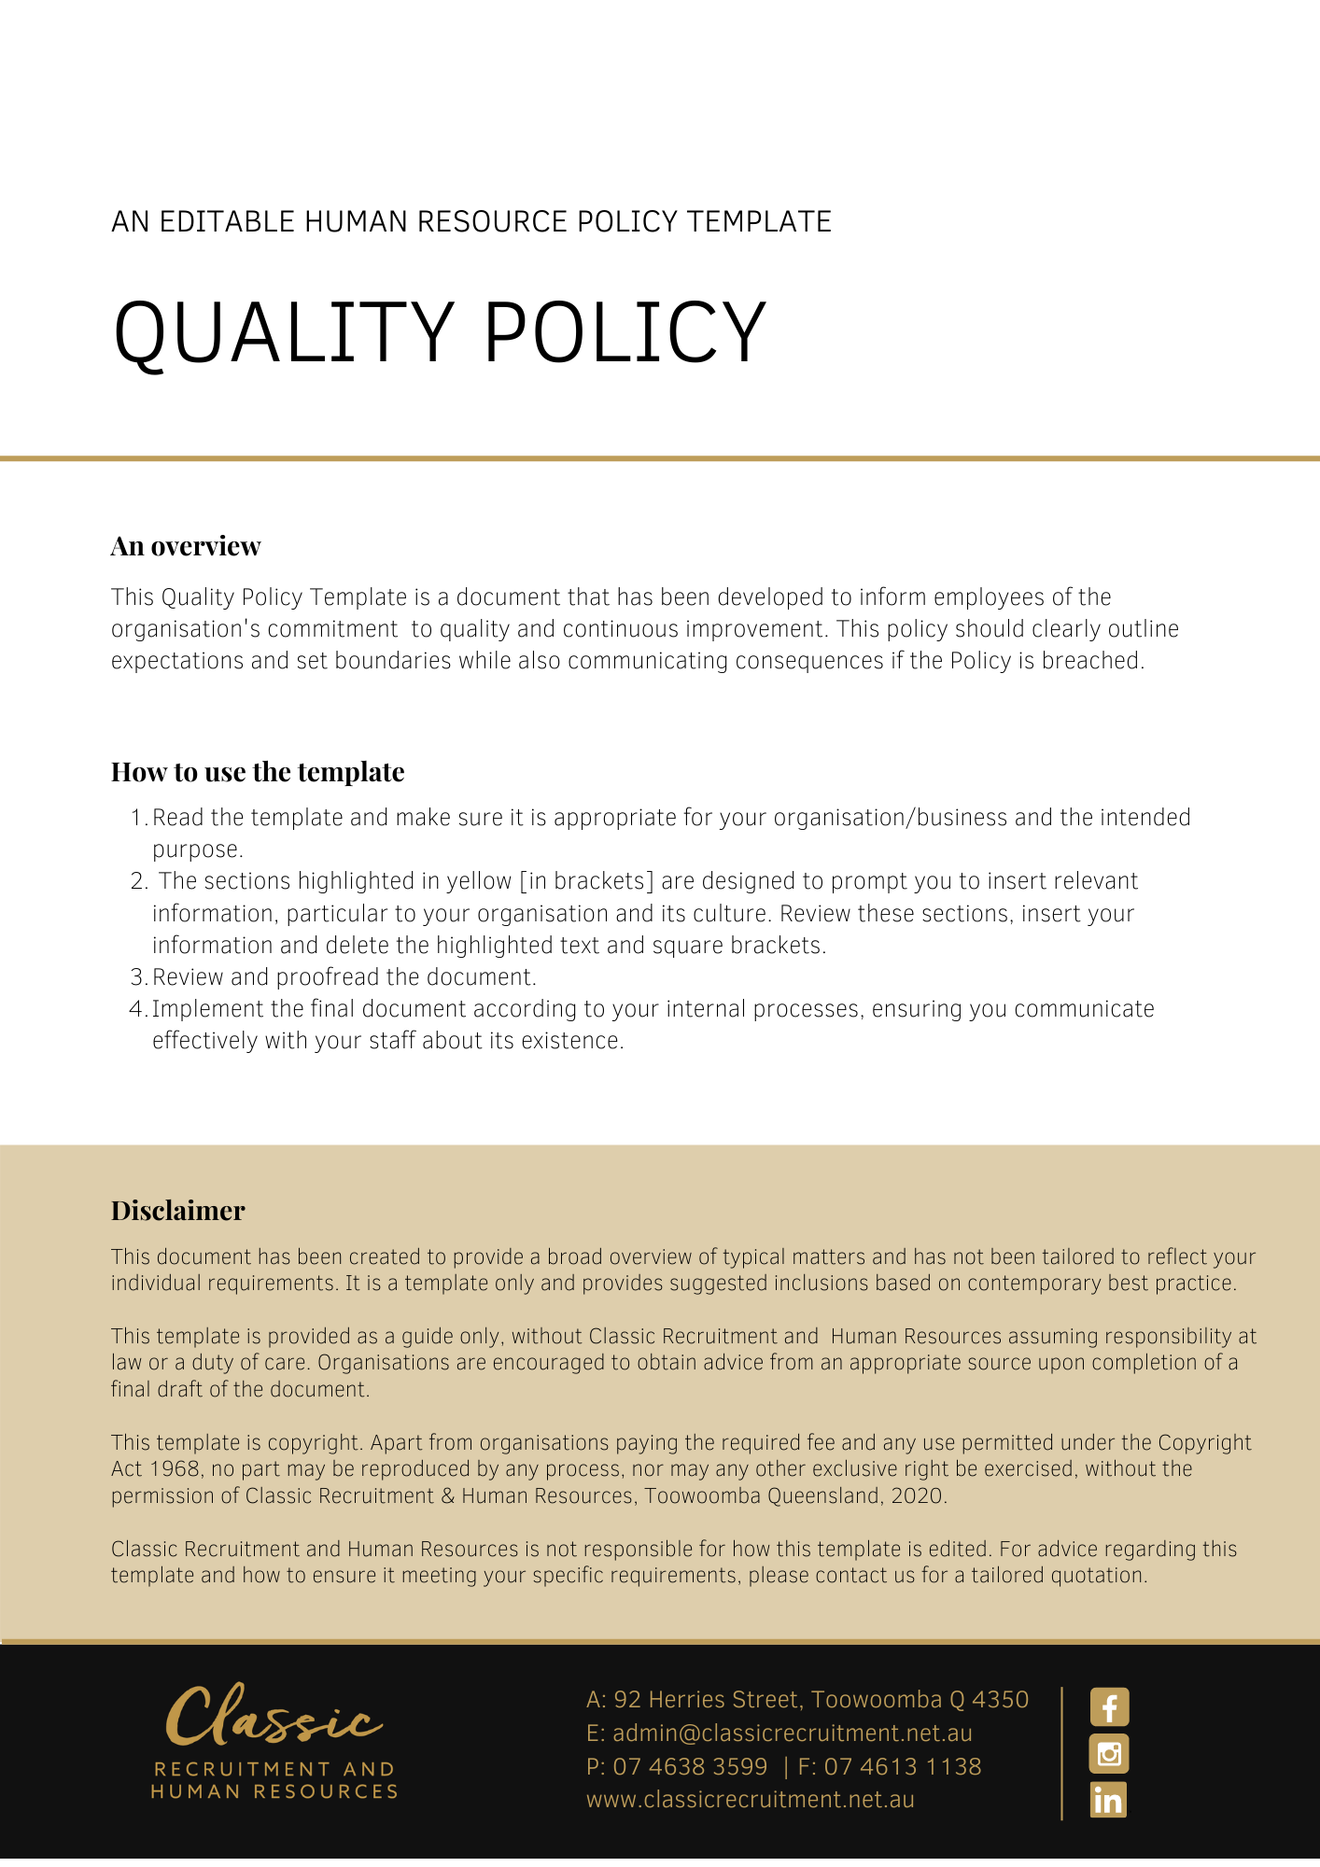

Quality Policy

Overview
[Company Name] has implemented a Quality Policy. The policy takes effect immediately and has been developed to inform employees of our expectations while employed by [Company Name].

The aim of this policy is to confirm our commitment to quality and professional ethics that we believe are essential within the business to achieve sustainable growth by providing services that consistently meet and exceeds customer expectations and deliver exceptional value. We are committed to continually improving the services we deliver. The quality of our services forms the basis for the trust our customers put in us. This policy explains our objectives and the responsibilities of both management and employees.

Application
This policy applies to all employees of [Company Name] regardless of whether they are permanent full-time, permanent part-time or casual employees. This policy applies to all employees while they are in our workplace under the management and control of [Company Name] and/ or using [Company Name] vehicles, machinery, plant or substances and/or performing work in the conduct of [Company Name] (including at a client site away from their usual workplace).

Procedure
[Company Name] assures quality through the alignment and integration of its strategic and operational planning with its evaluation, accreditation, and review processes.

All employees are responsible for the quality of our work and for maintaining high standards.

We achieve quality through:

- Being committed, transparent and flexible when recommending products to clients
- Attracting and retaining top quality, committed and adaptable people who listen to the needs of our clients and offer qualified and well thought out advice to clients to enhance their financial security
- Maintaining our reputation as honest, friendly, and likeable professionals who put the client first
- Always maintaining open and transparent relationships with our people, suppliers and clients and working with simple and easy-to-use systems and processes
- Excellence in our delivery to achieve and maintain a level of quality that enhances our reputation with clients
- Ensuring continual quality improvement and promoting a culture of getting things right first time
- Measuring our progress against meaningful targets
- Providing a learning environment where the professional growth and development of employees is actively encouraged and supported

Quality Framework
The [Company Name] quality management framework operates to support our clients through specific, critical aspects of the organisation which is considered to underpin understanding and achievement of quality in all parts of the organisation.

The components of this framework are:

- Planning and performance monitoring of products and services, including regular (at least annual) performance reporting to clients
- Process improvement steps
- Knowledge Management
- Risk
- Compliance
- Benchmarking

The Quality Committee meets annually and reviews quality systems and processes, seeking input from each employee. This is to ensure our culture of continuous improvement is maintained. Here at [Company Name] we seek to build quality into each of our activities.

What do I need to do?
You need to read through the Quality Policy to make yourself familiar with the contents of the policy and procedures. You are expected to comply with this policy as amended and implemented from time to time.

What happens if I do not comply with the Quality Policy?
The consequences of a breach of this policy will vary depending on the type and seriousness of the breach and will be at the discretion of [Company Name].

Depending on the circumstances, [Company Name] may take disciplinary action up to and including termination of employment.

Policy and further information
To the extent that the contents of this Policy refers to obligations on [Company Name], they are guidelines for management or summaries of applicable legislative requirements only and are not contractual terms, conditions or representations on which a staff member may rely. Management is available to assist with any queries you have relating to the Policy which is detailed above.

Management is available to assist with any queries you have relating to the policy which is detailed above. Further information may be found in:

Code of Conduct

Document Control
This Policy will be reviewed on a regular basis and approved by the [Insert Position (e.g. CEO/Director/Owner)].

Implementation date | Author | Approved by | Date of next review
[Date] | [Name] | [Position] | [Month, Year]

