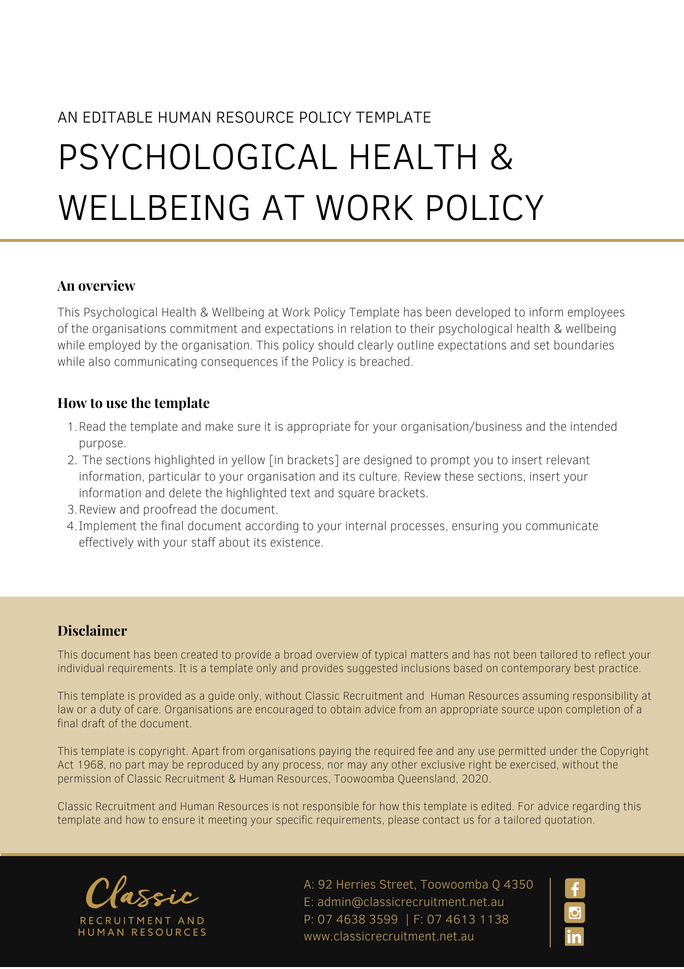

Psychological Health & Wellbeing at Work Policy

Overview
[Company Name] has implemented a Psychological Health & Wellbeing at Work Policy. The policy takes effect immediately and has been developed to inform employees of our commitment and expectations in relation to their psychological health & wellbeing while employed by [Company Name].

The working environment can often present hazards that may impact on the mental health of workers, potentially causing the worker to suffer a psychological injury or perhaps even exacerbate a pre-existing condition. This may occur at a physical workplace, or any location or situation related to work or in which work is performed.

Hazards in the workplace that may impact upon the mental health of workers, and therefore potentially result in psychological injuries, include:

- the physical workplace environment
- the nature and complexity of the work itself
- work procedures
- behaviour of workers towards one another
- the potential exposure to violent or traumatic events and/or,
- the introduction of work restrictions that are beyond the control of [Company Name].

[Company Name] is committed to helping to support the overall mental wellbeing of its workers and ensuring that the risk of psychological and/or psychosocial injuries in the workplace are eliminated as far as is practical and is effectively and pro-actively managed through a risk management approach.

Injuries sustained outside of the workplace are the responsibility of the employee. If an employee is unfit for work, they will be required to access Personal Leave or Leave Without Pay (LWOP). If suitable duties are unavailable, or working from home is not appropriate, leave will need to be taken. Of course, [Company Name] will try to assist however, this may not always be possible or practical. Employees will not be able to return to the workplace until their medical certificate has been completed. If an employee recovers sooner than anticipated, it is the employee’s responsibility to obtain a revised Medical Certificate from their medical practitioner. Costs for medical assessments etc will of course be for the employee’s personal account.

Application
This policy applies to all employees of [Company Name] regardless of whether they are permanent full-time, permanent part-time or casual employees. This policy applies to all employees while they are in our workplace under the management and control of [Company Name] and/ or using [Company Name] vehicles, machinery, plant or substances and/or performing work in the conduct of [Company Name] (including at a client site away from their usual workplace).

Identifying Mental Health Risks
Workplace hazards that may result in mental health risks and psychological injuries include anything in the overall design or management of work and/or the workplace that increases the risk of work-related stress and results in a physical, mental or emotional reaction.

Such hazards may be identified by:

- having conversations with workers, supervisors, and managers
- inspecting the workplace to see how work is carried out
- identifying how workers interact with each other during work activities
- reviewing relevant information and records such as reporting systems including incident reports, workers’ compensation claims, staff surveys, grievance records, absenteeism, and staff turnover data
- using surveys to gather information from workers, supervisors, and managers, and
- ensuring regular feedback from isolated workers such as those working from home is taken into consideration.
[Company Name] recognises that individuals respond to hazards in different ways and that individual differences such as age, existing disabilities, injuries or illnesses as well as life experiences may make some workers more susceptible to harm from exposure to the same hazard.

It is also recognised that there may be more than one aspect of the working environment or workplace that is contributing to the mental health of workers and the risk of psychological injuries.

To clearly identify the risk of psychological injuries to workers, [Company Name] ensures that the job, task and role hazards are identified, particularly where:

- work requires sustained high physical, mental and or emotional effort, including long work hours, shift work and related fatigue, excessive workloads, emotionally distressing work or episodes, exposure to traumatic events, and exposure to extremes in the work environment such as prolonged exposure to physical and environmental workplace hazards
- work requires only low levels of physical, mental, or emotional effort, including repetitive and/or monotonous tasks
- workers have a low level of control over the work being undertaken and are not involved in decisions that may impact upon them
- work is performed in an area of the workplace that may have minimal support from supervisors and co-workers such as remote or isolated workers such as workers who are working from home
- workers may not have received sufficient training, information, and instruction to undertake the work required safely and correctly
- there may be known or potential poor relationships or conflict between management and workers or between co-workers. This includes the identification of workplace bullying, aggression, harassment (including sexual harassment), discrimination, or other unreasonable behaviour by co-workers, supervisors, or clients
- there may be a perceived lack of fairness by workers in addressing organisational issues and resource allocation or where performance issues have been inappropriately or poorly managed
- the role being undertaken by workers is not clearly defined, involves frequent changes or conflicts in expectations, procedures, or performance standards, and
- the workplace is undergoing structural or organisational change whether initiated by [Company Name] or by demands or restrictions placed upon the workplace that are beyond the control of [Company Name]
- the workplace is investigating a complaint made by a client.

Assessing Mental Health Risks
As part of the risk management approach, [Company Name] ensures that any work-related hazards that could impact upon a worker’s mental health are assessed to determine the seriousness of these hazards.

The first step in assessing mental health risks is to focus on those parts of the organisation where risks to the mental health of workers have already been identified or where a potential of such risk has been identified.

In assessing these risks, the following factors should be taken into account:

- the social and physical environment, such as the individual or group of workers’:
  - their role within the Organisation
  - their opportunities for career development and their overall status, including remuneration levels
  - conflicting home/work demands
  - overall working environment, including physical and environmental conditions, the condition of plant and machinery used at work and the presence of workplace hazards such as hazardous noise, hazardous manual handling, and hazardous chemicals
- the way that work and systems of work are organised, such as:
  - the complexity, content and demands of the work required
  - the workload expectations and pace of the work
  - work schedules and working hours
  - work procedures
  - the extent of participation and control that workers have over the work
- the way that work is managed, including:
  - the level and quality of supervision provided to workers
  - the level of information, instruction and training provided to workers and whether it is sufficient to enable workers to do their work safely and correctly and allows them to meet the Organisation’s expectations
  - the level of resources allocated to undertake the work
- interpersonal relationships, particularly where there may be poor existing relationships resulting from:
  - breakdowns in relations between management/supervisors and workers
  - breakdowns in relationships between co-workers
- organisational or structural change within the business, including restructures, potential sale of the business or work restrictions placed upon the Organisation over which it has little or no control, and
- the introduction of new or additional resources or processes that may change the way work is undertaken.

Controlling Mental Health Risks
[Company Name] recognise that the management of work-related mental health issues and the psychological health and safety of workers starts with a clear and open commitment from [Company Name]. To this end, we ensure as far as is practical that:

- any work-related factor that may impact upon the mental health of workers is identified, recognised, assessed, and controlled, including where such impact is not able to be controlled by the organisation such as a change in regulatory policy
- the work expectations of workers are clearly identifiable, for example through job descriptions, relevant polices and work procedures
- all workers are provided with an appropriate induction that includes information related to our commitment to the mental health of workers and the workers responsibilities related to helping to ensure a healthy and safe workplace
- all workers have sufficient training, instructions, tools, and equipment to do their work safely
- the skills and experience of workers is appropriately utilised, and workers are not routinely underutilised or used in areas of work where they have not been deemed competent
- all managers and supervisors are provided with sufficient training in the identification, prevention, and management of mental health risks and in good management practices
- all managers and supervisors understand the procedures and processes in place, including those relating to the taking of reasonable management action, to eliminate or minimise the risks of work-related mental health risks and psychological injuries to workers
- there is adequate and appropriate supervision of workers and that there is a mechanism for consultation between management, supervisors, and workers in relation to mental health risks in the workplace
- all managers and supervisors understand our operations, including the hazards to the mental health of workers and the overall health and safety of workers
- all workers understand the applicable organisational operations that may impact upon their mental well-being and the processes and procedures in place to eliminate, minimise and report any mental health risks
- the physical work environment is safe with appropriate and adequate plant and equipment for workers to perform their jobs properly and safely
- the systems of work are safe when properly followed and that they take into account the establishment of realistic deadlines, access to adequate breaks and leave and include fair and equitable work scheduling and rostering
- there are appropriate resources and processes in place to eliminate or manage mental health risks and the risk of work-related psychological injuries
- the resources and processes designed to eliminate or manage mental health risks and the risks of work-related psychological injuries are effectively and efficiently implemented, managed, and utilised
- there are appropriate processes for receiving, monitoring, and reviewing information on incidents, hazards and risks related to the mental health of workers
- any reports or information related to potential work-related mental health issues are responded to in a timely way
- investigations in relation to mental health issues will be completed in a timely manner, and (if substantiated) appropriate action will be taken promptly to prevent re-occurrence
- it acquires up to date knowledge of work-related mental health matters, the risks to the psychological health of workers and general health and safety matters
- a process is in place to verify that resources and processes are provided and used to manage work-related risks to the mental health of workers
- there are sufficient resources in place to assist workers with non-workplace related mental health issues and their overall mental health, including the provision of confidential counselling for affected workers, whether work related or not
- workers receive adequate and appropriate feedback on work performance and that due recognition is given for positive performance
- it is able to offer a safe and effective return to work to any worker who may be returning to work following mental health issues or may have sustained a psychological injury, and
- regular monitoring and review of the effectiveness of measures are in place to eliminate or reduce mental health hazards and the risks of workers sustaining a psychological injury.

Bullying and Harassment
Here at [Company Name] we recognise that a major risk to the mental health and wellbeing of workers is bullying or harassment at the workplace. Regardless of whether bullying or harassment occurs via physical, verbal, or non-verbal conduct, it can be a major risk factor for psychological injuries potentially resulting in anxiety, depression and suicide, and can adversely affect the psychological and physical health of a worker.
In line with our policy in relation to mental health risks, we will ensure that effective control measures are put in place to address and resolve workplace issues early, thereby minimising the risk of workplace bullying or harassment.
Bullying is repeated, offensive, abusive, intimidating, insulting or unreasonable behaviour directed towards an individual or a group, which makes the recipient(s) feel threatened, humiliated, or vulnerable. Whether intentional or not, bullying creates a risk to health and safety and will not be tolerated by [Company Name].
Harassment is any unwanted physical, verbal or non-verbal conduct based on grounds of age, disability, gender identity, marriage and civil partnership, pregnancy or maternity, race, religion or belief, sex or sexual orientation which affects the dignity of anyone at work or creates an intimidating, hostile, degrading, humiliating or offensive environment. Whether intentional or not, harassment creates a risk to health and safety and will not be tolerated by [Company Name].
Where any incidents of bullying or harassment are identified, it will be addressed via a disciplinary procedure in line with our disciplinary policies and procedures.
If the behaviour involves violence such as physical assault or the threat of physical assault, the matter will be reported to the police.

Employee Responsibilities
[Company Name] recognises that the management of work-related mental health issues and the psychological health and safety of workers starts with a clear and open commitment from us as an organisation.

Importantly, the overall success of our risk management strategies is also dependent upon workers understanding their responsibilities in relation to helping to minimise the risks to their own mental health and the mental well-being of others at work.

To this end, workers are responsible for ensuring that they:

- understand our commitment to the overall mental health of workers and the policies and procedures developed to help identify, assess, and control risks to mental health in the workplace
- understand their role at work, ensure that it has been clearly identified and it is clearly within the scope of their skills, knowledge, and experience
- have received sufficient training, instructions, tools, and equipment to do their work safely
- actively participate in the consultation mechanisms or forums designed to help ensure their health and safety at work, including those targeted at the overall mental health of workers
- understand the applicable organisational operations that may impact upon their mental well-being, including those beyond the control of [Company Name], and the processes and procedures in place to eliminate, minimise and report any mental health risks
- comply with all systems of work and procedures that are designed to help ensure their health and safety and the health and safety of others at work, including those specifically designed to eliminate or minimise mental health risks
- utilise the applicable reporting procedure to report any work-related hazard to their own mental health or the metal wellbeing of others at work as soon as it becomes evident, include any incidence of bullying or harassment (as outlined below) affecting themselves or another worker.
In minimising the mental health risks to others in the workplace, workers must not act or behave in a manner that could be considered bullying or harassment. Such behaviour creates a risk to health and safety and, whether intentional or not, will not be tolerated by [Company Name].

Confidentiality
If a psychological injury is sustained, a confidential return to work file for each injured employee will be established, maintained and stored securely. Access will be restricted to those who have direct responsibility in the rehabilitation process. At the beginning of the return to work process the “Consent to disclose medical information” form shall be completed and signed by all involved with the rehabilitation process.

What do I need to do?
You need to read through the Psychological Health & Wellbeing at Work Policy to make yourself familiar with the contents of the policy and procedures. You are expected to comply with this policy as amended and implemented from time to time.

What happens if I do not comply with the Psychological Health & Wellbeing at Work Policy?
The consequences of a breach of this policy will vary depending on the type and seriousness of the breach and will be at the discretion of [Company Name].

Depending on the circumstances, [Company Name] may take disciplinary action up to and including termination of employment.

Policy and further information
To the extent that the contents of this Policy refers to obligations on [Company Name], they are guidelines for management or summaries of applicable legislative requirements only and are not contractual terms, conditions or representations on which a staff member may rely. Management is available to assist with any queries you have relating to the Policy which is detailed above.

Management is available to assist with any queries you have relating to the policy which is detailed above. Further information may be found in:

- Code of Conduct

- EEO Discrimination, Bullying, Harassment and Violence Policy

- Working from Home Policy

- Workplace Health & Safety Policy

- WorkCover Queensland https://www.worksafe.qld.gov.au/

Document Control
This Policy will be reviewed on a regular basis and approved by the [Insert Position (e.g. CEO/Director/Owner)].

Implementation date | Author | Approved by | Date of next review
[Date] | [Name] | [Position] | [Month, Year]

