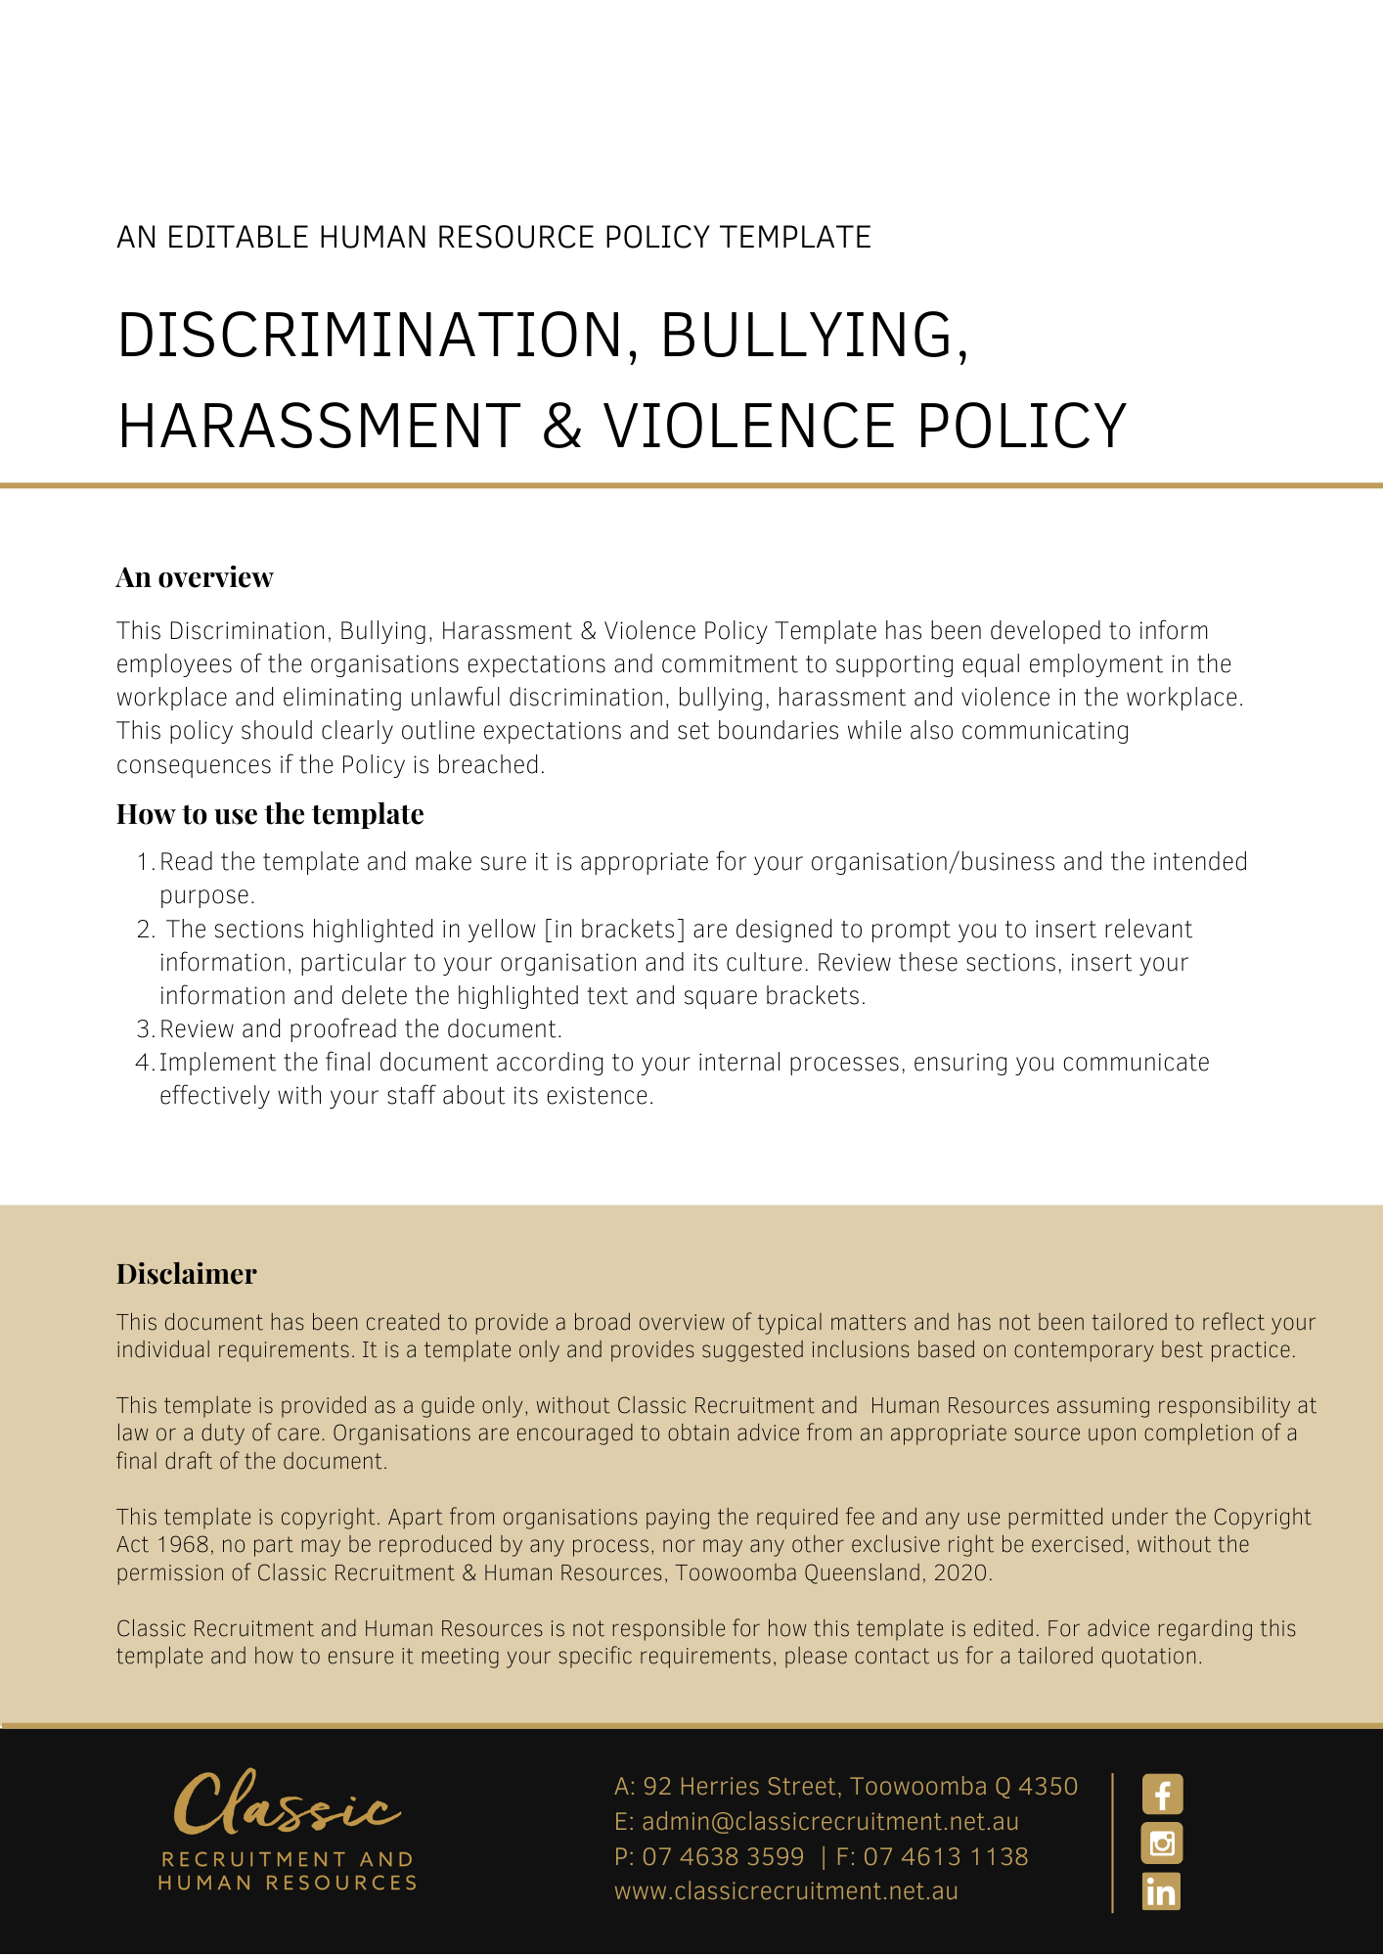

Discrimination, Bullying, Harassment & Violence Policy

Overview
[Company Name] has implemented a Discrimination, Bullying, Harassment and Violence Policy. The policy takes effect immediately and has been developed to inform employees of our expectations while employed by [Company Name].

The aim of this policy is to confirm our commitment to supporting equal employment in the workplace and eliminating unlawful discrimination, bullying, harassment, and violence in the workplace. We are committed to providing all workers with a healthy and safe work environment free from inappropriate behaviour.

This policy is intended to provide everyone with information to help [Company Name] achieve its policy objectives by outlining expectations of behaviour and procedures for dealing with complaints.

We expect everyone to behave in a professional manner and to treat each other with dignity and respect when they are at work. We encourage anyone who experiences inappropriate behaviour such as discrimination, bullying, harassment, or violence to report it. When inappropriate behaviour is reported, it will be seen as a serious matter and will be investigated in a timely manner.

[Company Name] supports the principle of equal employment opportunity and to providing a productive workplace in which everyone, including our clients, can work free of unlawful discrimination, bullying, harassment, and violence.

Application
This policy applies to all employees of [Company Name] regardless of whether they are permanent full-time, permanent part-time or casual employees. This policy applies to all employees while they are in our workplace under the management and control of [Company Name] and/ or using [Company Name] vehicles, machinery, plant or substances and/or performing work in the conduct of [Company Name] (including at a client site away from their usual workplace). This Policy also applies when representing or acting on behalf of [Company Name] at work related events and social functions.

Equal Employment Opportunity (EEO)
It is the policy of [Company Name] that all persons in the workplace be treated on the basis of merit and according to their skills and abilities. This shall include, but is not limited to, matters involving:

- recruitment, selection, transfers, promotions, performance reviews, training and development, supervision and management of staff, counselling, disciplinary procedures, and termination of employment; and

- remuneration practises and benefits.

An employee’s gender, marital status, pregnancy, parental or family responsibilities, race, age, physical or mental disability, sexual orientation, transgender, political or religious beliefs, social origin, trade union activity or inactivity, or physical appearance will not form the basis of employment or engagement decisions.

Discrimination & Harassment
[Company Name] believes that everyone has a right to work in a productive environment in which discriminatory conduct or harassment of others is not tolerated. Through reasonable management, we endeavour to prevent discrimination and harassment from occurring in the workplace. All forms of harassment and unlawful discrimination will not be tolerated and depending on the severity, can lead to disciplinary action including termination of employment or engagement.

What is Unlawful Discrimination?
Unlawful discrimination may occur when someone is treated less favourably than others because of that person’s individual characteristics or because that person belongs to a particular group of people. Everyone should feel comfortable in the workplace and individual differences should be respected.

Discrimination does not have to be intentional to be unlawful. As such, two types of discrimination can occur in the workplace:

- Direct Discrimination- this occurs when an individual treats another person less favourably for an unlawful reason.

- Indirect Discrimination- this occurs when a policy or practise appears neutral but in fact results in an individual or group being treated less favourably.
Employment decisions may be unlawful if they are made on the basis of a person’s:

- gender (including marital status, pregnancy or potential pregnancy or transgender status)
- race (including colour, nationality, ethnic or ethno-religious origin)
- sexuality (including sexual orientation)
- age
- marital status
- family or carer’s responsibilities
- religion
- political opinion
- criminal records
- disability; or
- Trade Union activity or non-activity.

Examples of Unlawful Discrimination
The following examples may constitute unlawful discrimination in the workplace:

- a pregnant employee being pressured to resign prior to taking any maternity leave; or
- deciding to employ an older person because ‘young’ people are not reliable
- making the decision not to hire an employee on the basis of the person's ethnicity.

It is illegal to discriminate on the basis that a person is perceived to have one of the above attributes, even if they do not actually have that attribute. For example, it is illegal to discriminate against a person because you think that the person has a disability, even if they do not in fact have the disability.

What is Harassment?
Harassment is any unwelcome or uninvited behaviour that offends, humiliates, or intimidates another person, whether or not that effect is intended. Harassment may occur as a single act, or as a series of incidents, persistent innuendoes, or threats. It can take many forms- it may be silent or loud, subtle, or openly hostile, private, or public. Harassment may take the form of general bullying or be specifically aimed at people with particular individual attributes and characteristics. This latter type of harassment can sometimes be unlawful discrimination.

Sexual Harassment
Sexual harassment in the workplace generally includes any unwelcome conduct of a sexual nature which a reasonable person would find offensive. It may be physical, verbal or written.

It is important that everyone understands that just because someone does not object to inappropriate behaviour in the workplace at the time, it does not mean that they are consenting to the behaviour towards them.

Sexual harassment is covered in the workplace when it happens at work, at work-related events, between people sharing the same workplace, or between colleagues outside of work.

A single incident is enough to constitute sexual harassment – it doesn’t have to be a repeated behaviour.

[Company Name] regards sexual harassment as a serious issue and endeavours to treat any complaints in a sensitive, fair, and confidential manner.

Examples of Sexual Harassment
The following examples may constitute sexual harassment – it is very important that everyone understands they may or may not be offensive, regardless of any innocent intent on the part of the offender:

- comments about a person’s private life or the way they look, intrusive questions or statements about a person’s private life
- sexually suggestive behaviour, such as leering or staring, brushing up against someone, touching, fondling or hugging someone
- sexually suggestive comments or jokes, enquiries into another person’s private life, their sexuality or physical appearance
- displaying offensive screen savers, photos, calendars or objects, including on the Internet
- repeated unwanted requests, for example persistent requests from a colleague to go out for a drink or a meal where such requests have been consistently declined, requests for social outings, requests for sex
- persistent staring or looking at a person or parts of their body, deliberate or unnecessary physical contact
- sexually explicit posts on social networking sites
- insults or taunts of a sexual nature
- requests for, or expectations of, sexual activity under threat, for example, in exchange for favours or promises of preferential treatment and or promotion at work
- sending sexually explicit emails or text messages
- inappropriate advances on social networking sites
- accessing sexually explicit Internet sites
- behaviour that may also be considered to be an offence under criminal law, such as physical assault, indecent exposure, sexual assault, stalking or obscene communications.

Victimisation
Victimisation occurs when a person victimises another person who makes a discrimination or harassment complaint or takes certain related actions.

Victimisation of others is unlawful. The intention of such protective measures is to ensure that a person who wants to use or does use their statutory rights to protect themselves against discrimination or harassment, is not further disadvantaged by other detriments being imposed on them.

Here at [Company Name] we have a low tolerance for victimisation. Disciplinary action will be taken against anyone who is found to have engaged in threatening or other inappropriate action against a person who has complained of harassment. The disciplinary action can be up to and including termination of the employment or engagement of an employee.

Bullying
An employee is bullied at work if a person or group repeatedly act unreasonably towards them or a group of employees and the behaviour creates a risk to their health and safety.

Bullying may involve physical or verbal abuse, aggression, or intimidation, but it may also be more subtle or indirect and can include behaviours such as:

- putting new staff through “initiation rituals”
- verbal abuse, threats, sarcasm, or other forms of demeaning or intimidating language or communication
- constant negative criticism
- threatening to take unjustified action against a person unless they comply with unreasonable requests
- placing unreasonable work demands on people
- deliberately isolating staff members.

Examples of bullying may include (but are not limited to):

- a manager or supervisor using a management style that is harsh, involves shouting, constant criticism or humiliation of an employee or group of employees in private or in front of their peers
- an employee being treated less favourably by another employee or group of employees in the workplace, including, but not limited to, bullying or intimidation; forcing an employee to participate in an “initiation” process; the playing of practical jokes or forcing an employee to undertake demeaning tasks
- sniggering or gossiping behind someone’s back
- laughing at someone in the workplace which is intended to make them feel uncomfortable or distressed
- a manager setting unreasonable timelines or constantly changing deadlines for an employee to meet, or setting tasks that are unreasonably below or beyond a person’s skill level; and/or
- continuously and deliberately excluding someone from workplace activities including ignoring them and keeping them isolated from relevant communications about work issues.

What is not bullying
Many things that happen at work are generally not considered to be bullying, although some experiences can be uncomfortable for those involved. Differences of opinion, performance management, conflicts and personality clashes can happen in any workplace, but are not necessarily bullying.

Reasonable management of employees carried out in a reasonable manner is not bullying. [Insert Position (e.g. CEO/Director/Owner)] have the right, and should, manage their staff. This includes directing the way in which work is performed, undertaking performance reviews and providing feedback (even if negative) and disciplining and counselling staff. According to Safe Work Australia, examples of reasonable management action include:

- setting reasonable performance goals, standards, and deadlines in consultation with workers and after considering their respective skills and experience
- allocating work to a worker in a transparent way
- fairly rostering and allocating working hours
- transferring a worker for legitimate and explained operational reasons
- deciding not to select a worker for promotion, following a fair and documented process
- informing a worker about unsatisfactory work performance in a constructive way and in accordance with any workplace policies or agreements
- informing a worker about inappropriate behaviour in an objective and confidential way
- implementing organisational changes or restructuring, and
- performance management processes.
Fair and reasonable management action taken in order to counsel an employee for instances of underperformance, investigating complaints made against employees, discipline for misconduct and other work directions in line with business needs does not amount to bullying.

Amicable Resolution
In the first instance, the aggrieved [Delete after reading: you may prefer distressed/upset/offended] employee should, wherever practicable and if they feel comfortable doing so, attempt to amicably resolve the matter with the employee/s or manager/s or otherwise who are alleged to have engaged in bullying. When confronting the issue, the individual should clearly state the offensive behaviour experienced, explain that the behaviour is unwelcome and offensive and ask that the behaviour does not continue. The person engaging in the behaviour may actually not be aware that their behaviour or conduct was causing offense or was unwelcome.

This is not a compulsory part of the complaint procedure, and if an employee does not wish to confront the person directly, then this is not mandatory.

Where the alleged bullying involves the employee’s Supervisor and it is not practical for them to directly resolve the matter, they shall immediately notify the [Insert Position (e.g. CEO/Director/Owner)], who, with the employee’s approval will endeavour to investigate and resolve the matter on an informal basis in accordance with the procedure set out below.

Reporting Procedure
All employees covered by this policy should report instances of any of the behaviours described in this policy to either the [Insert Position (e.g. CEO/Director/Owner)]. If these behaviours are not reported by employees, it damages our workplace culture and our core values. Any employees that are found to be encouraging or covering up any form of bullying, unlawful discrimination, sexual harassment, or victimisation will be disciplined.

Violence
A worker may be exposed to work-related violence as a victim or witness to a violent incident.

Work-related violence is any incident in which a person is abused, threatened, or assaulted in circumstances relating to their work. Violence at work can come from a member of the public, a customer or even a colleague.

The term ‘work-related violence’ covers a broad range of actions and behaviours that can create a risk to workers’ health and safety, such as:

- verbal threats
- threatening/injuring someone with a weapon
- throwing objects
- pushing, shoving and hitting
- spitting and biting
- sexual abuse.
Here at [Company Name] we do not tolerate the threat of violence or actual violence. All incidents of violence and aggression will be reported and investigated. All causes will be identified, and appropriate action taken to prevent it happening again. If any person is found to have been violent to another person within the workplace, or threatened violence to another person in the workplace, the employee may be subject to disciplinary action up to and including termination of an employee’s employment or engagement.

Responsibilities
[Company Name] has a duty of care to its Workers to take reasonable steps to prevent unlawful harassment, bullying and discrimination.

Managers and supervisors have a responsibility to:

- comply with this policy
- monitor the working environment to ensure that acceptable standards of conduct are observed at all times
- model appropriate behaviour
- ensure that all employment, advancement, and training decisions are consistent with this policy
- seek appropriate [Delete after reading: You may prefer that all situations are just directly referred to the CSM and/or MP] advice and assistance when dealing with formal or informal complaints.

All Workers have a responsibility to:

- comply with this policy
- co-operate in the event of an investigation
- when appropriate, deal with sensitive information in a confidential manner.

What if you have a Complaint
Employees who become aware of a breach or suspected breach of this policy are encouraged to discuss this matter with their [Insert Position (e.g. CEO/Director/Owner)] on a confidential basis. An employee who believes they are the victim of discrimination, bullying, harassment, or violence may deal with the matter:
- Informally - by confronting the person with whom they are aggrieved (if the worker feels safe to do so); and/or
- Formally - by using the grievance procedure.
Should the employee decide to raise a formal grievance/complaint, [Company Name] will carry out an investigation. Typically, this will be conducted by the [Insert Position (e.g. CEO/Director/Owner)]. It is acknowledged that an employee may prefer to remain anonymous when making a complaint. It is important however to acknowledge that an accused employee has the opportunity to defend their actions/respond to the allegation. In affording them this opportunity, they will likely need to be given information relating to the complaint.
All employees involved will be consulted as part of the investigation to ensure the validity of the complaint and the necessary checks will be undertaken and recorded. All employees are required to fully co-operate with the investigation. A failure or refusal to fully co-operate will constitute misconduct and may result in disciplinary action.
Consideration will be given to the employee’s identity and, if possible, this will be kept confidential. The appropriate resolution will be considered, and the best solution will be adopted. Employees should feel comfortable that there will not be any repercussions or adverse outcomes because they lodge a complaint.
Employees who make a complaint will be advised of the outcome.
Assurances that the matter has reached a satisfactory resolution will be undertaken.
If after an investigation an employee’s complaint or statement is found to be false and malicious, disciplinary action may be taken against the employee up to and including termination of the employee’s employment or engagement.
If an employee’s complaint is substantiated, disciplinary action may be taken against the perpetrator.
Depending upon the seriousness of the breach of this policy, such action may include termination of an employee’s employment or engagement.

What do I need to do?
You need to read through this Policy to make yourself familiar with its contents. You are expected to comply with this policy as amended and implemented from time to time.

What happens if I do not comply with the Discrimination, Bullying, Harassment and Violence Policy?
The consequences of a breach of this policy will vary depending on the type and seriousness of the breach and will be at the discretion of [Company Name].

Depending on the circumstances, [Company Name] may take disciplinary action up to and including termination of employment.

Policy and further information
To the extent that the contents of this Policy refers to obligations on [Company Name], they are guidelines for management or summaries of applicable legislative requirements only and are not contractual terms, conditions or representations on which a staff member may rely. Management is available to assist with any queries you have relating to the Policy which is detailed above.

Further information may be found at:

Human Rights Act 2019 QLD https://www.legislation.qld.gov.au/view/whole/html/asmade/act-2019-005

https://www.qhrc.qld.gov.au/__data/assets/pdf_file/0009/19908/QHRC_factsheet_QueenslandHumanRightsAct.pdf

Australian Human Rights Commission https://humanrights.gov.au/

Work Health & Safety Act 2011 Queensland (the WHS Act) https://www.legislation.qld.gov.au/view/pdf/inforce/current/act-2011-018

WorkSafe QLD https://www.worksafe.qld.gov.au/

Document Control
This Policy will be reviewed on a regular basis and approved by the [Insert Position (e.g. CEO/Director/Owner)].

Implementation date | Author | Approved by | Date of next review
[Date] | [Name] | [Position] | [Month, Year]

