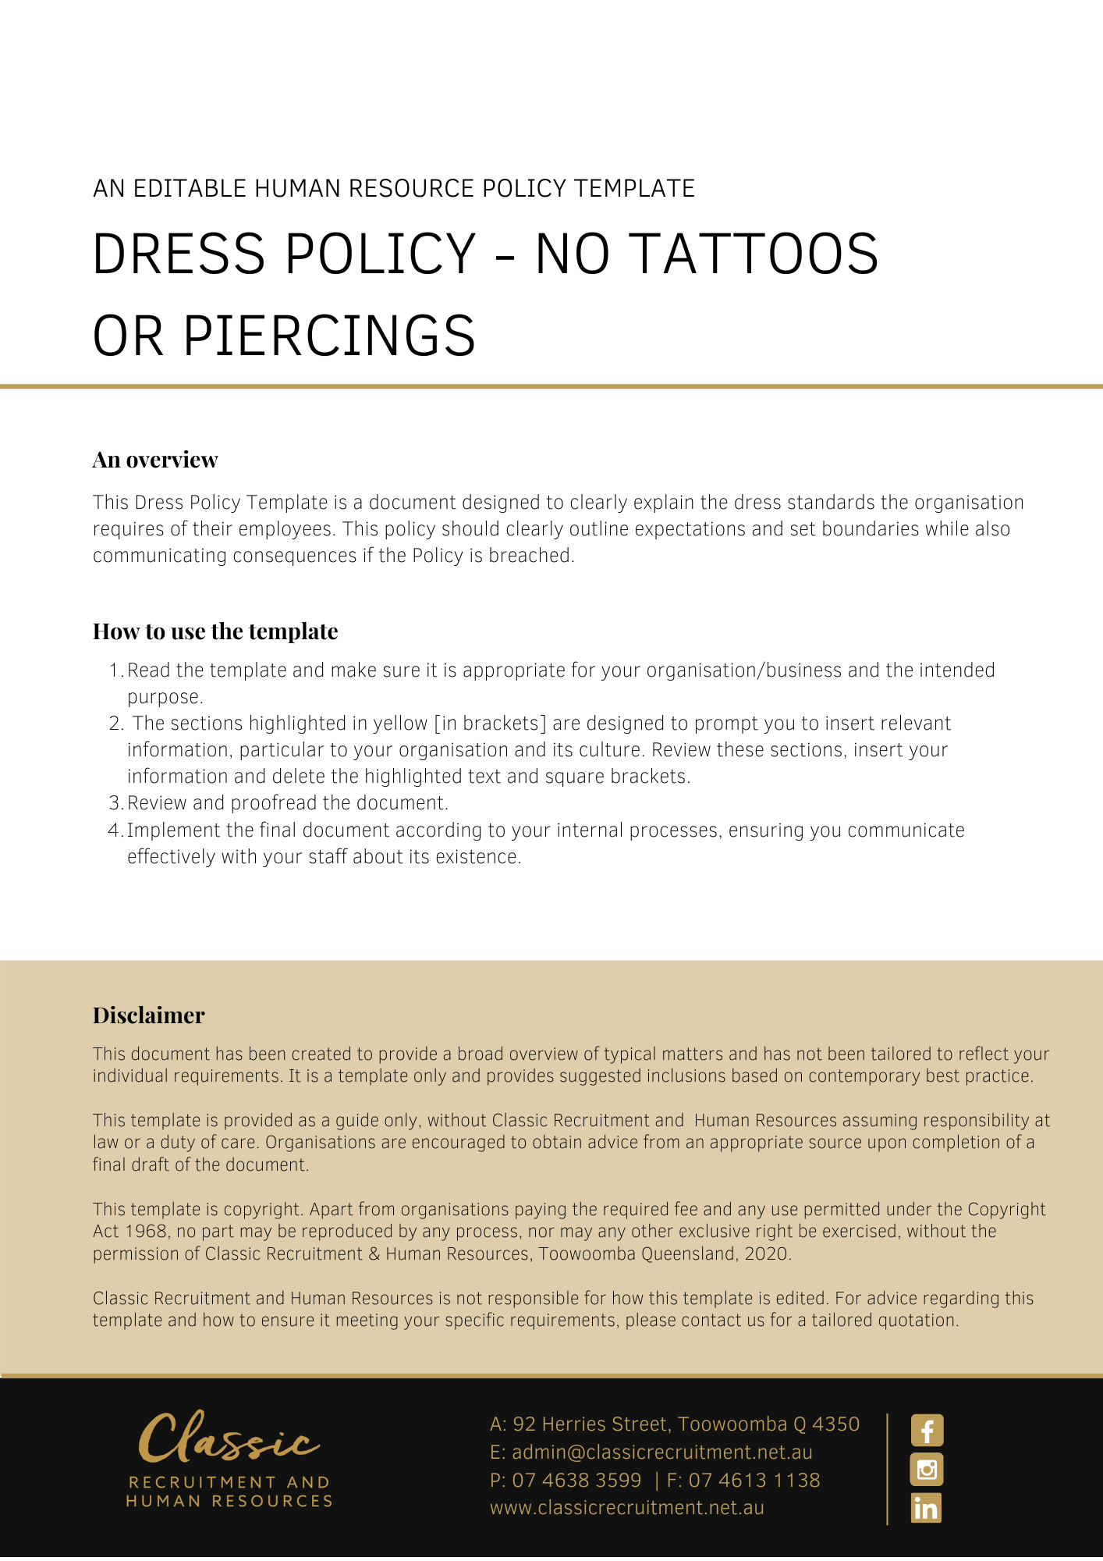

Dress Policy

Overview
The purpose of this Dress Policy is to describe the standard of dress expected by [Company Name] in the workplace.

[Company Name] requires that all staff wear a standard of dress appropriate to the circumstances and environment in which work is performed. Importantly, attire should be neither offensive nor likely to give rise to health and safety risks in the workplace.

Application
This Policy applies to employees and contractors (including temporary contractors) of [Company Name], collectively referred to in this Policy as ‘workplace participants’. This Policy does not form part of any employee’s contract of employment. Nor does it form part of any other workplace participant’s contract for service.

Health and Safety
[Company Name] is required to remove any reasonably foreseeable risk to workplace health and safety. If [Company Name] considers that a particular item of clothing or jewellery constitutes a foreseeable hazard having the potential to harm health or safety, [Company Name] may take whatever action it considers necessary to satisfactorily address the situation.

Action may include directing the workplace participant to remove the particular item of clothing or jewellery whilst in the workplace. If it is not practicable to remove the particular item, [Company Name] may direct the workplace participant to leave the workplace. A workplace participant is required to comply with any such direction.

Jewellery
Any item of jewellery that constitutes a foreseeable hazard having the potential to harm health or safety must not be worn in the workplace. In particular, rings and chains or any other hanging pieces that may have the potential to become entangled in machinery or equipment and therefore pose a risk to health and safety.

Hair
Hair should be worn in a neat and tidy fashion. If directed to do so by [Company Name], a workplace participant must tie back long hair in either a hair net or another similar device.

Nails
Nails should be neatly trimmed and only nail polish that is in keeping with the business dress policy should be worn. [Insert Position (e.g. CEO/Director/Owner)] reserves the right to instruct a workplace participant to remove any unacceptable nail polish that is not keeping with the business dress policy or causes a risk to health and safety.

Tattoos
Tattoos of an offensive nature must be covered.

Uniform
Any workplace participant supplied with a uniform is required to wear it whilst on duty and to take responsibility for its maintenance.

Casual Days
When a ‘casual’ day is held, it is expected that workplace participants will dress in ‘smart casual’ clothing.

If it is found that workplace participants are abusing the privilege of ‘casual’ days then [Insert Position (e.g. CEO/Director/Owner)] may, at their discretion, decide to withdraw the privilege.

Breach of This Policy
Any breaches of this Policy by an employee may result in [Company Name] taking disciplinary action, against that person.

Any breaches of this Policy by a contractor may result in [Company Name] terminating the contract for services.

Variations
[Company Name] reserves the right to vary, replace or terminate this policy from time to time.

Policy and further information
To the extent that the contents of this Policy refers to obligations on [Company Name], they are guidelines for management or summaries of applicable legislative requirements only and are not contractual terms, conditions or representations on which a staff member may rely. Management is available to assist with any queries you have relating to the Policy which is detailed above.

Document Control
This Policy will be reviewed on a regular basis and approved by the [Insert Position (e.g. CEO/Director/Owner)].

Implementation date | Author | Approved by | Date of next review
[Date] | [Name] | [Position] | [Month, Year]

