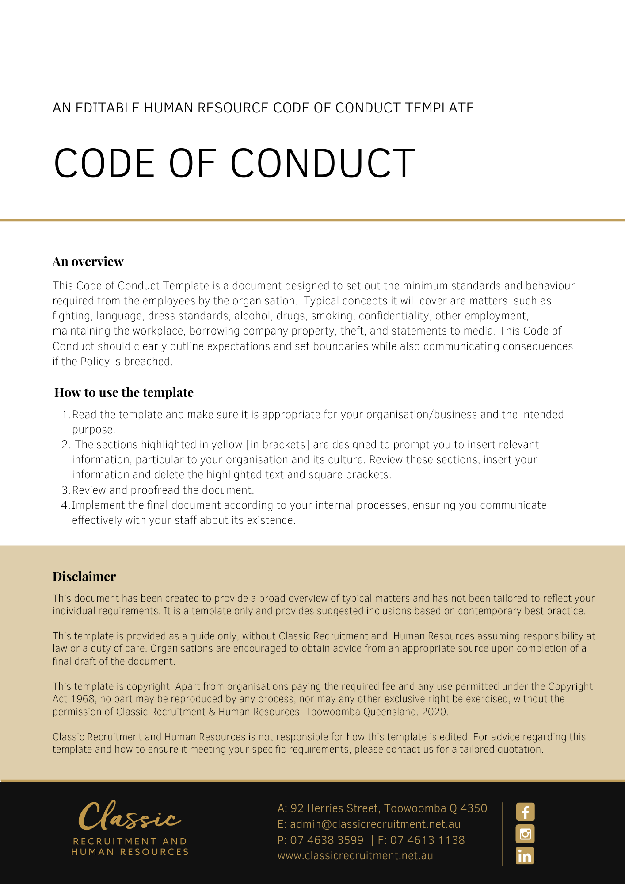
Code of Conduct

Overview
The Code of Conduct (‘Code’) for [Company Name] recognises the importance of a work environment which actively promotes best practice. The purpose of this Code is to describe the standards of behaviour and conduct expected from employees and others in their dealings with customers, suppliers, clients, co-workers, management, and the general public.

[Company Name] expects all employees and others in the workplace to observe the standards set out in this Code. Compliance with this Code is expected, and non-compliance may result in disciplinary action up to and including the termination of employment or contract for services.

Where relevant, this Code operates in conjunction with other policies relating to minimum standards of behaviour and conduct, contract of employments or contract for services.

Application
The Code applies to all employees, agents and contractors (including temporary contractors) of [Company Name], collectively referred to as ‘workplace participants’.

The Code does not form part of a workplace participant’s contract of employment or contract for services.

The Code Requirements
All workplace participants are expected to observe the highest standards of ethics, integrity and behaviour during the course of their employment or engagement with [Company Name]. This Code provides an overview of [Company Name]’s fundamental business values. It is by no means exhaustive but summarises some of [Company Name]’s most important policies, which are based on standards that underlie business ethics and professional integrity, standards that apply to all workplace participants.

As representatives of [Company Name], all workplace participants are expected to conduct themselves in a professional and courteous manner and observe the following standards of behaviour both inside the workplace and outside the workplace where the workplace participant can be perceived as representing [Company Name]:

- Comply with all laws, policies, procedures, rules, regulations, and contracts.
- Comply with all lawful and reasonable directions from [Company Name].
- Be honest and fair in dealings with customers, clients, suppliers, co-workers, management, and the general public.
- Display the appropriate image of professionalism at the workplace. This may include wearing the required uniform, safety equipment or work clothes, and if a workplace participant wears their own clothes, ensuring their appearance is neat and tidy.
- Treat customers, clients, suppliers, co-workers, company management and the general public in a non-discriminatory manner with proper regard for their rights and dignity. In this regard, discrimination, victimisation or harassment based on a person’s race, colour, religion, national origin, age, sex, sexual orientation, marital status, family responsibilities, pregnancy or potential pregnancy, union membership or non-membership, mental or physical disability, or any other classification protected by law will not be tolerated.
- Promptly report any violations of law, ethical principles, policies, and this Code.
- Maintain punctuality. If a workplace participant is late or cannot report for work, please telephone, and let the supervisor know as soon as possible.
- Do not use work time for private gain. If a workplace participant is required to leave the work premises for personal reasons, they should advise their Manager well in advance.
- [Company Name] has a legitimate interest in the private activities of workplace participants where such activities may bring disrepute upon [Company Name] in its relationships with customers, clients, suppliers, and the general public at large and may possibly call the workplace participant’s fitness for continued employment or to provide services into question.
- Maintain and develop the knowledge and skills necessary to carry out duties and responsibilities.
- Observe health and safety policies and obligations and co-operate with all procedures and initiatives taken by [Company Name] in the interests of work health and safety.
- Be truthful in all dealings with persons encountered at the workplace. Workplace participants must not make false or misleading declarations during the performance of their duties or when providing services on behalf of [Company Name]. A declaration can be considered to be misleading if information is omitted or presented in a manner that enables a misleading view of the situation to be formed. This includes failure to comply with reporting requirements and falsifying records and other documents.
- Refrain from any form of conduct which may cause any reasonable person unwarranted offence or embarrassment or give rise to the reasonable suspicion or appearance of improper conduct or biased performance.
- Not act for an improper or ulterior purpose to the detriment (whether perceived or actual) of [Company Name].
- Workplace participants must not abuse the advantages of their position for private purposes, or solicit or accept any gift or benefit in connection with their employment or engagement which might compromise, or be seen to compromise their integrity or [Company Name]’s reputation.
- Respect [Company Name]’s ownership of all of its property including but not limited to funds, equipment, supplies, books, records and confidential information (however described).
- Maintain during their employment or engagement with [Company Name] and after the termination of employment or engagement, the confidentiality of any confidential information, records or other materials acquired during the employment or engagement with [Company Name].
- While employed at [Company Name], not accept any employment with another organisation that is a supplier or competitor of [Company Name], or any other employment that is in conflict with your position at [Company Name].
- Not make any unauthorised statements to the media about [Company Name]’s business (requests for media statements should be referred to the [Media Policy] [Delete after reading – if not applicable change policy or delete suggestion] or to [Insert Position (e.g. CEO/Director/Owner)]).
- Do not fight in the workplace.
- Do not use inappropriate language in the workplace.

- Never report for work in circumstances where there is a risk that you could be affected by or ‘under the influence’ of illicit drugs or alcohol (e.g. if you have ingested or otherwise taken drugs or alcohol the night before or in the period leading up to your next work period). If a workplace participant is taking prescription medication, they must inform their manager at the commencement of their working day. Workplace participants may be required to produce medical evidence to prove their medication does not affect their capacity to perform their duties in a safe manner without harm to themselves or others.
- Do not smoke during working hours unless it is during prescribed breaks and within designated areas.
- We act professionally with honesty and integrity.
- We respect and value differences and create a safe working environment.
- We identify and manage any conflicts of interest responsibly.
- We respect and maintain privacy and confidentiality.
- We comply with our legal and regulatory obligations, internal standards and policies and deal with breaches promptly and appropriately.

Issues for Managers and Supervisors
Managers and supervisors should:

- Promote a team spirit.
- Maintain confidentiality so far as is reasonably practicable when conducting investigations into grievances and disputes.
- Avoid bias in decision making.
- Ensure compliance with [Company Name] procedures when carrying out counselling and discipline.
- Exercise objectivity when administering rewards or discipline.
- Not condone, permit, or fail to report any breaches of the Code as outlined above by workplace participants under their supervision.

Breaches of This Code
A breach of this Code may lead to disciplinary action including, but not limited to, termination of employment or services.

Variations
[Company Name] reserves the right to vary, replace or terminate this Code from time to time.

Policy and further information
To the extent that the contents of the Code refers to obligations on [Company Name], they are guidelines for management or summaries of applicable legislative requirements only and are not contractual terms, conditions, or representations on which a staff member may rely.

Management is available to assist with any queries you have relating to the Code which is detailed above.

Document Control
This Policy will be reviewed on a regular basis and approved by the [Insert Position (e.g. CEO/Director/Owner)].

Implementation date | Author | Approved by | Date of next review
[Date] | [Name] | [Position] | [Month, Year]

