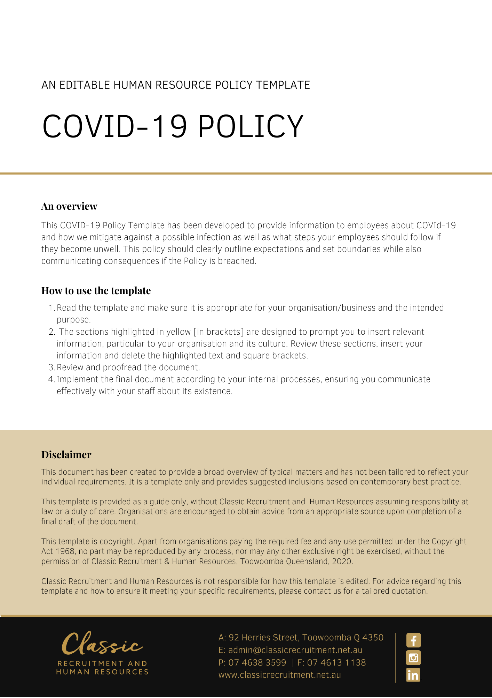

COVID-19 Policy

Overview
[Company Name] has implemented a COVID-19 Policy. The policy takes effect immediately. This policy has been developed to provide information to employees about COVID-19 and how we mitigate against a possible infection as well as what steps our employees should follow if they become unwell.

Coronaviruses are a large family of viruses that cause respiratory infections. These can range from the common cold to more serious diseases. COVID-19 is a disease caused by a new form of coronavirus that was first reported in December 2019. COVID-19 is a respiratory illness with symptoms including fever, coughing, a sore throat, and shortness of breath. The virus is highly contagious and can spread rapidly from person to person, but good hygiene can prevent infection.

Under the model Work Health and Safety laws, [Company Name] has a duty of care for the health and safety of our employees and others at the workplace. These laws apply even if employees are required to work somewhere other than their usual workplace, for example, working from home.

Employees also have a duty to take reasonable care of their own health and safety, and to not adversely affect the health and safety of others.

This policy seeks to clarify both employee’s obligations and entitlements in relation to COVID 19 as well as to explain [Company Name] initiatives to identify and minimise risks to employees, explain procedures for managing working from home and wherever possible, implement appropriate controls while following government directions.

For the safety of employees and others in the workplace, this policy must be followed at all times.
[Company Name] sets guidelines and policies in the workplace as follows. We believe it is important to clearly communicate our expectations of all employees. It is every employee’s responsibility to act in accordance with this policy.

What is COVID-19?
Coronaviruses are a large family of viruses that cause respiratory infections. These can range from the common cold to more serious diseases. COVID-19 is a disease caused by a new form of coronavirus. It was first reported in December 2019 in Wuhan City in China. Other coronaviruses include Middle East Respiratory Syndrome (MERS) and Severe Acute Respiratory Syndrome (SARS). On 11 March 2020, the World Health Organization (WHO) declared COVID-19 a pandemic (an infectious disease outbreak that spreads on a global scale).

What is [Company Name] doing to reduce the risk of infection to employees?
[Company Name] is committed to following government directions, advice from the Federal Department of Health, state government departments and Safe Work Australia as appropriate. Importantly, [Company Name] will communicate regularly with all employees, providing updates when appropriate.

In each of the [Company Name] offices, specific measures have been implemented as follows [Delete after reading: Amend the following points if they are not applicable]:

- Physical distancing is actively monitored – everyone at the workplace must ensure they are at least 1.5 metres physically apart and the number of people allowed in rooms has been limited based on the directive of only 1 person per 4 sqm
- Alcohol based hand sanitiser and anti-bacterial soap is available in all kitchens and bathrooms. Hand sanitiser is also available at Reception for use on your way in and out of the office
- We encourage everyone to practice good hygiene to protect against infection and prevent the virus spreading and have posters with reminders and instruction up around the offices. Good hygiene is characterised by:
  - covering your coughs and sneezes with your elbow or a tissue
  - dispose of tissues hygienically
  - washing your hands often with soap and water, including before and after eating, after going to the toilet and after changing tasks
  - using alcohol-based hand sanitisers
  - avoiding the touching of your eyes, nose and mouth and avoiding close physical contact such as the shaking of hands
  - cleaning and disinfecting frequently used surfaces such as benchtops, desks, and doorknobs
  - cleaning and disinfecting frequently used objects such as mobile phones, keys, wallets, and work passes
  - cleaning up after yourself and placing rubbish in the bins provided
  - avoiding putting personal items such as mobile phones on meal surfaces
  - not shaking hands and avoiding any other close physical contact where possible.
- Employees have been advised if they are experiencing any flu-like symptoms, not to attend the workplace and seek advice from a health care professional
- Access to personal protective equipment such as gloves has been provided
- More regular cleaning and disinfecting of workspaces is taking place
- Employees are allowed, in certain circumstances and by agreement with the [Insert Position (e.g. CEO/Director/Owner)], to work from another location such as their home. Working from home procedures have been implemented and are closely monitored
- All staff have access to video conferencing functionality to assist with communication between colleagues and also with clients
- Access to the workplace is limited for clients by encouraging meetings to occur by phone or video conference where possible
- Only urgent maintenance to buildings and equipment will take place. When required, contractors visiting the office are advised of our hygiene protocols and provided access to alcohol-based hand sanitiser for use during their time in the office. Suppliers have also been asked to confirm how they are internally managing hygiene protocols in their business and with their employees
- Systems are in place to facilitate cashless transactions, so clients do not need to attend the office to pay their accounts
- Employees have access to available entitlements in line with obligations under any applicable enterprise agreement, award, employees’ contracts of employment, and workplace policies

What should employees do?
Employees should follow all directions and recommendations of [Company Name] as well as:

- Practice good hygiene as outlined above
- Stay away from the workplace (self-quarantine) if unwell and not fit for work and seek medical advice as appropriate. Ensure you follow established communication protocols with the [Insert Position (e.g. CEO/Director/Owner)] and appropriate leave request procedures
- Stay away from the workplace (self-quarantine) if they have been in close contact with someone who has the virus or suspects they may have contracted the virus. Ensure you follow established communication protocols with the [Insert Position (e.g. CEO/Director/Owner)] and appropriate leave request procedures
- Encourage your clients to participate in meetings over the phone or via video conference to limit access to the workplace by other people, unless it is absolutely necessary for them to attend in person
- Reconsider work-related travel and implement other methods of communication. For example, rather than attending face to face meetings, facilitate attendance by tele or videoconference
- Remember that everyone has a duty to take reasonable care for their own health and safety and to not adversely affect the health and safety of others
- Discuss any concerns with the [Insert Position (e.g. CEO/Director/Owner)] so we can resolve any issues proactively

The Continuation of Business Operations
It is our expectation that you attend work as normal during this time, unless:

- you are on a period of authorised leave (personal, annual or long service)
- you are not attending work due to a Government mandated self-isolation period
- you are not attending work under our specific instruction; or
- there is a safety reason why you cannot be at work that has been discussed and agreed with the [Insert Position (e.g. CEO/Director/Owner)]
As time progresses, it may become necessary for the business to temporarily reduce or cease operations, for example if someone in the workplace is diagnosed with COVID-19.

[Company Name] will do everything possible to continue operating in these circumstances, however ultimately will take the action that is necessary to comply with Government advice and ensure safety within the workplace.

In the unlikely scenario of a shutdown, we may have no choice but to place you on an unpaid stand down. For clarity, this will only occur under specific circumstances in line with the Fair Work Act 2009, and all alternatives will be considered prior to taking this step.

To maintain normal business operations, it may be necessary for us to require you to work from an alternative work location if, for example, instructions from a third party mean that entry into our current workplace is not permitted. Your flexibility in this regard will be required. It likely may be necessary for you to work remotely. Advance authorisation to work remotely is needed in every case.

We operate a zero tolerance policy to all forms of harassment and bullying in the workplace. We will not tolerate any unacceptable behaviour to colleagues, clients or other members of the public. Any complaints of this nature will be investigated in line with our usual policy and may result in disciplinary action, up to and including termination of employment.

COVID-19 Diagnosis or Exposure
If you begin to display symptoms of the virus, you must follow Government guidance to find out what to do next. You must seek medical attention and notify the [Insert Position (e.g. CEO/Director/Owner)] at the earliest opportunity. In order to protect your fellow colleagues, you are required to remain absent from the workplace on personal leave and provide us with a medical certificate. You are required to get a medical clearance from your doctor or provide us with the QLD Health Coronavirus test result confirming a negative result prior to returning to the workplace.

If you have been in contact with someone who has a confirmed case of COVID-19 and are not unwell, you are required to notify the [Insert Position (e.g. CEO/Director/Owner)] immediately. In order to protect your fellow colleagues, we ask you to seek direction from your health care provider and remain absent from the workplace on unpaid leave (or annual leave with your approval) until you are cleared to return. In this instance, [Company Name] will consider on a case by case basis whether it is possible for you to work remotely. Advance authorisation to work remotely is needed in every case.

If you have been in contact with someone who has a suspected case of COVID-19, you are required to notify the [Insert Position (e.g. CEO/Director/Owner)] immediately. We will likely make the decision to send you home and require you not to attend work as a safety precaution until results have been obtained. In these circumstances, we may require you to work remotely if possible. Advance authorisation to work remotely is needed in every case.

Self-Isolation
You must not attend the workplace during any self-isolation period that the Government requires you to undertake.

If you are unwell during this self-isolation period, you should follow the usual procedure to notify [Company Name] that you require personal leave and obtain a medical certificate in support of your leave. You are required to get a medical clearance from your doctor prior to returning to the workplace.

If you are well during this period of isolation, [Company Name] will consider any available type of leave that may be taken to cover the absence. [Company Name] will also consider on a case by case basis whether it is possible for you to work remotely.

If there are no forms of accrued paid leave available, the absence will be unpaid.

Some important points to consider
As you are an important part of the [Company Name] team, your wellbeing and that of our fellow workers is fundamental to you fulfilling your workplace obligations to [Company Name]. It is our policy that employees should follow these guidelines, communicate with the [Insert Position (e.g. CEO/Director/Owner)] and comply with government directions.

What do I need to do?
You need to review the COVID-19 Policy and make yourself familiar with the contents of the policy. In the event that you have any questions, make sure you address these to either the [Insert Position (e.g. CEO/Director/Owner)].

What happens if I do not comply with the COVID-19 Policy?
The consequences of a breach of this policy will vary depending on the type and seriousness of the breach and will be at the discretion of [Company Name]. Depending on the circumstances, [Company Name] may take disciplinary action up to and including termination of employment.

Given the contagious nature of COVID-19 and the health ramifications it is imperative that employees should contact either the [Insert Position (e.g. CEO/Director/Owner)] with any concerns they may have relating to their personal wellness in the first instance.

Policy and further information
To the extent that the contents of the COVID-19 Policy refers to obligations on [Company Name], they are guidelines for management or summaries of applicable legislative requirements only and are not contractual terms, conditions or representations on which a staff member may rely. [Insert Position (e.g. CEO/Director/Owner)] is available to assist with any queries you have relating to the policy which is detailed above.

Refer to the Working from Home Policy as well for further information and guidelines.

Document Control
This Policy will be reviewed on a regular basis and approved by the [Insert Position (e.g. CEO/Director/Owner)].

Implementation date | Author | Approved by | Date of next review
[Date] | [Name] | [Position] | [Month, Year]

