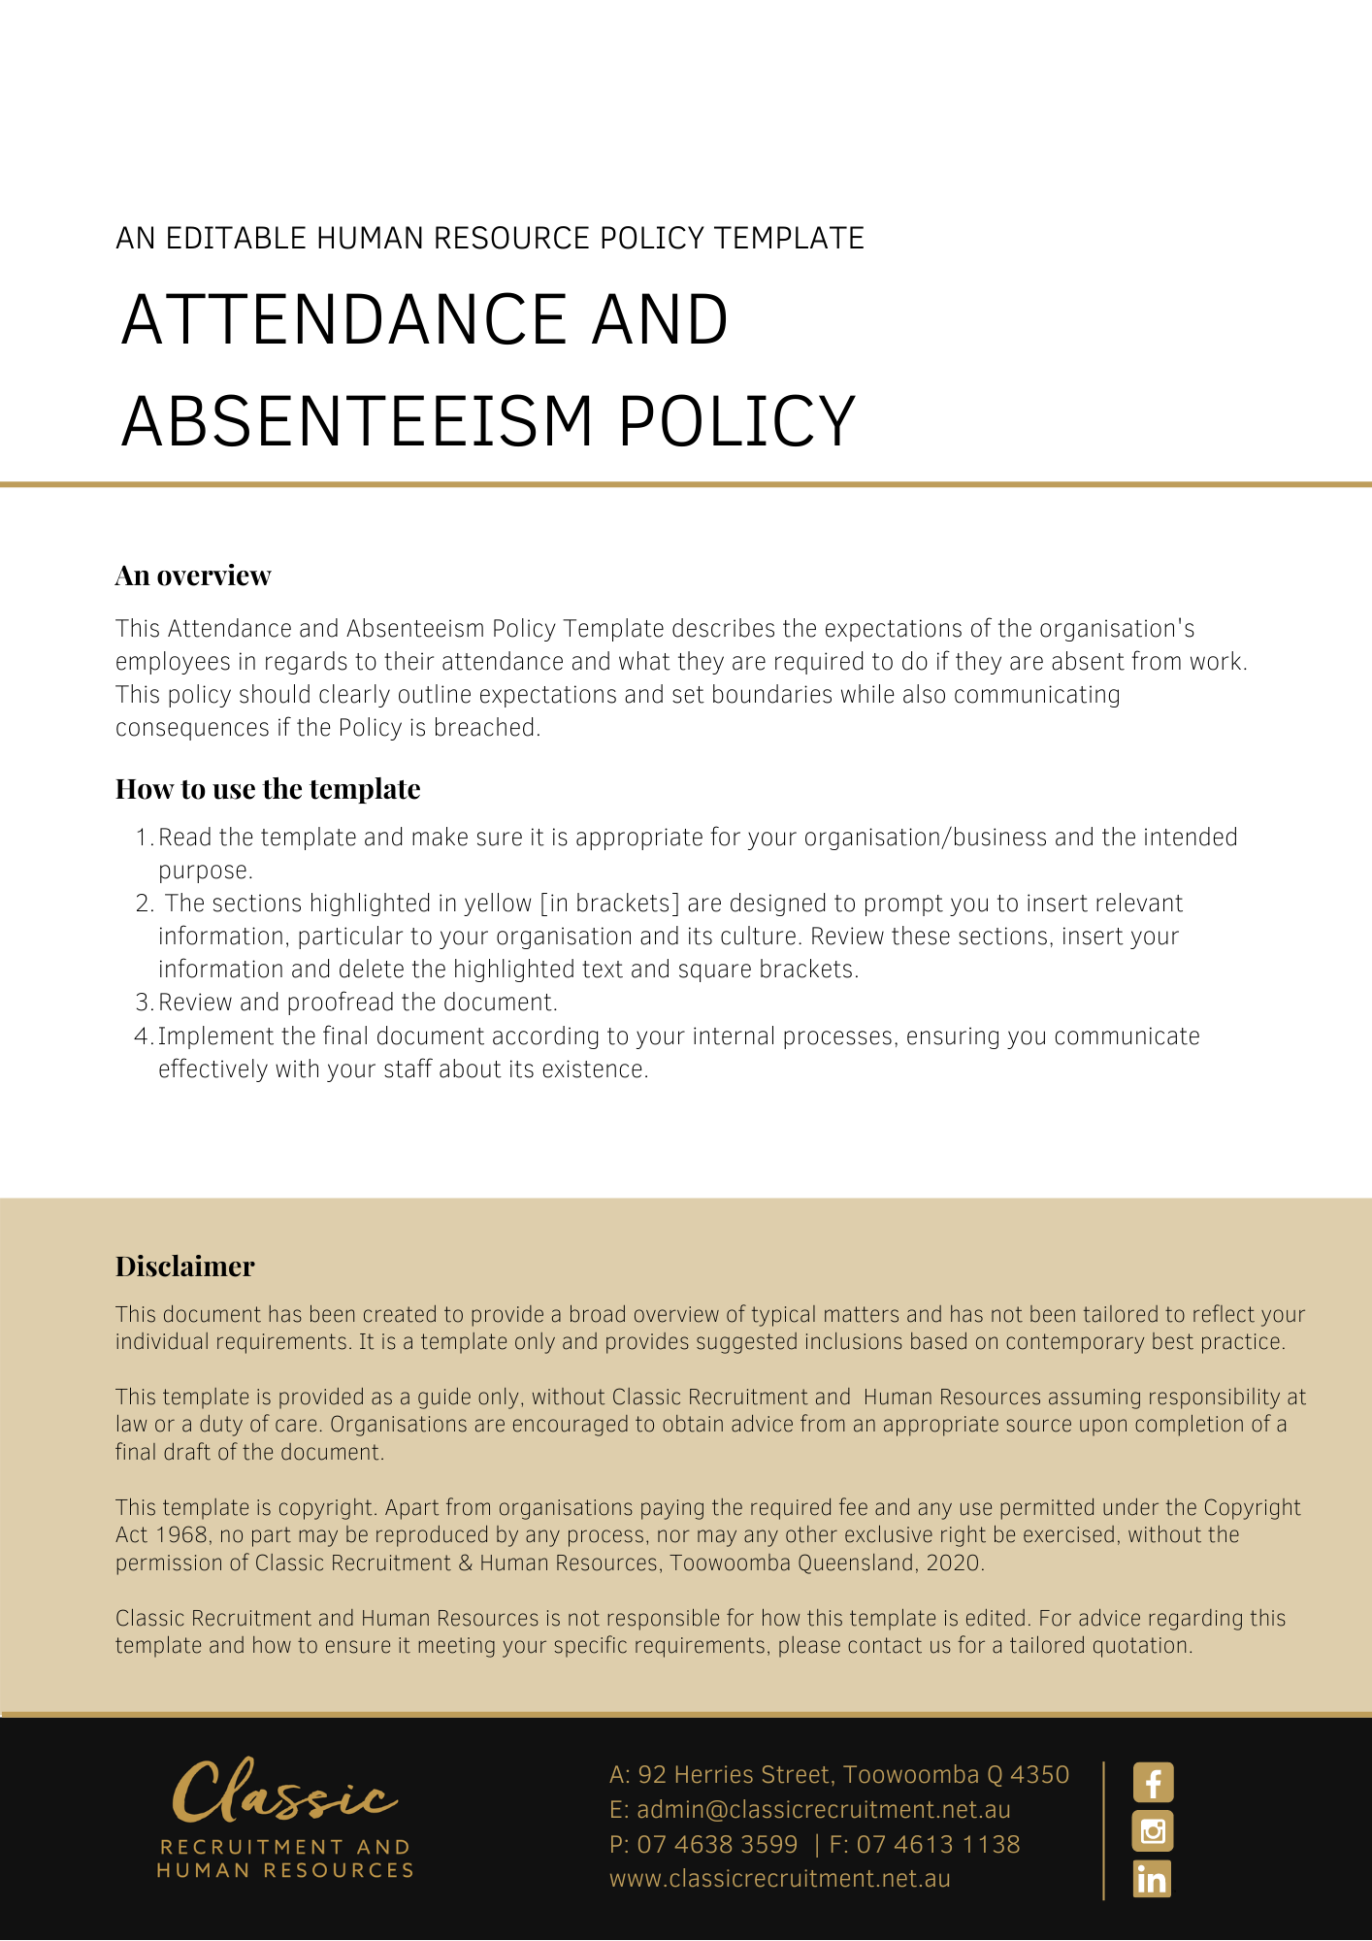

Attendance and Absenteeism Policy

Overview
This Policy sets out what is expected of [Company Name] employees in terms of their attendance at work, and what they are required to do if they are absent from work.

Application
This Policy applies to employees of [Company Name]. It does not form part of any employee’s contract of employment.

Attendance
Regular attendance is essential to the efficient workflow and productivity of [Company Name]. An employee not attending for duty as required will not be paid for such time as they are absent from the workplace unless they are on authorised paid leave. [Company Name] may require the employee to make up any time lost due to an unauthorised non-attendance.

Absence
Employees must comply with any enterprise agreement or modern award that applies to their employment and deals with attendance or absence. Employees must also comply with any requirements set out in their contract of employment, this Policy and any other [Company Name] policy concerning leave and absenteeism.

If an employee is absent for any reason, they must notify their supervisor or manager as soon as reasonably practicable, indicating the reason for the absence and extent of the anticipated absence. [Delete after reading: Insert particular requirements here e.g. text the [Insert Position (e.g. CEO/Director/Owner)] on XXXX XXX XXX no later than 7am in the morning].

During absences extending more than one day, employees must contact their supervisor regularly to keep [Company Name] updated as to the circumstances of the employee’s continuing absence. Where an employee finds that they cannot return to work as scheduled, they must notify their supervisor or manager as soon as possible. Depending on the circumstances of the absence, the leave of absence may be approved, denied, paid or unpaid.

Further, [Company Name] may require reasonable evidence (e.g. medical certificate or statutory declaration) to support the reason(s) for the absence. If such evidence is required, it must be supplied as soon as reasonably practicable. Where such evidence is required but not provided, the leave of absence will be on an unpaid basis.

Disciplinary Action
Repeated late attendance or absence from work, without a valid reason, proper notification, or a failure to provide requested evidence to support the absence will be cause for disciplinary action, which may include termination of the employee’s employment.

Variations
[Company Name] reserves the right to vary, replace or terminate this Policy from time to time.

Policy and further information
To the extent that the contents of this Policy refers to obligations on [Company Name], they are guidelines for management or summaries of applicable legislative requirements only and are not contractual terms, conditions or representations on which a staff member may rely. Management is available to assist with any queries you have relating to the Policy which is detailed above.

Document Control
This Policy will be reviewed on a regular basis and approved by the [Insert Position (e.g. CEO/Director/Owner)].

Implementation date | Author | Approved by | Date of next review
[Date] | [Name] | [Position] | [Month, Year]

