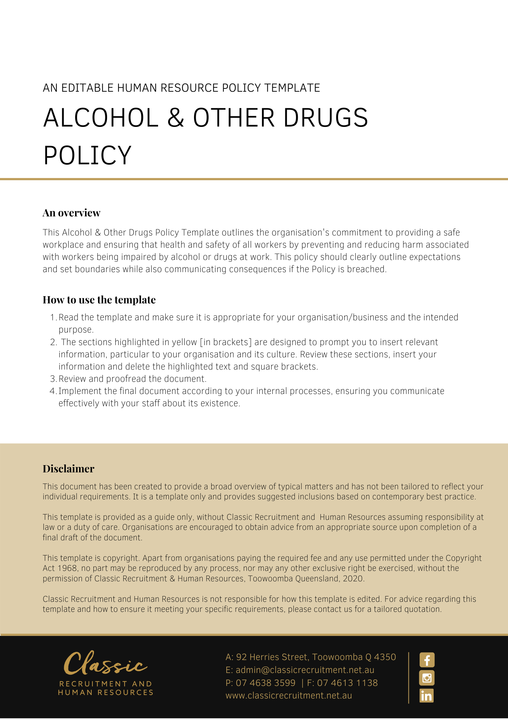

Alcohol & Other Drugs Policy

Overview
[Company Name] has implemented an Alcohol & Other Drugs Policy. The policy takes effect immediately. This policy outlines our commitment to providing a safe workplace and ensuring the health and safety of all workers by preventing and reducing harm associated with workers being impaired by alcohol or drugs at work.

[Company Name] is also committed to the establishment of programs and attitudes that contribute to a safe working culture. We endeavour to maintain a positive professional profile with clients, suppliers, and other members of the public.

We recognise that involvement with alcohol and drugs can have serious repercussions for employees and their performance in the workplace. Incidents involving inappropriate drug and alcohol can also impact on an individual’s friends and family as well as our reputation. This Policy seeks to describe both our expectations and the support available to employees.

Application
This policy applies to all employees of [Company Name] regardless of whether they are permanent full-time, permanent part-time or casual employees. The Policy applies to all employees while at any [Company Name] workplace and any other place where the employee performs work for the business.

[Company Name] Management Responsibilities
It is the Company’s responsibility to:

- Direct any employee reasonably suspected of being under the influence of drugs or alcohol away from the work area
- Arrange for a safe option of transport home for any worker under the influence of drugs or alcohol
- Request workers to see a medical practitioner if it is reasonably suspected that they are under the influence of drugs or alcohol
- Provide information regarding internal and external support systems available to the worker.

Employee Responsibilities
It is the workers to responsibility to:

- Understand and comply with this policy;
- Attend work free from the impairment of alcohol and other drugs;
- Consult with management if they believe they are impaired by alcohol or drugs whilst at work.

[Company Name] encourages all its workers to proactively discuss any prescription drugs they are taking with their doctor to determine whether use of the drug will impair their ability to operate tools, machinery or equipment or to carry out work tasks.

[Company Name] also encourages workers consult with their [Insert Position (e.g. CEO/Director/Owner)] at an early stage, to ensure that a decision can be made as to whether the employee is capable of performing their work tasks while taking the prescribed drugs.

Managers of the Company are expected to monitor employees who report to them and to immediately discuss with either the [Insert Position (e.g. CEO/Director/Owner)] any situations that may breach this Policy.

Appropriate steps must be taken to discuss concerns with the employee if there is a suggestion that an employee’s behaviour, actions or conduct suggest that they have breached this Policy. Of course, taking care to ensure the employee’s privacy is not compromised is essential. Confidentiality and sensitivity are paramount.

In summary, it is not against a breach of this Policy for an employee to take drugs that are legally prescribed by a doctor for the purposes of treating a medical condition. However, where an employee is on prescribed medication which may impair their judgment or performance, they must notify the [Insert Position (e.g. CEO/Director/Owner)] and may be required to take sick leave or unpaid leave. This is to ensure employee safety. It is a breach of this Policy however if the employee does not communicate this with their Director and/or Human Resources. Such discussions will of course be kept confidential.

Worker Assistance
If an employee is concerned they have an alcohol or drug problem that is affecting their ability to perform the requirements of their role, [Company Name] encourages employees to ask for help from the [Insert Position (e.g. CEO/Director/Owner)] at an early stage (that is, before the problem is the subject of disciplinary action), without fear of punishment. Such discussions will be kept confidential.

[Company Name] may at its own discretion, provide an employee with access to an Employee Assistance Program (“EAP”), through an [Delete after reading: e.g. Catholic Care or you many have an existing provider] appropriate EAP provider. The purpose of the EAP is, amongst other things, to assist workers who voluntarily seek help for Alcohol and/or Drug dependence problems. Participation by any employee in the EAP will be regarded as confidential.

Alcohol & Drug Testing
During employment or engagement, the Company may require a worker to undergo a drug and alcohol test to monitor compliance with this Policy.

This testing may be carried out by either [Company Name] or by one of its clients (if an employee is on site with a client) and may be pre-arranged or random in nature.

If testing is carried out on a client site, this will be covered off in their on-site Induction policies and procedures. Accordingly, all employees who are taking prescription drugs and required to travel to client sites as part of their employment should always discuss prescription drugs with either the [Insert Position (e.g. CEO/Director/Owner)] prior to travelling to a client site.

Procedure if employee is thought to be under the influence of alcohol or another drug
The following procedure will apply:

- The person who observes concerning behaviour should contact either the [Insert Position (e.g. CEO/Director/Owner)] for advice and support. One of these will then approach the employee and may request that the employee attend a doctor medical practice for drug/alcohol testing.
- If the employee is willing to undergo a drug and alcohol test, transport will be arranged to either the employee’s doctor or a doctor selected by [Company Name].
- If the medical practitioner determines that the employee is unfit to continue working, then the employee will be sent home for the day. No payment will be made for the time lost due to being unfit for work unless it relates to legally prescribed medication and the employee has previously notified their requirement to take the prescribed medication. In this circumstance, the employee may be required to take Personal (sick) leave or unpaid leave
- [Company Name] may contact QLD Police to report any drug use
- If the employee is fit to continue working, the employee will return to their job. All time lost in attending the medical practitioner will be paid
- If the employee is unwilling to submit to a test or is uncooperative, the [Insert Position (e.g. CEO/Director/Owner)] will discuss this with to the employee, with a view to influencing the employee to attend a medical practitioner for testing
- If the employee refuses to cooperate, then the normal disciplinary procedures will be commenced. The counselling and disciplinary procedure may result in disciplinary action up to and including termination of the employee’s employment contract
- All matters will be treated in the strictest confidence.

Smoke free work environment
[Company Name] recognises and accepts its obligation to provide its employees with a healthy and safe working environment. We support the principle of a smoke-free environment for our employees, clients, suppliers, and visitors at our workplaces.

Our specific requirements are:

- Smoking is prohibited in all internal areas of our workplaces and any area which has been deemed to be hazardous or is a designated no smoking area. 'No smoking' legislative requirements may also apply to public areas accessed by our employees
- Smoking is limited to approved meal / break times
There are no exceptions to this policy and wilful disregard will be treated as a serious breach.

Employees are permitted to smoke in the designated smoking areas outside our building and must dispose of cigarettes in designated bins.

What do I need to do?
You need to review the Alcohol & Other Drugs Policy and make yourself familiar with the contents of the policy. In the event that you are required to travel, make sure you complete a written request for approval, outlining all details of the trip, by either the [Insert Position (e.g. CEO/Director/Owner)].

What happens if I do not comply with the Alcohol & Other Drugs Policy?
The consequences of a breach of this policy will vary depending on the type and seriousness of the breach and will be at the discretion of [Company Name].

Depending on the circumstances, [Company Name] may take disciplinary action up to and including termination of employment.

Policy and further information
To the extent that the contents of the Alcohol & Other Drugs Policy refers to obligations on [Company Name], they are guidelines for management or summaries of applicable legislative requirements only and are not contractual terms, conditions or representations on which a staff member may rely.

Management is available to assist with any queries you have relating to the policy which is detailed above.

Further information may be found at:

EAP Provider – [Insert details of existing EAP provider]

Q:LD Health - https://www.health.qld.gov.au/public-health/topics/atod/services

Lifeline - https://www.lifeline.org.au/get-help/information-and-support/substance-misuse-and-addiction/

QLD Government QUIT HQ - https://quithq.initiatives.qld.gov.au/quit-support/quitline/get-help-from-quitline/

Alcoholics Anonymous - https://aa.org.au/

Document Control
This Policy will be reviewed on a regular basis and approved by the [Insert Position (e.g. CEO/Director/Owner)].

Implementation date | Author | Approved by | Date of next review
[Date] | [Name] | [Position] | [Month, Year]

