**Engagement Letter Full Time**

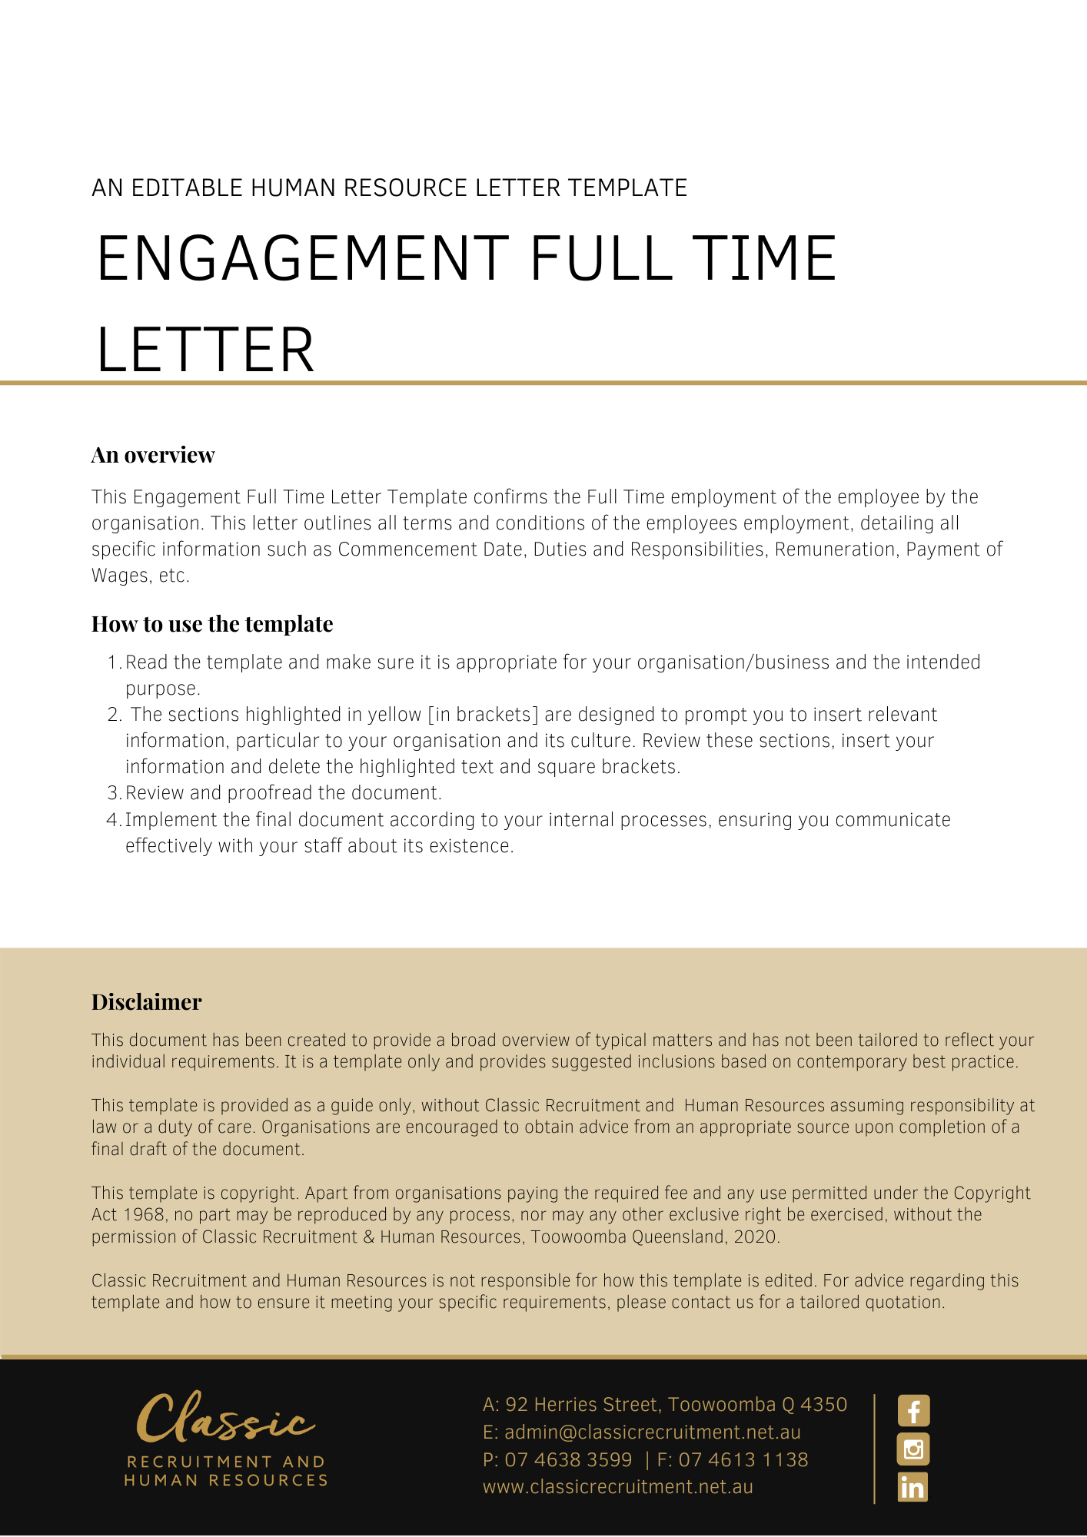

[Date]

[Employee First Name] [Employee Surname]

[Employee Address]

PRIVATE AND CONFIDENTIAL

Dear [Employee First Name],

**Position:** [Employee Position]

***Terms and Conditions***

1. Nature of employment
   1. This agreement will commence on [Commencement Date]. Your position is [Employee Position]. You will be employed on a Full Time basis. However, the commencement of the employment relationship is conditional upon you attending at the workplace and commencing the performance of work in accordance with this agreement.
2. **Location**
   1. Your work location will be [Work Location], however, your location may change during your employment.
3. **Duties and Responsibilities**
   1. In your employment you will perform:
      1. those duties set out in the Position Description attached to this contract; and
   2. any other duties which [Company Name] may reasonably require from you.
   3. [Company Name] may change your position in order to meet business needs from time to time in accordance with the needs of the business. You agree that irrespective of any such changes, the terms and conditions of this contract continue to apply unless varied in writing in accordance with this contract.
4. **Probationary Period**
   1. Your employment is probationary for the first six (6) months [Delete after reading: adjust probation period as required] from the date of commencement. Your work performance and conduct will be monitored during this period. Prior to the completion of your probationary period, will decide on your suitability to continue employment.
   2. During the Probationary Period either you or may terminate your employment upon 1 week’s notice, except in cases of summary dismissal where no notice is required. may elect to pay you in lieu of part or all of your notice period.
   3. Your minimum employment period (as defined in the *Fair Work Act 2009* (Cth)) is unaffected by this clause.
5. Hours
   1. As a full-time employee, your hours from the commencement of your employment will be 38 per week, averaged over a period of up to 26 weeks. In addition, you are expected to work such additional hours as are necessary to fulfil the duties and responsibilities of your position. You will not receive any additional remuneration for any additional hours worked.
6. Salary & Superannuation
   1. Your salary will be [Insert Salary Per Annum] per annum. In addition [Company Name] will, where required, make compulsory superannuation guarantee contributions on your behalf in accordance with the relevant legislation and/or industrial instrument in force from time to time.
7. Payment of Salary
   1. Your salary will be paid on a [Insert Pay Basis] basis, deposited by direct credit, into the bank account of your choice.
8. Compensation for all Legal Entitlements
   1. Except as specifically provided for under this Contract, the salary and any other benefits are in satisfaction of any legal entitlement arising under an award, NAPSA, collective/enterprise agreement, the National Employment Standards or any other law or legal instrument (collectively ‘the Instruments’), such as, but not limited to, any periodic rate of pay, overtime payments, weekend and holiday penalties, shift allowance, vehicle allowance, travelling expense, penalty payments and annual leave loading.
   2. You expressly agree that any remuneration you receive that is greater than the entitlement you would receive under the Instruments satisfies any other legal entitlements where you receive less than the minimum amount under the Instruments.
   3. The remuneration paid to you in excess of your entitlements or benefits under an applicable award or industrial instrument in any week or month, may be offset against any underpayment of award or industrial instrument entitlements in any other week or month.
9. Annual Leave
   1. You will accrue an amount of paid annual leave in accordance with relevant legislation.
10. **Personal/Carer’s Leave**
    1. You will accrue an amount of paid personal/carer’s leave in accordance with relevant legislation.
11. **Employment Policies and Procedures** 
    1. You are directed to comply with [Company Name]’s policies and procedures as varied from time to time.
    2. Such policies and procedures do not form part of your contract of employment.
12. **Confidential Information**
    1. **‘Confidential Information’** means trade secrets and other information that is the property of [Company Name] (whether in writing or otherwise) given to or gained by you in confidence at any time, whether before, during, or after your employment with [Company Name], except for any information that has become part of the public domain other than by reason of your breach of this clause (or any other obligations that you may have to [Company Name]).
    2. Except in the normal course of your employment, you will at all times (including after termination of your employment with [Company Name]) keep confidential and not use or disclose any Confidential Information.
13. Workplace Surveillance
    1. puts you on notice that surveillance in the workplace will be carried out by [Company Name] whilst you are at work and/or performing work. The purpose of workplace surveillance is to protect the general security of ’s property and assets, operational needs, and for the protection and safety of employees and the general public.
    2. will carry out surveillance and monitoring at work using the following:
       1. “camera surveillance”, which is surveillance or monitoring by means of a camera that monitors or records visual images or activities on premises or in any other place;
       2. “computer surveillance" , which is surveillance or monitoring by means of software or other equipment that monitors or records the information input or output, or other use, of a computer (including, but not limited to, the sending and receipt of emails and the accessing of Internet websites);
       3. “tracking surveillance" , which is surveillance or monitoring by means of an electronic device the primary purpose of which is to monitor or record geographical location or movement of a person or object (such as a Global Positioning System tracking device);
       4. “listening device surveillance", which is surveillance or monitoring by means of any device capable of being used to overhear, record, monitor or listen to a conversation or words spoken to or by any person in conversation, but does not include a hearing aid or similar device used by a person with impaired hearing to overcome the impairment and permit that person to hear only sounds ordinarily audible to the human ear.
    3. The workplace surveillance referred to in this Contract will occur on an ongoing basis.
    4. You consent to the workplace surveillance as per the terms of this clause 13.
14. **Termination**
    1. Your employment may be terminated without notice in circumstances warranting summary termination. For example, where you have been found to have engaged in serious misconduct.
    2. Following your probationary period and in circumstances where 14.1 does not apply, your employment (and this contract) may be terminated by either party providing (4) weeks’ notice of termination.
    3. If you are over 45 years of age and have completed at least five years of service, an additional one week’s notice will be given by [Company Name].
    4. If [Company Name] terminates your employment, it may make a payment to you in lieu of notice or provide you with altered duties during part or all of the notice period.
15. **Return of Property**
    1. Immediately upon the termination of your employment for any reason, or otherwise at [Company Name]’s request, you must return to [Company Name] all property belonging to [Company Name] which is in your possession, custody or control.
    2. To the extent permitted by law, [ShortEmployerName] will be entitled to deduct from any remuneration or accrued entitlements (if any), the value of any [ShortEmployerName] property not returned or the costs of replacing all such property. You agree to indemnify [Company Name] for any shortfall in the value of property not returned which exceeds the value of your remuneration and accrued entitlements (if any) on termination.
16. **Complete Agreement**
    1. This contract sets out all of the terms of your employment with [Company Name] and supersedes and replaces all prior representations and agreements, whether oral or in writing, concerning your employment with [Company Name].
    2. If there are any other matters that you have relied on in your discussions or other communications to date or there are any other matters you wish to discuss, please let [Company Name] know before you sign a copy of this contract. [Company Name]’s representative may then consider them and discuss them with you. If agreed, the terms set out in this letter will be amended to ensure that it contains all the agreed terms of your contract, when you sign it. Once you sign this letter you are confirming the contract is complete and no agreed terms are missing from the letter.

If you agree this letter sets out the complete contract between you and [Company Name], please signify your acceptance of these terms and conditions by signing the enclosed duplicate and returning it to me to acknowledge that you accept [Company Name]’s offer of employment on the terms and conditions set out in this contract.

I look forward to your contribution to the work of [Company Name] and wish you every success in your appointment.

[Salutations for goodbye],

[Company Name]

[Letter Signatory Name]

[Letter Signatory Position]

|  |
| --- |
| **I,** [Employee Name], have read and understood this letter and accept the terms and conditions contained in it. I believe the terms and conditions set out in this letter to be fair and reasonable.  Signed:  _______________________________________________ Date:______________________ |

**Position Description**

**Position Title:**

* [Employee Position]

**Reporting To:**

* [Employee Report To [Insert Position (e.g. CEO/Director/Owner)]]

**Position Summary:**

* [Position Summary]

**Duties:**

* [Position Duties]